UNITED STATES

SECURITIES AND EXCHANGE COMMISSION

Washington, D.C. 20549

FORM 6-K

REPORT OF FOREIGN PRIVATE ISSUER PURSUANT TO RULE 13a‑16 OR 15d‑16

UNDER THE SECURITIES EXCHANGE ACT OF 1934

FOR THE MONTH OF NOVEMBER 2020

COMMISSION FILE NUMBER 001-39081

BioNTech SE

(Translation of registrant’s name into English)

An der Goldgrube 12

D-55131 Mainz
Germany
+49 6131-9084-0

(Address of principal executive offices)

Indicate by check mark whether the registrant files or will file annual reports under cover Form 20‑F or Form 40‑F: Form 20‑F ☒ Form 40‑F ☐

Indicate by check mark if the registrant is submitting the Form 6‑K in paper as permitted by Regulation S‑T Rule 101(b)(1): ☐

Indicate by check mark if the registrant is submitting the Form 6‑K in paper as permitted by Regulation S‑T Rule 101(b)(7): ☐

DOCUMENTS INCLUDED AS PART OF THIS FORM 6-K

BioNTech SE (the “Company”) posted five presentations at the Society for Immunotherapy of Cancer (SITC) Annual Meeting, held virtually from November 9 to November 15, 2020, with data from clinical and pre-clinical trials across the Company’s platforms. These presentations are attached hereto as Exhibit 99.1.

SIGNATURE

Pursuant to the requirements of the Exchange Act, the registrant has duly caused this report to be signed on its behalf by the undersigned, thereunto duly authorized.

BioNTech SE

By: /s/ Dr. Sierk Poetting
Name: Dr. Sierk Poetting
Title: Chief Financial Officer

Date: November 9, 2020

 |  |  |  | EXHIBIT INDEX
Exhibit |  | Description of Exhibit
99.1 |  |  | Society for Immunotherapy of Cancer (SITC) Annual Meeting Presentation Materials

Exhibit 99.1


DuoBody®-PD-L1×4-1BB (GEN1046) induces superior immune-cell activation, cytokine production and cytotoxicity by combining PD-L1 blockade with conditional 4-1BB co-stimulation

Alexander Muik1, Isil Altintas2, Rachelle Kosoff2, Friederike Gieseke1, Kristina Schödel1, Theodora Salcedo2, Saskia Burm2, Aras Toker1, Lena M Kranz1, Mathias Vormehr1, David Eisel1, Mark Fereshteh2, Özlem Türeci1, Esther Breij2, Tahamtan Ahmadi2, Ugur Sahin1*, Maria Jure-Kunkel2*

1BioNTech SE, Mainz, Germany; 2Genmab *Last authors have contributed equally Contact details: Alexander.muik@biontech.de
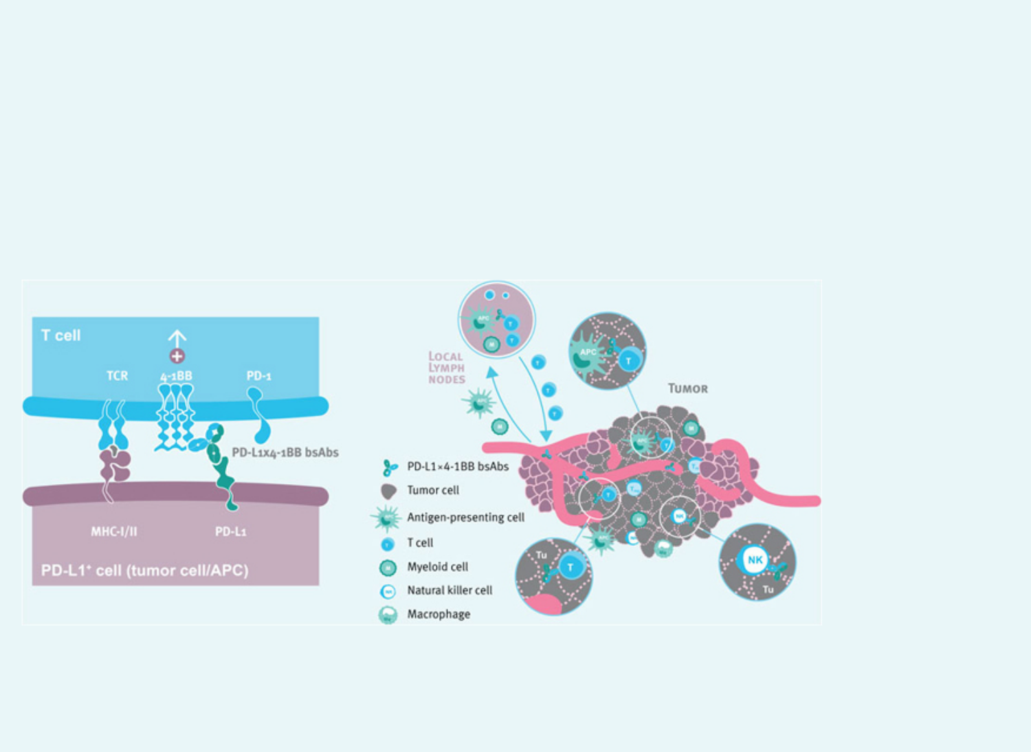

INTRODUCTION

- Checkpoint inhibitors (CPI) targeting the PD-1:PD-L1 axis have changed the treatment paradigm for patients with advanced solid tumors, but many patients experience limited benefit due to treatment resistance1,2.

- 4-1BB co-stimulation can activate cytotoxic T-cell and NK-cell mediated anti-tumor immunity and has been shown to synergize with CPI in preclinical models.

- Clinical development of 4-1BB agonists has been hampered by the occurrence of dose-limiting liver toxicity or lack of efficacy as monotherapy.2-5 In preclinical models, combination of PD-1 and 4-1BB mAbs efficiently induced anti-tumor activity in syngeneic tumor models6.

- Targeting 4-1BB agonist activity to the tumor and lymphoid tissues by using bispecific antibodies (bsAbs) targeting 4-1BB and PD-L1 may provide for a safe and effective anti-tumor immune response.

MECHANISM OF ACTION OF FC-SILENCED PD-L1×4-1BB BSABS

Fc-silenced PD-L1×4-1BB bsAbs are designed to re-activate anti-tumor immune responses by blockade of the PD-1:PD-L1 axis and conditional 4-1BB stimulation. PD-1:PD-L1 checkpoint blockade by the PD-L1-specific arm is constitutively active, whereas co-stimulatory activity mediated by the 4-1BB specific arm strictly depends on cell-cell crosslinking by simultaneous binding to both 4-1BB and PD-L1. The resulting clustering of 4-1BB provides a local co-stimulatory signal to T cells, further enhancing its T-cell receptor (TCR)-mediated activity and leading to tumor destruction. PD-L1×4-1BB bsAbs are expected to support priming processes in lymphatic tissue, re-activate anti-tumor immune responses in tumor tissue and promote survival of antigen-specific T cells.


OBJECTIVES

- We studied the mechanism of action of an Fc-silenced bispecific antibody (bsAb) targeting human PD-L1 and 4-1BB, and evaluated its potential to enhance T cell effector functions in vitro.

- We conducted proof-of-concept studies to assess the anti-tumor activity of a bsAb targeting murine PD-L1 and 4-1BB, and studied the associated in vivo immune responses.


RESULTS

DuoBody-PD-L1×4-1BB combines checkpoint blockade and conditional 4-1BB agonist activity

- DuoBody-PD-L1×4-1BB effectively antagonizes the PD-1:PD-L1 checkpoint by monovalent binding to PD-L1.

- DuoBody-PD-L1×4-1BB-induced 4-1BB signaling occurs only upon simultaneous binding to PD-L1- expressing cells, which provides Fab-dependent receptor crosslinking.

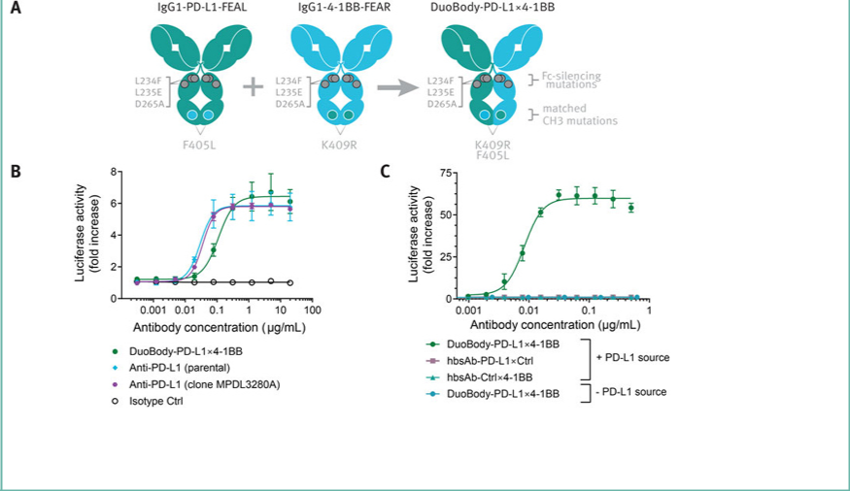

Figure 1A. DuoBody-PD-L1×4-1BB was generated by controlled Fab-arm exchange of monoclonal PD-L1 and 4-1BB antibodies using the DuoBody® bispecific antibody platform.7-8 B. The effect of indicated antibodies on the interaction between PD-1 and its ligand PD-L1 was determined in a bioluminescent cell-based PD-1:PD-L1 Blockade Bioassay. C. 4-1BB- agonist activity of the indicated antibodies was determined in a modified luciferase-based 4-1BB-activation reporter assay with or without adherent human PD-L1+ ES-2 tumor cells.

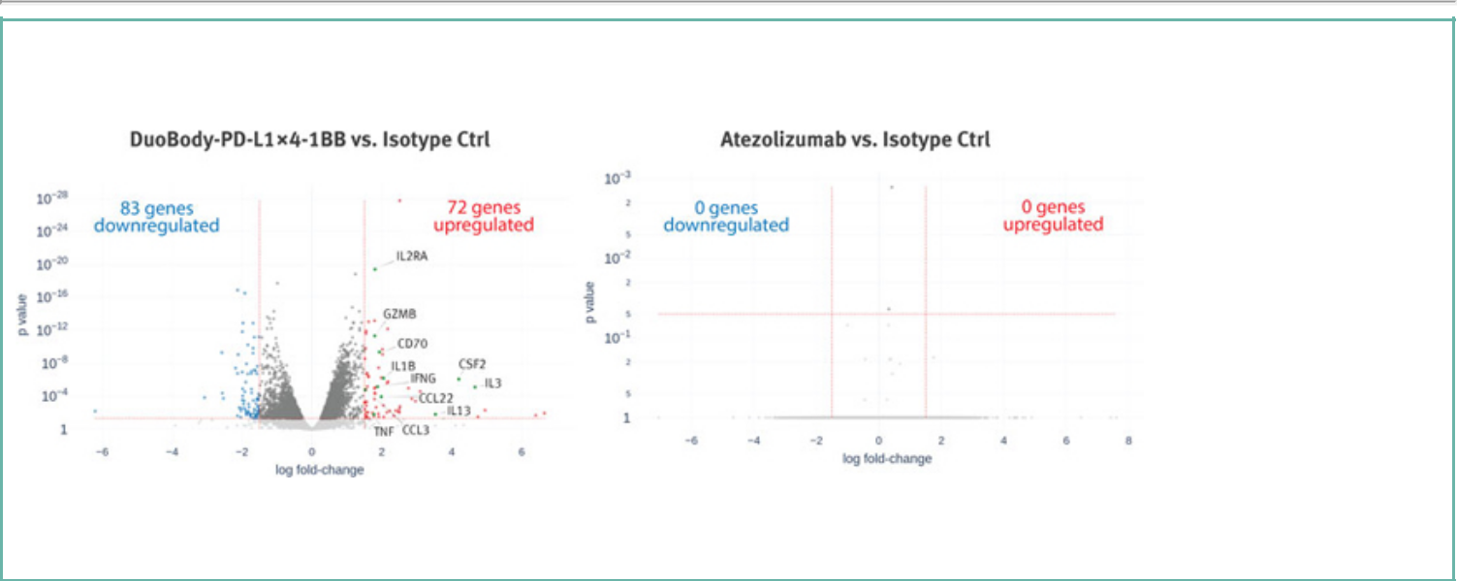
DuoBody-PD-L1×4-1BB induces expression of genes associated with enhanced immune responses

- DuoBody-PD-L1×4-1BB significantly induces expression of genes associated with immune cell activation, migration and cytokine production in activated CD8+ T cells, which are not altered by atezolizumab.

Figure 2. CD8+ T cells and CD14+ monocytes were isolated from PBMCs, and co-cultured in the presence of 10-90 ng/mL anti-CD3 and 3 µg/mL anti-CD28, as well as 0.2 µg/mL DuoBody-PD-L1×4-1BB or atezolizumab. After 48 hours the cells were harvested and subjected to transcriptomic analysis by RNA-sequencing.
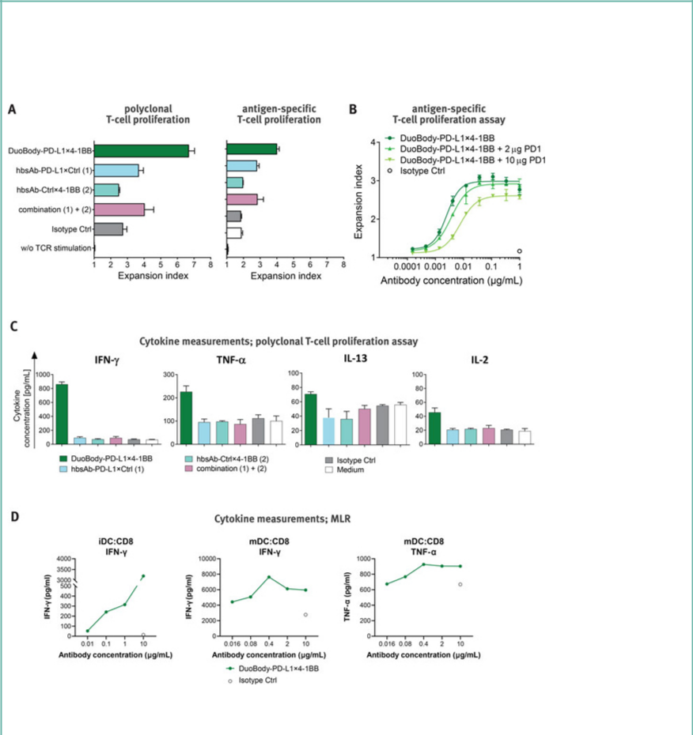

DuoBody-PD-L1×4-1BB demonstrates enhanced proliferation and cytokine secretion of activated T cells in the presence of PD-L1+ cells in vitro

- DuoBody-PD-L1×4-1BB conditionally enhances T-cell proliferation and cytokine secretion in a dose-dependent manner. Binding of only the PD-L1 arm enhances T-cell proliferation to a lesser extent, while binding of only the 4-1BB arm has no effect. EC50 values for proliferation are in the picomolar range.

- DuoBody-PD-L1×4-1BB does not induce proliferation in T cells that have not been activated by TCR stimulation.

Figure 3. A-B. Antigen-specific T-cell proliferation assay: CD8+ T cells were electroporated with RNA encoding an HLA-A2/CLDN6 -specific TCR and PD-1 (A. 5 µg; B. w/o, 2 or 10 µg, as indicated), and labeled with CFSE, co-cultured with autologous DCs electroporated with CLDN6-

encoding RNA in presence of the indicated antibodies for 4 days. Polyclonal T-cell proliferation assay: CFSE-labeled human PBMCs were stimulated with 0.1 µg/mL anti-CD3 and incubated with the indicated antibodies for 4 days. CFSE dilution in CD8+ T cells was analyzed by flow cytometry and the expansion index was calculated. C. Cell culture supernatants were collected 48 h after the start of the polyclonal T-cell proliferation assays, and cytokine concentrations measured using the MSD V-PLEX Pro-inflammatory Panel 1 Human Kit. D: Naive CD8+ T cells were co-cultured with immature or LPS-matured (24 h prior to start of the co-culture) allogeneic dendritic cells in the presence of DuoBody-PD-L1×4-1BB or isotype control for 5 days. IFN-g and TNF-a concentrations were determined in the culture supernatant.


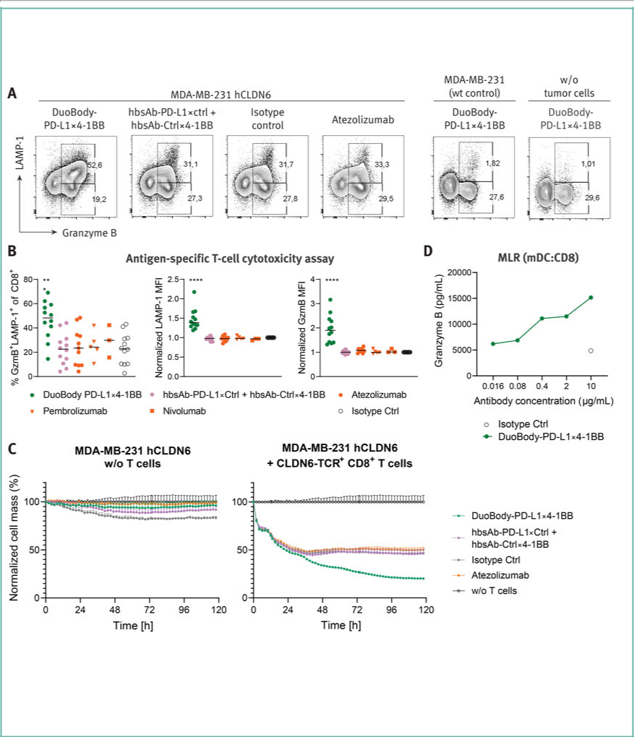
DuoBody-PD-L1×4-1BB demonstrates enhanced antigen-specific T-cell mediated cytotoxicity in vitro

- DuoBody-PD-L1×4-1BB dose-dependently and conditionally induces expression of the cytotoxic mediator granzyme B (GzmB) and the degranulation marker LAMP-1.

- DuoBody-PD-L1×4-1BB enhances antigen-specific T-cell mediated cytotoxicity, which is superior to atezolizumab.

Figure 4. A-C. PBMC-derived CD8+ T cells were electroporated with a CLDN6-specific TCR, and preactivated in co-culture with adherent MDA-MB-231 cells stably transduced with CLDN6, or co-cultured with untransduced parental cells. One day later, 4-1BB expression in preactivated T cells was verified. The T cells were transferred to new co-cultures with CLDN6-transduced or untransduced MDA-MD-231 cells as before, and incubated in the presence of the indicated antibodies. After 48 hours, T cell intracellular Granzyme B and LAMP-1 expression was analyzed by flow cytometry (A-B). Separate co-cultures with the identical setup were subjected to impedance analysis in 30-minute intervals over 5 days using an x CELLigence Real-Time Cell Analyzer (C). D. Naive CD8+ T cells were co-cultured with LPS-matured (24 h prior to start of the co-culture) allogeneic dendritic cells in the presence of DuoBody-PD-L1×4-1BB or isotype control for 5 days, and GzmB concentrations were determined in the culture supernatant.


DuoBody-PD-L1×4-1BB increases tumor infiltrating lymphocyte (TIL) expansion in human tumor tissue cultures ex vivo

- DuoBody-PD-L1×4-1BB i) increases total TIL count, ii) induces expansion of CD4+, CD8+ T cells, and CD56+ NK cells, and iii) induces clonal expansion of the TCR repertoire.

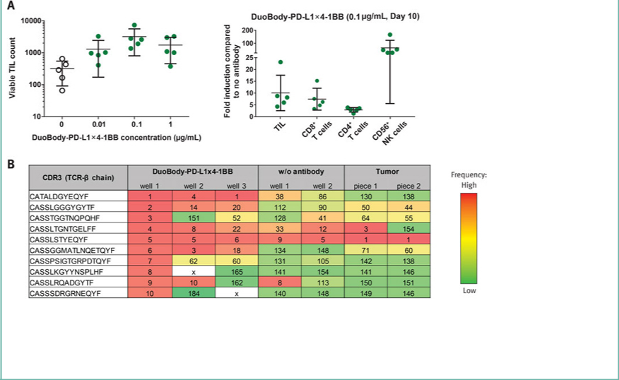

Figure 5. A. Tumor tissue of a NSCLC patient was resected, cut into pieces of 1-2 mm3, and cultured in the presence of IL-2 (10 U/mL) and the indicated antibodies. On day 10, viable TIL were counted and the fold expansion of the indicated subpopulations was analyzed by flow cytometry. Data shown represents mean±SD of n=5 individual wells. B. Clonotype repertoire analysis was performed on TCR sequencing of the CDR3 region of the expanded TIL and the frozen tumor. The ten most frequent clones (1-10) for well 1 of DuoBody-PD-L1×4-1BB-treated cultures were used as reference and the frequency rank of these sequences in all other samples is visualized according to the color scheme. About 200 sequences were obtained per sample. Each sample contained about 100,000 cells.

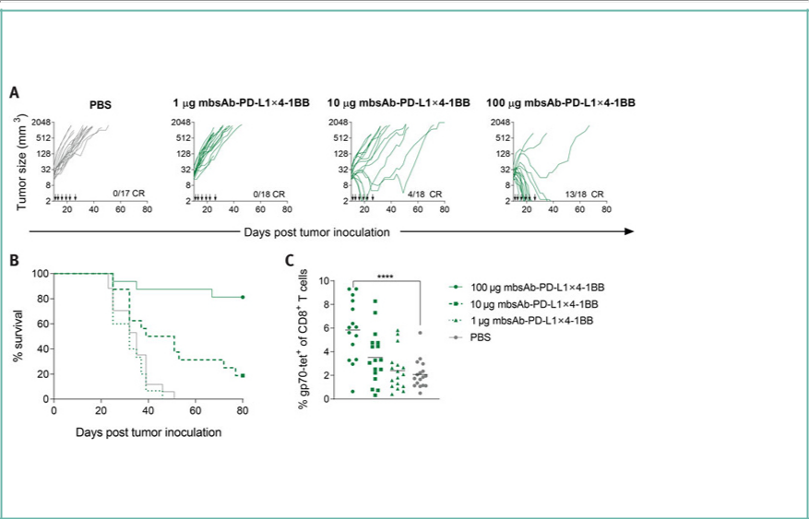
An Fc-silenced bsAb targeting mouse PD-L1 and 4-1BB (mbsAb-PD-L1×4-1BB) induces tumor regression and increases the frequency of tumor-reactive T cells in CT26-tumor bearing mice

- mbsAb-PD-L1×4-1BB-treatment leads to complete tumor regression in the majority of mice and significantly improves survival, which is associated with an increased frequency of tumor-reactive T cells in the peripheral blood.

Figure 6. BALB/c mice bearing subcutaneous CT26 tumors were treated after tumors reached a size ³ 30 mm3. Antibody was dosed every 2-3 days for three weeks starting at day 11 (indicated by arrows). A. Individual tumor growth curves; CR: complete regression. B. Kaplan-Meier analysis of animal survival. C. On day 18, blood was drawn and the relative frequency of CD8+ T cells specific for gp70, the immunodominant antigen expressed by CT26, was determined by flow cytometry. ****, p<0.0001, One-way ANOVA with Dunnett’s multiple comparisons test.
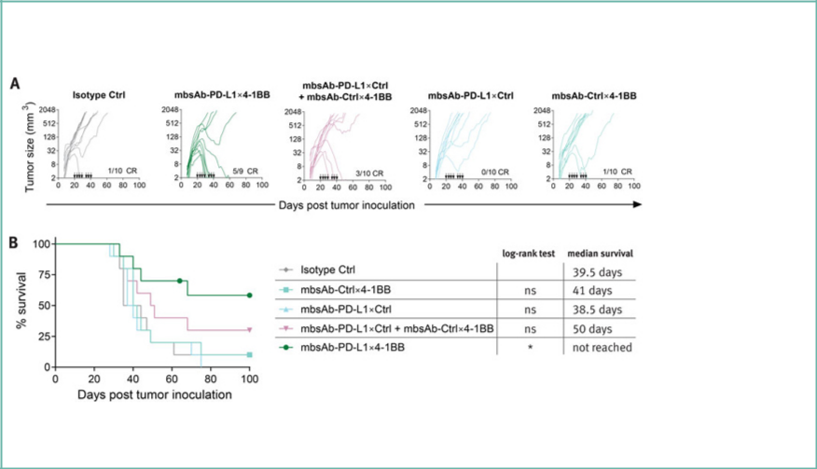

mbsAb-PD-L1×4-1BB shows superior efficacy compared to a combination of Fc-silenced PD-L1 or 4-1BB monovalent control antibodies

- mbsAb-PD-L1×4-1BB induces superior anti-tumor activity compared to a combination of both monovalent controls and efficiently induces tumor regression in mice bearing medium-sized tumors.

Figure 7. BALB/c mice bearing subcutaneous CT26 tumors were treated after tumors reached a mean size of approximately 100 mm3. Antibody was dosed at 100 µg per mouse every 4 days, for three weeks starting at day 20 (indicated by arrows). A. Individual tumor growth curves, CR: complete regression. B. Kaplan-Meier analysis of animal survival. *, p<0.05; log-rank (Mantel-Cox) test.


mbsAb-PD-L1×4-1BB shows superior efficacy compared to PD-L1 blockade

- In mice bearing subcutaneous CT26 tumors, a model that is insensitive to PD-L1 blockade, mbsAb-PD-L1×4-1BB elicits tumor rejection in the majority of the mice at active dose levels and significantly improves survival.

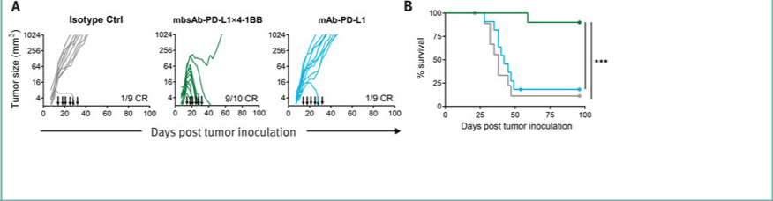

Figure 8. BALB/c mice bearing subcutaneous CT26 tumors were treated after tumors reached a mean size of approximately 76 mm3. Antibody was dosed at 100 µg per mouse every 3-4 days for three weeks starting at day 14 (indicated by arrows). A. individual tumor growth curves, CR: complete regression. B. Kaplan-Meier analysis of animal survival. ***, p<0.001, log-rank (Mantel-Cox) test.

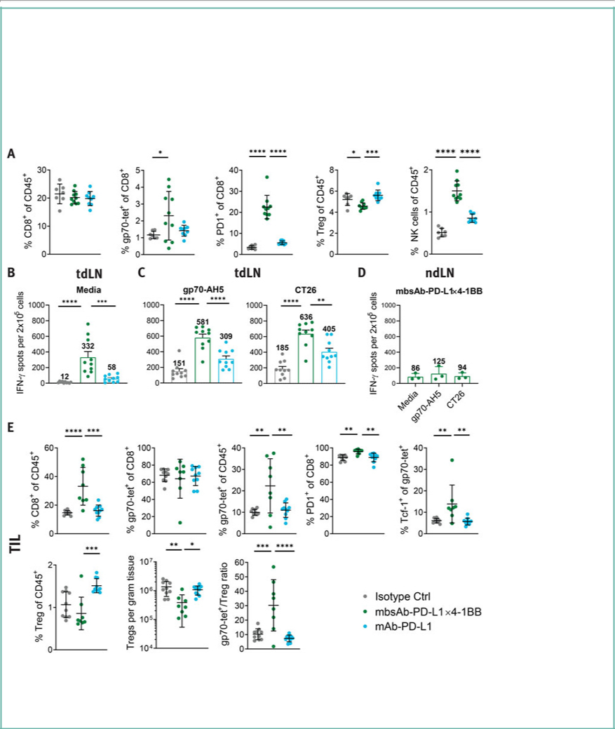
mbsAb-PD-L1×4-1BB modulates tumor-draining lymph node and intratumoral immune-cell composition in favor of anti-tumor immunity

- mbsAb-PD-L1×4-1BB-treatment leads to increased frequencies of tumor antigen-specific T cells, PD-1+ activated T cells and NK cells in tumor-draining lymph nodes (tdLNs).

- The proportion of IFN-g secreting cells is increased in the tdLNs of mbsAb-PD-L1×4-1BB-treated mice ex vivo and in response to restimulation with tumor antigen.

- Increased proportions of CD8+ T cells, most of which are tumor antigen-specific, and reduced Treg proportions are present within the tumor microenvironment (TME) of mbsAb-PD-L1×4-1BB-treated mice, resulting in a CD8:Treg cell ratio in favor of an anti-tumor immune response.

- An increased subset of Tcf-1+ tumor-specific T cells with self-renewal capability is present in the tumors of mbsAb-PD-L1×4-1BB-treated mice.

Figure 9. BALB/c mice bearing subcutaneous CT26 tumors were treated with the indicated antibodies after tumors reached a median size of 38 mm3. Antibody was dosed at 100 µg per mouse on days 12 and 17. Mice were sacrificed on day 18 after inoculation for analysis. A. Flow cytometry analysis of tdLNs. B-C. tdLN cell suspensions were either left unstimulated (B) or restimulated with a gp70 peptide or CT26 cells (C), and IFN-g secretion was assessed by ELISpot. D. IFN-g ELISpot using distant non-draining LN cell (ndLN) suspensions of mbsAb-PD-L1×4-1BB treated mice. E. Flow cytometry analysis of enzymatically dissociated tumors. Data from individual mice are shown, as well as group mean (± SD). *, P<0.05; **, P<0.01; ***, P<0.001; ****, P<0.0001; One-way ANOVA with Dunnett‘s multiple comparisons test.


CONCLUSIONS

- Dual targeting of PD-L1 and 4-1BB with an Fc-silenced bsAb combines immune checkpoint blockade and conditional T-cell co-stimulation in one molecule.

- DuoBody-PD-L1×4-1BB constitutively blocks the inhibitory PD-1:PD-L1 signaling axis and induces conditional 4-1BB stimulation in vitro in a PD-L1-dependent fashion.

- By combining these mechanisms, DuoBody-PD-L1×4-1BB enhances proliferation and cytokine production of human primary T cells in vitro, and enhances TIL expansion.

- DuoBody-PD-L1×4-1BB enhances antigen-specific T-cell mediated cytotoxicity superior to checkpoint inhibition in vitro.

- Mouse-reactive mbsAb-PD-L1×4-1BB efficiently induces tumor regression in murine models that are insensitive to PD-L1 blockade. Anti-tumor activity of mbsAb-PD-L1×4-1BB is dependent on simultaneous engagement of both PD-L1 and 4-1BB

- Anti-tumor activity is associated with an increased prevalence of tumor antigen-specific T cells as well as reduced immunosuppression in the TME and tdLNs.

- The clinical safety of DuoBody-PD-L1×4-1BB (GEN1046) is currently being assessed in patients with advanced malignant solid tumors in a first-in-human trial (NCT03917381).

References

1 | Zou et al., 2016, Sci Transl Med | 5 | Segal et al., 2018, Clin Cancer Res
2 | Perez-Ruiz et al., 2017, Clin Cancer Res | 6 | Wei et al., 2014, Oncoimmunol
3 | Bartkowiak et al., 2015, Front Oncol | 7 | Labrijn et al., 2013, PNAS
4 | Segal et al., 2017, Clin Cancer Res | 8 | Labrijn et al., 2014, Nat Protoc

Society for Immunotherapy of Cancer (SITC); 11-14 November, 2020; Poster # 561


First-in-human, phase I/IIa trial to evaluate the safety and initial clinical activity of DuoBody®-PD-L1×4-1BB (GEN1046) in patients with advanced solid tumors

Elena Garralda1, Ravit Geva2, Eytan Ben-Ami3, Corinne Maurice-Dror4, Emiliano Calvo5, Patricia LoRusso6, Özlem Türeci7, Michelle Niewood8, Uğur Şahin7, Maria Jure-Kunkel8, Ulf Forssmann9, Tahamtan Ahmadi8, Ignacio Melero10

1Medical Oncology Department, Vall d’Hebron University Hospital and Institute of Oncology (VHIO), Barcelona, Spain;

2Oncology Division, Tel-Aviv Sourasky Medical Center, Tel Aviv, Israel; 3Department of Oncology, Chaim Sheba Medical Center, Ramat Gan, Israel; 4Institute of Oncology, Rambam Health Care Campus, Haifa, Israel; 5START Madrid-CIOCC, Centro Integral Oncológico Clara Campal, Madrid, Spain; 6Yale Cancer Center, Yale University, New Haven, Connecticut, USA; 7BioNTech SE, Mainz, Germany; 8Genmab A/S, Princeton, New Jersey, USA; 9Genmab A/S, Copenhagen, Denmark; 10Department of Immunology, Clinica Universidad de Navarra, Pamplona, Spain


INTRODUCTION

PD-(L)1 AND 4-1BB AS TARGETS

- PD-(L)1 inhibition has changed the treatment paradigm for patients with advanced solid tumors.1-3 However, not all patients respond to this approach, and not all responders continue to experience long-term benefit.1

- 4-1BB is a co-stimulatory receptor expressed on activated, antigen-experienced T cells and activated natural killer (NK) cells.4

– In preclinical studies, co-stimulation with 4-1BB monoclonal agonists was shown to activate cytotoxic T-cell and NK-cell mediated anti-tumor response.5-7

– Clinical development of 4-1BB agonists has been hampered by severe liver toxicity and lack of monotherapy efficacy.8,9

– The combination of PD-(L)1 blockade and 4-1BB agonists was associated with enhanced T-cell effector function and anti-tumor efficacy in preclinical mouse models.10,11

- Targeting 4-1BB agonist activity may improve the efficacy of PD-(L)1 blockade through concurrent enhancement of T-cell function, and conditional activation may mitigate the potential for liver toxicity.

MOA AND PRECLINICAL DATA

- GEN1046 is a first-in-class, next generation, checkpoint immunotherapy designed to enhance T-cell and NK cell function through conditional 4-1BB co-stimulation, while simultaneously blocking the PD-L1 axis (Figure 1A).

- GEN1046 is a full-length IgG1 bispecific antibody created via Fab-arm exchange using the DuoBody® technology platform, which generates stable antibodies that retain native IgG structure and pharmacokinetics.12,13

– Effector-silenced Fc-region ensures 4-1BB signaling is strictly dependent on simultaneous binding of the PD-(L)1-binding arm.

- By combining checkpoint blockade with 4-1BB–dependent T-cell activation, GEN1046 enhances proliferation and cytokine production of activated T cells, activates immune cells in the tumor-draining lymph nodes, and induces tumor regression in vivo (Figure 1B) (see Muik A, et al. SITC 2020, Poster 561 for additional information).14

Figure 1. GEN1046: IgG1 bispecific PD-L1×4-1BB antibody and mechanism of action

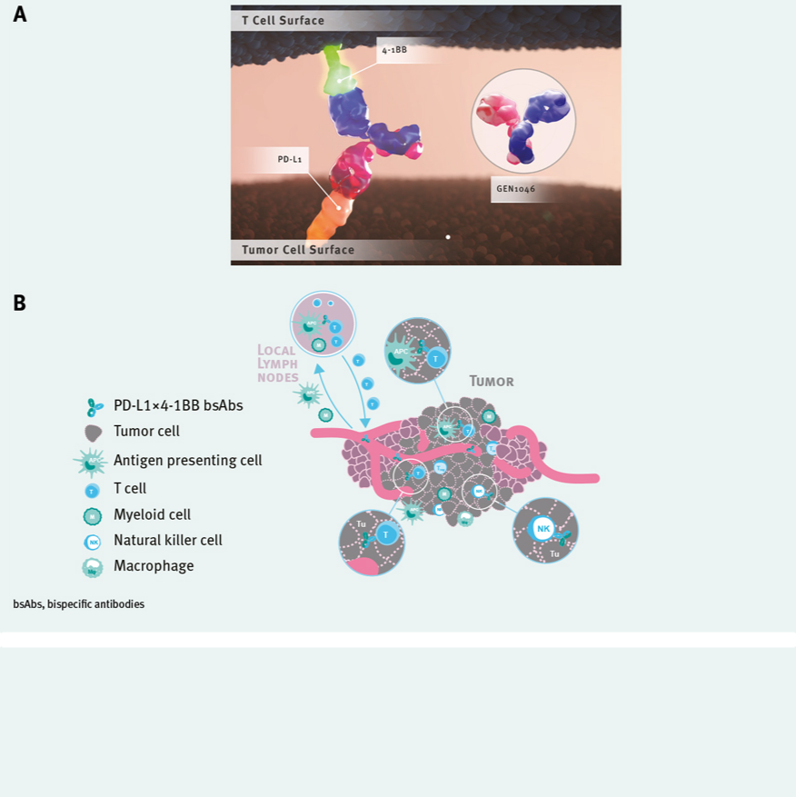

OBJECTIVES

- The primary objectives of this trial include characterization of the safety and efficacy profile of GEN1046 and determination of the maximum tolerated dose (MTD).

- Secondary objectives include the establishment of a pharmacokinetic profile and evaluation of the immunogenicity and anti-tumor activity of GEN1046.

- Exploratory objectives include the assessment of pharmacodynamic endpoints and potential biomarkers of clinical response, and assessment of anti-tumor activity of GEN1046 based on immune Response Evaluation Criteria in Solid Tumors (iRECIST).


METHODS

TRIAL DESIGN

- This is a first-in-human, multicenter, open-label, phase I/IIa trial of GEN1046 in advanced solid tumors (NCT03917381) (Figure 2).

- The trial consists of two consecutive parts: dose escalation (phase I) and expansion (phase IIa).

- The dose-limiting toxicity (DLT) monitoring period was 21 days.

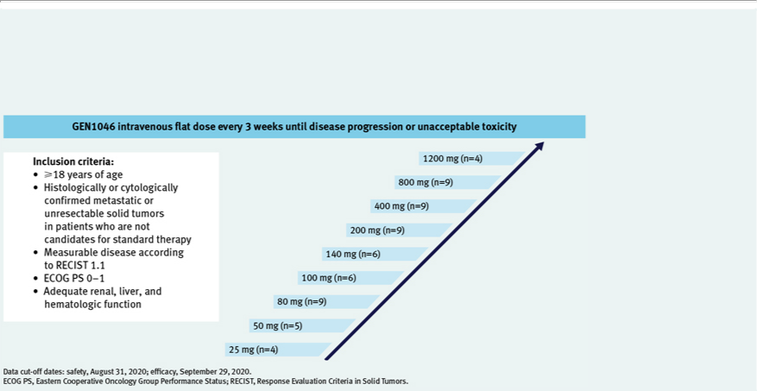
TREATMENT

- Dose escalation started with an accelerated phase consisting of single-patient cohorts followed by larger cohorts that were informed by both the modified Continual Reassessment Method and the Escalation with Overdose Control design.

- Efficacy was assessed by on-treatment computed tomography or magnetic resonance imaging at Week 6 (-7 days) and every 6 weeks (±7 days) thereafter until disease progression (unless the investigator elected to continue treatment and follow iRECIST).

Figure 2. Trial design (dose escalation)


RESULTS

Patient characteristics and disposition

- A total of 61 patients were enrolled in the dose escalation part of the trial (Table 1).

- Patients were heavily pretreated, receiving a median (range) of 3 (1–11) treatments; 37.7% of patients had received prior treatment with a PD-(L)1 immunotherapy.

- As of data cut-off date of August 31, 2020, treatment is ongoing in 10 (16.4%) patients (Table 2).

- MTD was not reached.

- Patients discontinued treatment due to the following adverse events (AEs): alanine aminotransferase (ALT) increase (n=3), aspartate aminotransferase (AST) increase (n=2), hepatoxicity (n=1), immune-mediated nephritis (n=1), and pneumonitis (n=1); all were Grade 3.

- There was a single on-treatment death which was due to disease progression and unrelated to treatment.

Table 1. Baseline demographics and clinical characteristics
Dose escalation cohort |  |  | All patients
 |  |  | N=61
Median (range) age, years |  |  | 59 (23–79)
Age group, n (%)
<65 years |  |  | 44 | (72.1)
 | >65 years |  | 17 | (27.9)
Female, n (%) |  |  | 28 | (45.9)
Cancer type, n (%)a
Colorectal |  |  | 12 | (19.7)
Ovarian |  |  | 9 (14.8)
Pancreatic |  |  | 6 | (9.8)
NSCLC |  |  | 6 | (9.8)
Other |  |  | 28 | (45.9)
ECOG performance status, n (%)
0 |  |  | 32 | (52.5)
1 |  |  | 29 | (47.5)
Median (range) number of prior regimens |  |  | 3 (1–11)
Prior treatment with PD-(L)1 inhibitor, n (%) |  |  | 23 | (37.7)
Data cut-off: August 31, 2020.
ªCancer types occurring in <5 patients were categorized as “Other”.
ECOG, Eastern Cooperative Oncology Group; NSCLC, non-small cell lung cancer; PD-(L)1, programmed death (ligand) 1.
Table 2. Patient disposition and exposure
Dose escalation cohort |  |  | All patients
 |  |  | N=61
Median (range) duration of follow-up, months |  |  | 6.0 (0.3–14.7)
Treatment ongoing, n (%) |  |  | 10 | (16.4)
Treatment discontinuation due to, n (%)
Progressive disease |  |  | 44 | (72.1)
AE |  |  | 6 | (9.8)
Death |  |  | 1 (1.6)a
Median (range) number of GEN1046 dose infusions |  |  | 4 (1–18)
Median (range) duration of exposure, months |  |  | 3 (0.7–13.9)
Data cut-off: August 31, 2020.
AE, adverse event.
ªRelated to disease progression.

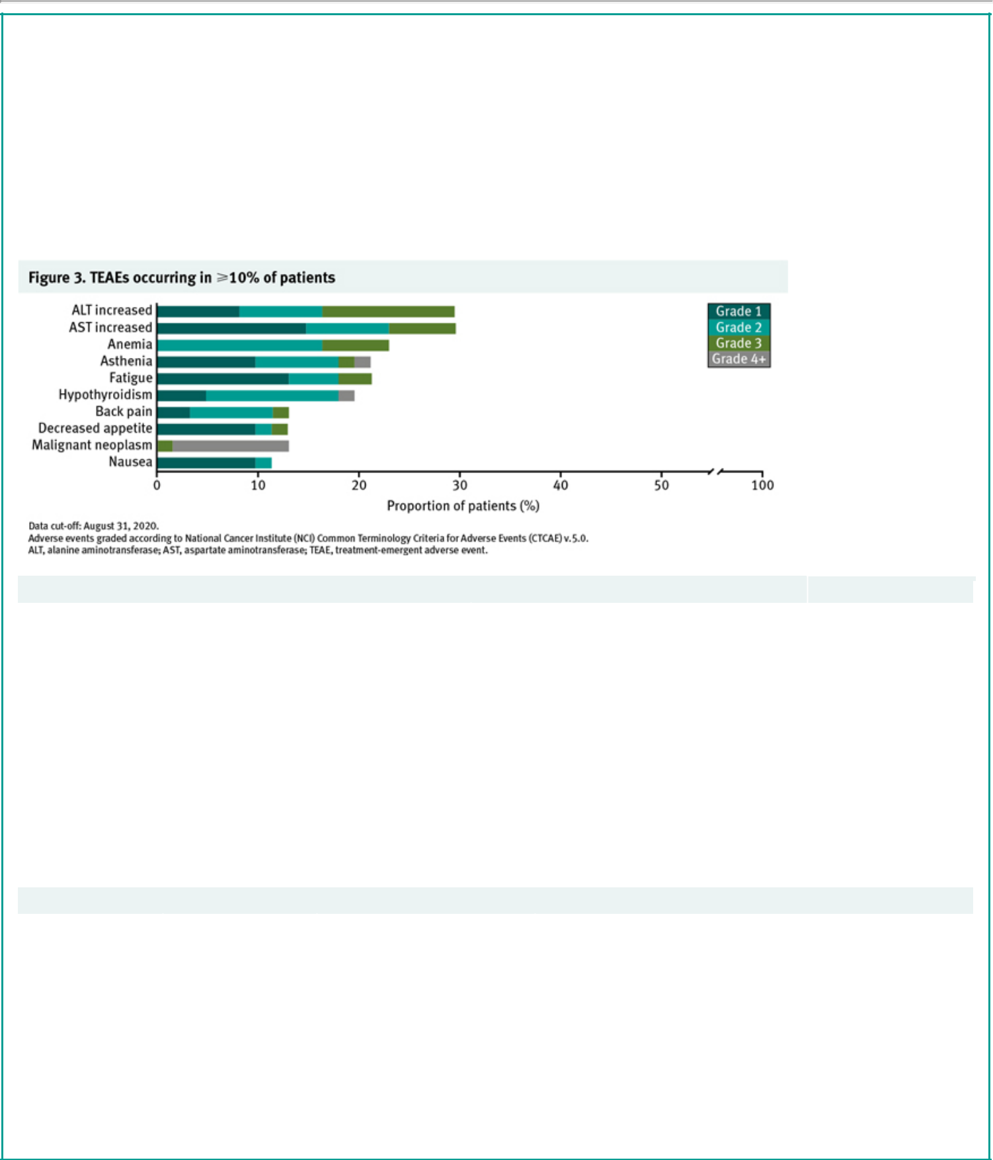
Safety

- Treatment-emergent adverse events (TEAEs) occurred in 58 (95.1%) patients. Most AEs were Grade 1–2 (Figure 3).

–The most common (³10%) TEAEs were transaminase elevations, anemia, and asthenia.

–Grade 3–4 TEAEs were experienced by 36 (59.0%) patients.
–Treatment-emergent transaminase elevations (AST increased and/or ALT increased, transaminase increased) occurred in 32.8% of patients (Grade 3: 16.4%).

- Treatment-related adverse events (TRAEs) occurred in 43 (70.5%) patients (Table 3).

–Grade 3–4 TRAEs were experienced by 17 (27.9%) patients.
–Treatment-related transaminase elevation (AST increased and/or ALT increased, transaminase increased) occurred in 26.2% of patients (Grade 3: 9.8%) and improved with corticosteroid administration.

- No patients had treatment-related bilirubin or Grade 4 transaminase elevations.

Table 3. TRAEs occurring in ³10% of patients

Dose escalation cohort |  |  |  | All patients
 |  |  |  |  | (N=61)
 |  |  | All grades, n (%) | Grade 3, n (%) |  | Grade 4, n (%)
Any TRAE |  |  | 43 (70.5) | 15 | (24.6) | 3 (4.9)
TRAEs in > 10% of patients, by preferred term
Transaminase elevation |  |  | 16 (26.2) | 6 | (9.8) | 0
Hypothyroidism |  |  | 11 (18.0) |  | 0 | 1 (1.6)
Fatigue |  |  | 8 (13.1) | 1 | (1.6) | 0

Data cut-off: August 31, 2020.

Adverse events graded according to National Cancer Institute (NCI) Common Terminology Criteria for Adverse Events (CTCAE) v.5.0.
TRAE, treatment-related adverse event.

- Six patients experienced DLTs across the dose range evaluated (Table 4).

–All six patients recovered without sequelae.
–Cases of neutropenia (n=2) were managed with granulocyte colony stimulating factor administration (G-CSF).
–Transaminase increases improved with corticosteroid administration.

Table 4. Summary of dose-limiting toxicities

Dose level | Patients, n | Patients with DLTs, n | DLT
25 mg | 4 | 1 | Grade 4 febrile neutropenia
50 mg | 5 | 0 | –
80 mg | 9 | 1 | Grade 4 febrile neutropenia
100 mg | 6a | 0 | –
140 mg | 6 | 2 | Grade 3 nephritis; Grade 3 ALT increased
200 mg | 9 | 1 | Grade 3 AST increased/ALT increased
400 mg | 9 | 0 | –
800 mg | 9b | 1 | Grade 3 transaminases increased
1200 mg | 4 | 0 | –

Data cut-off: August 31, 2020.
ªOne patient in the 100-mg cohort died due to disease progression on study Day 8.
^{b}One backfill patient in the 800-mg cohort did not complete the C1D8 and C1D15 assessments. The patient elected not to attend follow-up visits to avoid contracting COVID-19.
ALT, alanine aminotransferase; AST, aspartate aminotransferase; DLT, dose-limiting toxicity.

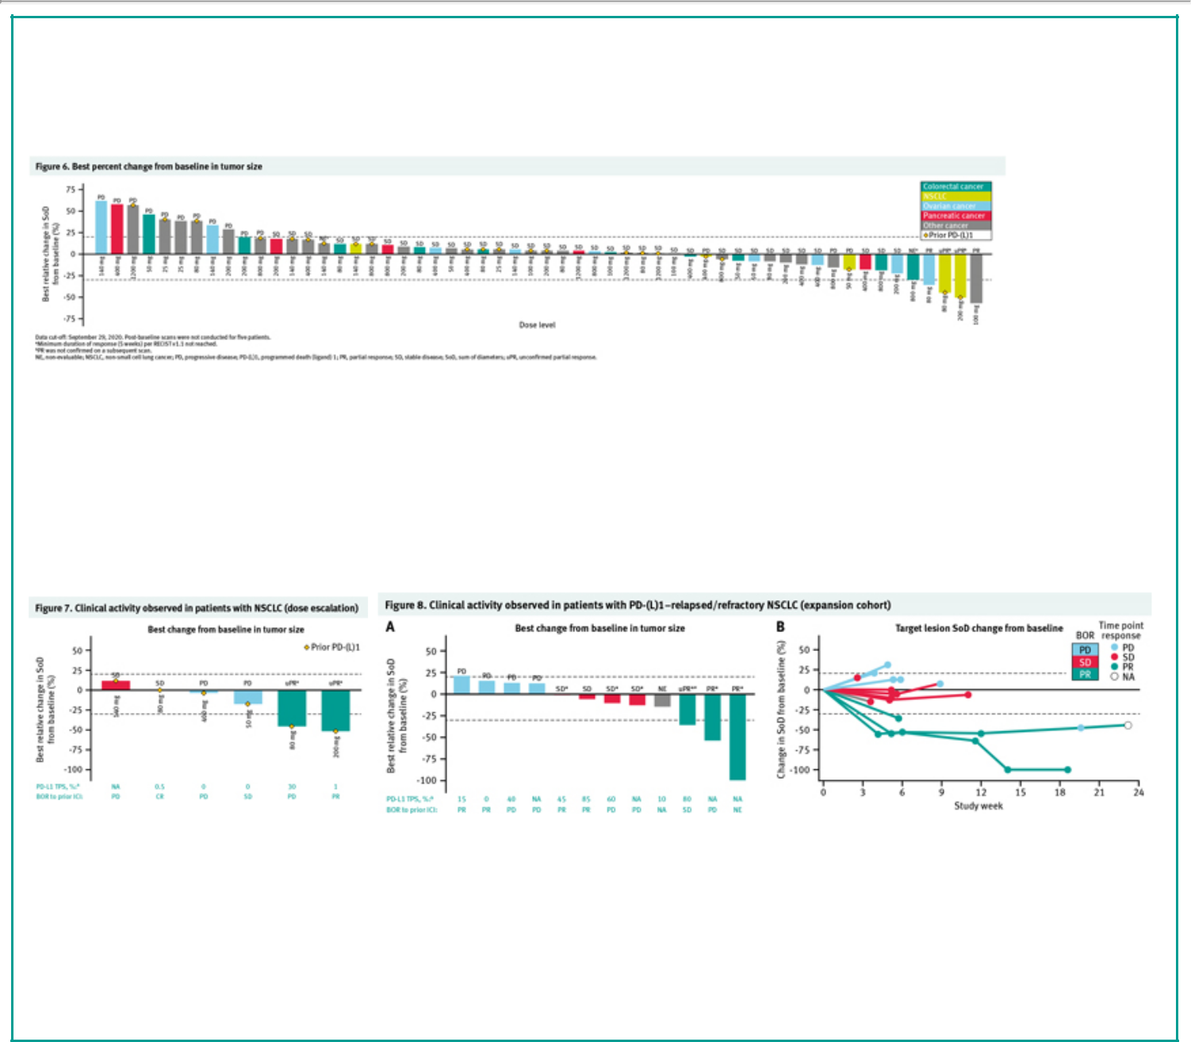
Efficacy

Dose escalation

- Of 61 patients, 56 were evaluable.

- Disease control occurred in 40/61 (65.6%) patients in the dose escalation phase (Figure 6).

– Partial response (PR) was achieved in four patients with triple-negative breast cancer (n=1), ovarian cancer (n=1), or non-small cell lung cancer (NSCLC) (n=2); 36 patients maintained stable disease (SD).

Data cut-off: September 29, 2020. Post-baseline scans were not conducted for five patients.
ªMinimum duration of response (5 weeks) per RECIST v1.1 not reached.
^{b}PR was not confirmed on a subsequent scan.
NE, non-evaluable; NSCLC, non-small cell lung cancer; PD, progressive disease; PD-(L)1, programmed death (ligand) 1; PR, partial response; SD, stable disease; SoD, sum of diameters; uPR, unconfirmed partial response.

- Of six patients with NSCLC, all of whom had received prior immune checkpoint inhibitor (ICI) therapy, two achieved unconfirmed PR, two maintained SD, and two experienced progressive disease (Figure 7).

Data cut-off: September 29, 2020.
ªPR was not confirmed by a subsequent scan.
^{b}PD-L1 expression was assessed in archival tumor specimens.
BOR, best overall response; CR, complete response; ICI, immune checkpoint inhibitor; NA, not available;

PD, progressive disease; PD-(L)1, programmed death (ligand) 1; PR, partial response; RECIST, Response Evaluation Criteria in Solid Tumors; SD, stable disease; SoD, sum of diameters; TPS, tumor proportion score; uPR, unconfirmed partial response.

Expansion cohort
- As of October 12, 2020, 24 patients were enrolled in expansion cohort 1, which includes patients with NSCLC with progression on or after ICI therapy (Figure 8).

– 12 patients had post-baseline scans; six patients continued treatment with GEN1046, six patients discontinued.
– Preliminary efficacy in 12 patients who could be objectively assessed showed two patients who achieved confirmed PR, one with unconfirmed PR, and four patients with SD.

Data cut-off: October 12, 2020.
*Denotes patients with ongoing treatment.
ªPR was not confirmed by a subsequent scan.
^{b}PD-L1 expression was assessed in tumor biopsies obtained prior to initiation of GEN1046 treatment.
Includes all patients who had at least one post-baseline tumor assessment (schedule is every 6 weeks), and thus could be assessed for clinical benefit; 6 of 12 patients are still on treatment.

Of the remaining 12 patients not shown, three patients had clinical progression prior to first response assessment, and nine patients are still receiving treatment and have not had a first response assessment.
BOR and time point response assessed using RECIST 1.1; NA: Assessment succeeding first PD.
BOR, best overall response; ICI, immune checkpoint inhibitor; NA, not available, NE, non-evaluable; NSCLC, non-small cell lung cancer; PD, progressive disease; PD-(L)1, programmed death (ligand) 1; PR, partial response; RECIST, Response Evaluation Criteria in Solid Tumors; SD, stable disease; SoD, sum of diameters; TPS, tumor proportion score; uPR, unconfirmed partial response.

 | CONCLUSIONS | ● Clinical benefit across different dose levels was observed in patients,
 | ● GEN1046 is a first-in-class, next-generation, PD-L1×4-1BB bispecific |  | including those resistant to prior immunotherapy and those with
 | antibody with an acceptable safety profile and encouraging early |  | tumors typically less sensitive to ICIs.
 | clinical activity, potentially addressing key limitations of the existing |  | – Disease control was achieved in 65.6% of patients, including
 | 4-1BB agonists. |  | partial responses in triple-negative breast cancer (n=1), ovarian
 | – In the dose escalation phase of this phase I/IIa study, GEN1046 |  | cancer (n=1), and ICI-pretreated NSCLC (n=2).
 | demonstrated a manageable safety profile and preliminary | ● Modulation of pharmacodynamic endpoints was observed across a
 | clinical activity in a heavily pretreated population with advanced |  | broad range of dose levels demonstrating biological activity.
 | solid tumors. | ● Encouraging preliminary responses have been observed in the
 | ● Most AEs were mild to moderate; treatment-related Grade 3 |  | expansion cohort currently enrolling patients with NSCLC who have
 | transaminase elevations resolved with corticosteroids. |  | received prior ICI therapy.
 | – No treatment-related bilirubin increases or Grade 4 |  | https://clinicaltrials.gov/ct2/show/NCT03917381
 | transaminase elevations were observed.
 | – Six patients had DLTs; MTD was not reached.

Pharmacokinetics

- Peak concentrations were observed shortly after the end of infusion (Figure 4).
- Mean terminal half-life after first dose appeared to be in the range of 2.3 to 10.3 days (across doses of 25 to 1200 mg).

Pharmacodynamics ● Pharmacological
activity was | Data cut-off June 26, 2020.
observed across a
broad range of
dose levels.
- Increased levels of peripheral interferon gamma and IP-10, and frequency of proliferating (Ki67+) total CD8 and effector memory CD8+ T cells were observed (Figure 5).

- Reduced peripheral immune modulation was observed at higher dose levels.

Data extraction: June 26, 2020.
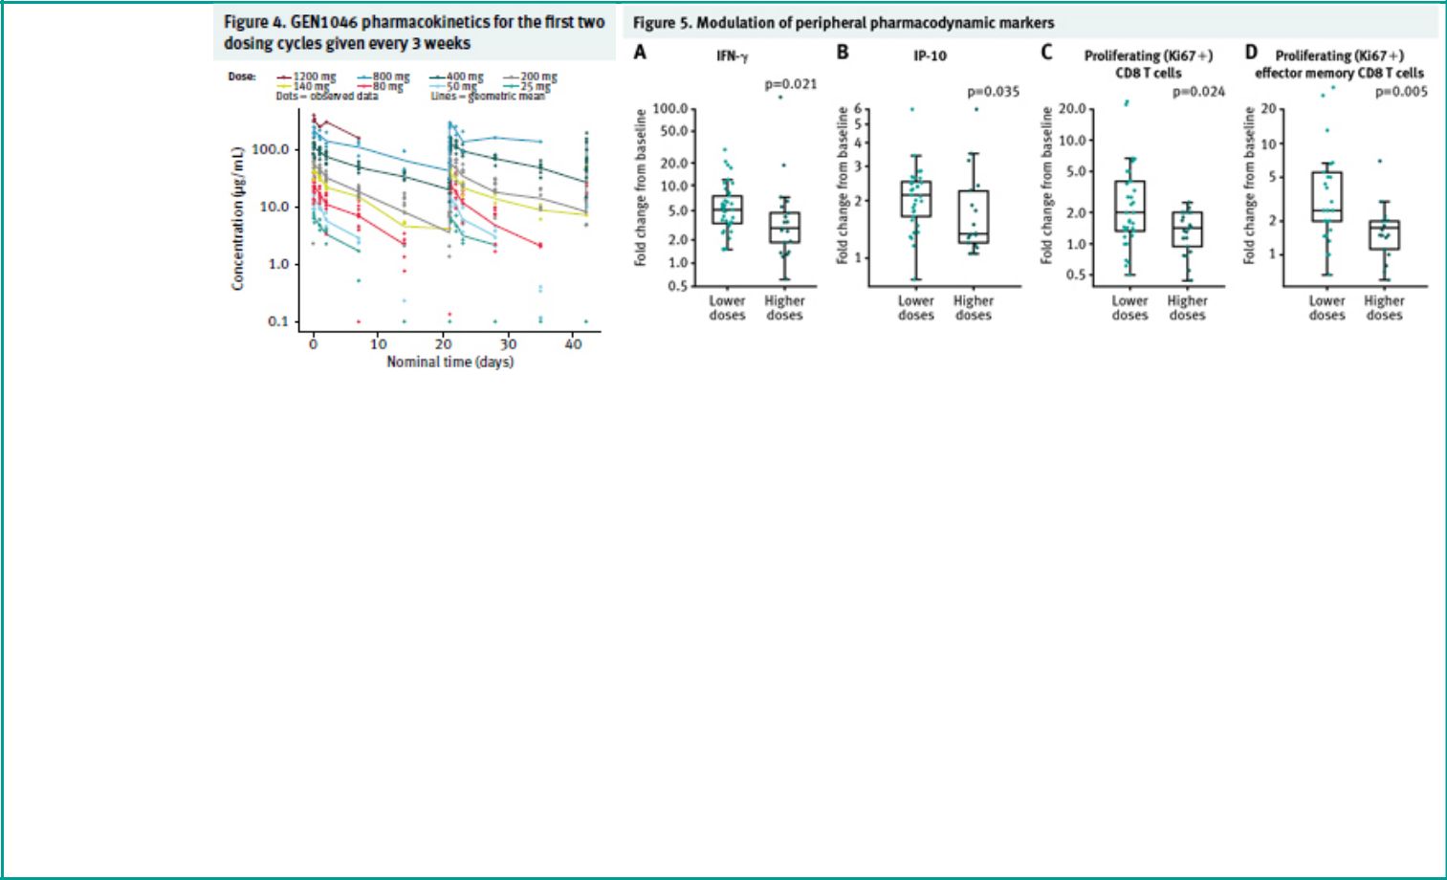
Maximal fold-change from baseline measured during cycle 1. Lower doses correspond to dose levels £200 mg and higher doses correspond to dose levels ³400mg. Wilcoxon-Mann-Whitney test. IFN, interferon; IP-10, interferon-gamma-inducible protein 10.

References |  | 8. Segal NH, et al. Clin Cancer Res 2017;23:1929–1936.
1. | Jenkins R, et al. Br J Cancer 2018;118:9–16. | 9. Segal NH, et al. Clin Cancer Res 2018;24:1816–1823.
2. | Galon J, Bruni D. Nat Rev Drug Discov 2019;18:197–218. | 10. | Shindo Y, et al. Anticancer Res 2015;35:129–136.
3. | Ghandi L, et al. N Engl J Med 2018;378:2078–2092. | 11. Wei H, et al. Oncoimmunology 2014;e28246.
4. | Chester C, et al. Blood 2018;131:49–57. | 12. | Labrijn AF, et al. Proc Natl Acad Sci USA 2013;110:5145–5150.
5. | Shuford WW, et al. J Exp Med 1997;186:47–55. | 13. | Labrijn AF, et al. Nat Protoc 2014;9:2450–2463.
6. | Williams JB, et al. J Exp Med 2017;214:381–400. | 14. | Muik A, et al. Presented at SITC 2020;P561.
7. | Melero I, et al. Clin Cancer Res 2013; 19:1044–1053.
Acknowledgments
The authors thank Manish Gupta, Gaurav Bajaj, Lei Pang, Brandon Higgs, and Thomas Breuer at
Genmab A/S; Alice Bexon, Alexander Muik, and Friederike Gieseke at BioNTech SE; and Zuzana
Jirakova (formerly at BioNTech SE) for their valuable contributions. This trial was funded by Genmab A/S
and BioNTech SE. Professional medical writing support was provided by Lindsay Craik, at Caudex, and
was funded by Genmab A/S.
Disclosures |  |  |  | Copies of this poster obtained though
IM reports receiving commercial research grants from Alligator, AstraZeneca, BMS, and Roche and |  |  |  | Quick Response (QR) Code are for
 |  |  |  | personal use only and may not be
serves as a consultant/advisory board member for Alligator, AstraZeneca, Bayer, Bioncotech, BMS, |  |  |  | reproduced without permission from
F-star, Genentech, Genmab, Merck Serono, Molecular Partners, Numab, Roche-Incyte, and Tusk. |  |  |  | the authors of this poster.


Presented at the Society for Immunotherapy of Cancer (SITC), November 11–14, 2020 – Poster #412


391

A first-in-human study of intratumoral SAR441000, an mRNA mixture encoding IL-12sc, interferon alpha2b, GM-CSF and IL-15sushi as monotherapy and in combination with cemiplimab in advanced solid tumors

Oliver Bechter, MD1, Jochen Utikal, MD2, Jean-Francois Baurain, MD3, Christophe Massard, MD4, Ugur Sahin, MD5, Evelyna Derhovanessian, PhD5, Marie-Laure Ozoux, PharmD6, Rahul Marpadga, MD6, Esteban-Rodrigo Imedio, MD5, Carmen Loquai, MD7

1Department of General Medical Oncology, University Hospitals Leuven, Campus Gasthuisberg, Leuven, Belgium; 2Skin Cancer Unit, German Cancer Research Center (DKFZ) and University Medical Center Mannheim, Heidelberg University, Theodor-Kutzer-Ufer 1-3, 68135 Mannheim, Germany; 3Melanoma Clinic at King Albert II Cancer Institute, Cliniques Universitaires Saint-Luc, Université Catholique de Louvain, Bruxelles, Belgium; 4Département d’Innovation Thérapeutique et des Essais Précoces (DITEP), Gustave Roussy, Université Paris Saclay, Villejuif, France; 5BioNTech, Mainz, Germany; 6Sanofi Research and Development, Cambridge, MA, USA; 7University Medical Center of the Johannes Gutenberg University, Langenbeckstraße 1, 55131 Mainz, Germany

BACKGROUND

- Messenger RNA (mRNA)-based-drugs can be employed for cancer immunotherapy1

- SAR441000 is a novel saline-formulated mixture of 4 mRNAs encoding interleukin-12 single chain, interferon alpha-2b, granulocyte-macrophage colony-stimulating factor, and interleukin-15 sushi that we have identified as mediators of tumor regression across different murine tumor models

- Once SAR441000 is delivered into the tumor, it is anticipated that the cytokine mRNAs will be taken up by the tumor and other resident cells and translated into functional cytokine proteins

- Local intratumoral administration of SAR441000 in immunocompetent mice mediates successful antitumor immunity leading to tumor eradication

- In these mice, effective antitumor activity of these cytokines was mediated by multiple immune cell populations and was accompanied by intratumoral interferon gamma induction, systemic antigen-specific T cell expansion, increased granzyme B+ T cell infiltration, and formation of immune memory

- Antitumor activity in animal studies extended beyond the treated lesions and inhibited growth of non-injected distant tumors

- Combining the mRNAs with checkpoint inhibitors enhanced antitumor responses in both injected and non-injected tumors, improving survival and tumor regression in mice

- Based on these preclinical observations a clinical study was initiated

Figure 1. Intratumoral mRNA-based cancer immunotherapy: Local approach with systemic antitumor effects
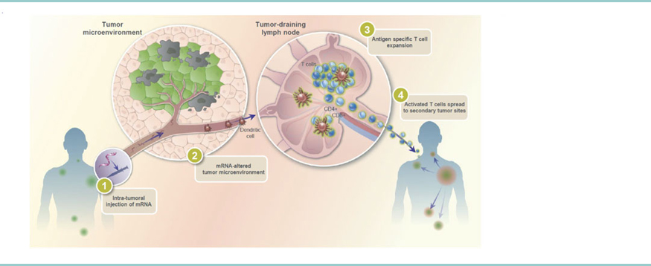

METHODS

- This is an ongoing, multicenter, phase 1 dose escalation study (NCT03871348) that enrolled patients with advanced solid tumors

– Key Inclusion criteria:

³18 years of age

Advanced solid tumors (including lymphomas) for which no standard alternative therapy is available

Minimum of 3 lesions at enrollment that were suitable for direct intratumoral injection and amenable for additional tumor biopsy

Measurable disease according to the Response Evaluation Criteria in Solid Tumors 1.1 criteria

– Key Exclusion criteria:

Eastern Cooperative Oncology Group (ECOG) Performance Status >1

Central nervous system lymphoma or any new and progressive brain lesions

Significant active or recent (within 5 years) autoimmune disease requiring treatment with systemic immunosuppressive treatments

History of an invasive malignancy other than the one treated in this study within the last 5 years

Poor liver and kidney functions, poor bone marrow function resulting in low blood cell counts, abnormal coagulation tests

Moderate to severe immune related adverse event to prior immune-modulating agents within 90 days prior to the first study treatment or lack of any prior TRAE to < grade 2

- Eligible patients were treated with either weekly intratumoral administration of SAR441000 (monotherapy arm) or in combination with fixed dose of cemiplimab 350 mg (combination arm)
- Plasma samples for cytokine analysis and tumor biopsies were collected at baseline and throughout the study to characterize the pharmacokinetics/pharmacodynamics profile of SAR441000, immune cell tumor infiltration by immunohistochemistry and the presence of corresponding tumor proinflammatory signatures by RNA sequencing

- Primary endpoints included:

– Dose limiting toxicities (DLTs) of SAR441000 monotherapy and in combination

– Maximum tolerated dose (MTD) of SAR441000 monotherapy and in combination

– Incidence of treatment-emergent adverse events (TEAEs), defined as all adverse events (related and not related to study treatment) that occurred after receiving the first dose and up to 30 days after the last dose of study treatment
- Secondary endpoint:

– Pharmacokinetics of SAR441000 as monotherapy and in combination

- Exploratory endpoint:

– Preliminary efficacy according to RECIST 1.1

RESULTS

- As of July 2020, 17 patients received SAR441000 monotherapy (7 patients with melanoma, 4 with breast cancer, 2 with sarcoma, 2 with cutaneous squamous cell carcinoma, 1 basal cell carcinoma, and 1 Merkel cell carcinoma) at dose levels 1 through 7 (Table 1)
- Six patients received SAR441000 in combination therapy (melanoma 3, breast 3) at dose levels 4 and 5

- No patient experienced a DLT

- No grade 3, 4, or 5 treatment-related adverse events (TRAEs) were reported in either treatment group (Tables 2 and 3)

- Of the 17 patients treated with SAR441000 monotherapy and 6 patients treated with combination therapy, 16 patients (94.1%) and 6 patients (100%) experienced at least 1 TEAE, respectively
- TEAEs related to study treatment (TRAEs) in 2 or more subjects in both treatment groups combined, consisting of grade 1 or 2 fatigue (43%; 10/23), vomiting (17%; 4/23), nausea (13%; 3/23); local injection site reaction (8.7%, 2/23); and chills, diarrhea, and rash were reported as 9% (2/23), respectively, are shown in Tables 2 and 3

- In some patients in monotherapy, modulation of IL15 levels (from 1.02 to 5.49 fold change) were measured in plasma even though no dose effect was determined (Figure 2)

- At monotherapy DL6 and DL7, increases in plasma IP10 and IFN gamma were observed (Figure 2) and CD8+ T cell infiltration was observed among few paired tumor biopsy samples analyzed in one patient
- Preliminary efficacy data collection is ongoing and will be analyzed at the end of dose escalation study

Table 1. Baseline characteristics of all treated patients

 |  |  |  |  |  |  |  |  |  |  |  | Monotherapy |  |  |  | Combination Therapy
 |  |  |  |  |  |  |  |  |  |  |  | (N = 17) |  |  |  | (N=6)
Age (years) |  |  |  |  | Mean (SD) |  |  |  |  |  |  | 65.9 (11.5) |  |  |  | 52.5 (7.7)
 |  |  |  |  |  | Median |  |  |  |  |  | 67 |  |  |  |  | 55.5
 |  |  |  |  |  | Range |  |  |  |  |  | 46; 83 |  |  |  |  | 38; 58
Sex, n (%) |  |  |  |  |  | Male |  |  |  |  |  | 6 (35.3) |  |  |  | 2 (33.3)
 |  |  |  |  |  | Female |  |  |  |  |  | 11 (64.7) |  |  |  | 4 (66.7)
Prior therapy, n (%)a |  |  |  |  | Immunotherapy |  |  |  |  |  |  | 11 (64.7) |  |  |  | 5 (83.3)
 |  |  |  |  | Chemotherapy |  |  |  |  |  |  | 8 (47.1) |  |  |  | 4 (66.6)
 |  |  |  |  |  | Other |  |  |  |  |  | 10 (58.8) |  |  |  | 6 (100.0)
 |  |  |  |  |  | Surgery |  |  |  |  |  | 15 (88.2) |  |  |  | 6 (100)
 |  |  |  |  | External radiotherapy |  |  |  |  |  |  | 12 (70.6) |  |  |  | 5 (83.3)
 |  |  |  |  | Internal radiotherapy |  |  |  |  |  |  | 2 (11.8) |  |  |  |  | 0
 |  |  |  |  | Anti-cancer therapy |  |  |  |  |  |  | 17 (100) |  |  |  | 6 (100)
Tumor diagnosis, n (%) |  |  |  |  | Melanoma |  |  |  |  |  |  | 7 (41.1) |  |  |  | 3 (50.0)
 |  |  |  |  | Breast carcinoma |  |  |  |  |  |  | 4 (23.5) |  |  |  | 3 (50.0)
 |  |  |  |  | Sarcoma |  |  |  |  |  |  | 2 (11.7)
 |  |  |  | Squamous cell carcinoma |  |  |  |  |  |  |  | 2 (11.7)
 |  |  |  |  | Basal cell carcinoma |  |  |  |  |  |  | 1 (5.8)
 |  |  |  |  | Merkel cell carcinoma |  |  |  |  |  |  | 1 (5.8)
Disease site, n (%) |  |  |  |  |  | Skin |  |  |  |  |  | 6 (35.3) |  |  |  | 1 (16.7)
 |  |  |  |  |  | Breast |  |  |  |  |  | 4 (23.5) |  |  |  | 3 (50.0)
 |  |  |  |  |  | Head |  |  |  |  |  | 1 (5.9) |  |  |  |  | 0
 |  |  |  |  |  | Limb |  |  |  |  |  | 3 (17.6) |  |  |  |  | 0
 |  |  |  |  | Lymph node |  |  |  |  |  |  | 2 (11.8) |  |  |  | 1 (16.7)
 |  |  |  |  |  | Other |  |  |  |  |  | 1 (5.9) |  |  |  | 1 (16.7)
Table 2. Frequency of patients with a treatment emergent AEa related to SAR441000 by dose group and grade
 |  |  |  |  |  |  | Escalation Monotherapy
 |  | DL1 |  | DL2 |  | DL3 |  |  |  | DL4 |  | DL5 |  | DL6 |  | DL7 |  | All
 |  | (N=1) |  | (N=1) |  | (N=3) |  |  | (N=3) |  |  | (N=3) |  | (N=3) |  | (N=3) |  | (N = 17)
 |  | All grades | Grade ³ 3 | All grades | Grade ³ 3 | All grades | Grade ³ 3 | All grades |  |  | Grade ³ 3 | All grades | Grade ³ 3 | All grades | Grade ³ 3 | All grades | Grade ³ 3 All grades |  | Grade ³
 |  |  |  |  |  |  |  |  |  |  |  |  |  |  |  |  |  |  | 3
 |  | n (%) | n (%) | n (%) | n (%) | n (%) | n (%) | n (%) |  |  | n (%) | n (%) | n (%) | n (%) | n (%) | n (%) | n (%) | n (%) | n (%)
Any TRAEa |  | 1 (100) | 0 | 1 (100) | 0 | 2 (66.7) | 0 | 2 (66.7) |  |  | 0 | 2 (66.7) | 0 | 2 (66.7) | 0 | 2 (66.7) | 0 | 11 (64.7) | 0
Fatigue |  | 1 (100) | 0 | 1 (100) | 0 | 0 | 0 | 0 |  |  | 0 | 1 (33.3) | 0 | 1 (33.3) | 0 | 1 (33.3) | 0 | 5 (29.4) | 0
Chills |  | 0 | 0 | 0 | 0 | 0 | 0 | 0 |  |  | 0 | 1 (33.3) | 0 | 1 (33.3) | 0 | 0 | 0 | 2 (11.7) | 0
Vomiting |  | 0 | 0 | 0 | 0 | 0 | 0 | 0 |  |  | 0 | 0 | 0 | 1 (33.3) | 0 | 1 (33.3) | 0 | 2 (11.7) | 0
Arthralgia |  | 0 | 0 | 0 | 0 | 0 | 0 | 0 |  |  | 0 | 0 | 0 | 1 (33.3) | 0 | 0 | 0 | 1 (5.9) | 0
Axillary pain |  | 0 | 0 | 0 | 0 | 0 | 0 | 0 |  |  | 0 | 0 | 0 | 1 (33.3) | 0 | 0 | 0 | 1 (5.9) | 0
Injection site reaction |  | 0 | 0 | 0 | 0 | 2 (66.7) | 0 | 0 |  |  | 0 | 0 | 0 | 0 | 0 | 0 | 0 | 2 (11.7) | 0
Myalgia |  | 0 | 0 | 0 | 0 | 0 | 0 | 0 |  |  | 0 | 0 | 0 | 0 | 0 | 1 (33.3) | 0 | 1 (5.9) | 0
Nausea |  | 0 | 0 | 0 | 0 | 0 | 0 | 0 |  |  | 0 | 0 | 0 | 0 | 0 | 1 (33.3) | 0 | 1 (5.9) | 0
Pruritis |  | 0 | 0 | 0 | 0 | 0 | 0 | 0 |  |  | 0 | 0 | 0 | 1 (33.3) | 0 | 0 | 0 | 1 (5.9) | 0
Pyrexia |  | 1 (100) | 0 | 0 | 0 | 0 | 0 | 0 |  |  | 0 | 0 | 0 | 0 | 0 | 0 | 0 | 1 (5.9) | 0
Rash |  | 0 | 0 | 0 | 0 | 0 | 0 | 0 |  |  | 0 | 1 (33.3) | 0 | 0 | 0 | 0 | 0 | 1 (5.9) | 0
Tumor pain |  | 0 | 0 | 0 | 0 | 0 | 0 | 0 |  |  | 0 | 0 | 0 | 1 (33.3) | 0 | 0 | 0 | 1 (5.9) | 0
aTRAE, treatment related adverse event; refers to a treatment emergent adverse event assessed as related to study treatment by both the investigator and the sponsor

Table 3. Frequency of patients with a treatment emergent AEa related to SAR441000 and/or cemiplimab by dose group and grade

Escalation Combination Therapy

 | DL4 |  | DL5 |  | All
 | (N=3) |  | (N=3) |  | (N=6)
 |  | Grade ³ 3 |  | Grade ³ 3 |  | Grade ³
 | All grades | Grade ³ 3 | All grades | Grade ³ 3 | All grades | 3
 | n (%) | n (%) | n (%) | n (%) | n (%) | n (%)
Any TRAEa | 2 (66.7) | 0 | 3 (100) | 0 | 5 (83.3) | 0
Fatigue | 2 (66.7) | 0 | 3 (100) | 0 | 5 (83.3) | 0
Diarrhea | 0 | 0 | 2 (66.7) | 0 | 2 (33.3) | 0
Nausea | 0 | 0 | 2 (66.7) | 0 | 2 (33.3) | 0
Vomiting | 0 | 0 | 2 (66.7) | 0 | 2 (33.3) | 0
Dermatitis acneiformb | 1 (33.3) | 0 | 0 | 0 | 1 (16.7) | 0
Decreased appetite | 1 (33.3) | 0 | 0 | 0 | 1 (16.7) | 0
aTRAE, treatment related adverse event; refers to a treatment emergent adverse event assessed as related to study treatment by both the investigator and the sponsor

bDermatitis acneiform included in the term rash for the summation of TRAEs occurring in both treatment groups

Figure 2. Pharmacokinetic and pharmacodynamic markers in monotherapy-Maximum fold change from baseline measured at any cycle in plasma for IL15 (a), IFNg (b), IP10 (c)
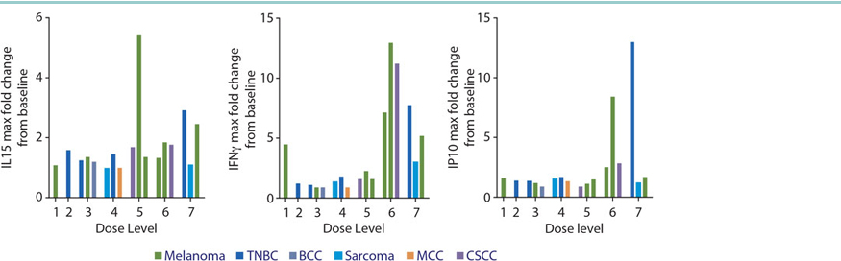

BCC, basal cell cancer; CSCC, cutaneous squamous cell cancer; MCC, Merkel cell carcinoma; TNBC, triple negative breast cancer

CONCLUSIONS

- SAR441000 administered as monotherapy and in combination with cemiplimab was generally well tolerated

- In monotherapy, initial signals at DL6 and DL7 are suggestive of an immunomodulatory effect by downstream effector cytokines. These data support further clinical evaluation of SAR441000

ACKNOWLEDGMENTS |  | • | Strategic oversight, study design and | DISCLOSURE | REFERENCE | The study was approved by each
• | Patients and investigators at |  | logistics support was provided by | Dr. Oliver Bechter has received | 1. Sahin U, Karikó K, Türeci O, | participating Institution’s Ethics or
 | participating sites |  | Nicolas Acquavella, MD | consultancy honorarium from Sanofi | mRNA-based therapeutics-- | Institutional Review Board(s) and
• | Research and analyses were | • | Editorial support was provided by |  | developing a new class of drugs. | each patient provided signed
 | supported by Sanofi and BioNTech |  | Michelle Daniels, MD of inScience |  | Nat Rev Drug Discov. 13, 759-780 | informed consent to participate in the
• | The authors were responsible for all |  | Communications, funded by Sanofi |  | (2014). | study.
 | content and editorial decisions
Presented at the SITC 2020 Virtual Scientific Program. November 9–14, 2020; |  |  |  |  |  | For any medical questions please
Poster 391 |  |  |  |  |  | contact Oliver Bechter:
 |  |  |  |  |  | oliver.bechter@uzleuven.be


A Personal Neoantigen Vaccine NEO-PV-01, in Combination with Chemotherapy and Pembrolizumab, Induces Broad De Novo Immune Responses in First-Line Non-Squamous NSCLC

Mark M. Awad1, David R. Spigel2, Edward B. Garon3, Saiama Waqar4, Aaron Lisberg3, Melissa Moles5, Jennifer Tepper5, April Lamb5, Amy Wanamaker5, Zak Khondker5, John Srouji5, Jesse Dong5, Asaf Poran5, Kristen Balogh5, Meghan Bushway5, Mark DeMario5, Lakshmi Srinivasan5, Richard B. Gaynor5, Ramaswamy Govindan4

1Dana Farber Cancer Institute, Brigham and Women’s Hospital, and Harvard Medical School, Boston, MA; 2The Sarah Cannon Research Institute, Tennessee Oncology, PLLC, Nashville, TN; 3Department of Medicine, University of California Los Angeles, Los Angeles, CA; 4Washington University School of Medicine, St Louis, MO; 5BioNTech US Inc., Cambridge, MA

Introduction

- Checkpoint inhibitors have been important therapeutic modalities for the treatment of NSCLC, either alone or in combination with chemotherapy.1

- Clinical outcomes with checkpoint inhibitors correlate with tumor mutational burden that generate neoantigens.2-4

- NEO-PV-01 is a personal neoantigen vaccine candidate custom-designed and manufactured specifically for the mutational profile of each individual’s tumor (Figure 1).5
- NEO-PV-01 is composed of a mixture of up to 20 unique neoantigen peptides of 14-35 amino acids in length, each at a concentration of 400 µg/mL.
  - Peptides are pooled together in four groups of up to five peptides each, and mixed with the adjuvant polyinosinic-polycytidylic acid-polylysine carboxymethylcellulose (poly-ICLC) at the time of administration.
  - In a Phase 1B clinical trial of NEO-PV-01, seven vaccine doses are administered over a 3-month period post-chemotherapy and pembrolizumab.

Figure 1: Neoantigens Are Key Targets of Tumor-Directed T cell Responses

NT-002 Study Design

NT-002 is a Phase 1B trial of NEO-PV-01 in combination with chemotherapy and pembrolizumab, in first-line therapy in patients with advanced or metastatic non-squamous NSCLC (NCT03380871). Target enrollment = 15 patients across 4 US sites.

Objectives

Primary: To evaluate the safety of NEO-PV-01 with pembrolizumab and carboplatin and pemetrexed.

Secondary: To determine clinical efficacy, assessed by objective response rate (ORR), progression-free survival (PFS), and overall survival (OS).

Exploratory: To characterize immune responses in the periphery and in the tumor, assessing for durability, presence of epitope spread, ability to kill tumor, and tumor cellularity.

Figure 2: NT-002 Study Schema and Enrollment
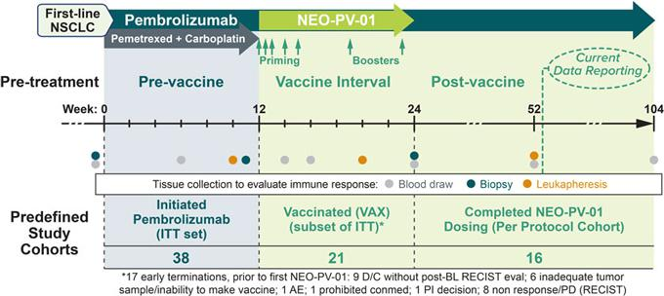

Top: Treatment with pembrolizumab + pemetrexed + carboplatin was initiated at Week 0 x 4 cycles. NEO-PV-01 was administered between Weeks 12 and 24, after which pembrolizumab was continued as monotherapy for up to 2 years. Bottom: Study patient cohorts. 38 patients initiated study treatments (ITT population), 21 and 16 patients initiated and completed NEO-PV-01 treatment, comprising the Vaccinated (VAX) group and Per Protocol study cohorts, respectively.

Methods

- Patients received 12 weeks of pembrolizumab (Q3W) plus carboplatin and pemetrexed. NEO-PV-01 was then given subcutaneously in a prime-boost format spanning 12 weeks, followed by pembrolizumab only for up to 2 years.
- Comprehensive comparisons of baseline and serial molecular and immunological characteristics between patients with vs. without PFS-9 (defined as 9-month PFS) were performed.
- All patients who initiated pembrolizumab and chemotherapy (ITT set) were analyzed for safety and efficacy. Subset analysis of efficacy was performed on patients who received at least one dose of NEO-PV-01 vaccine (VAX group).
- Peripheral blood samples were evaluated for the presence of neoantigen-specific T cell responses by IFN-y ELISpot, intracellular cytokine staining, multi-parameter surface and functional phenotyping by FACS, and presence of cytolytic properties. Tumor biopsies were analyzed for multiple immune and tumor markers by immunohistochemistry, gene expression and whole exome sequencing.

Abbreviations: AE = adverse event; ANC = absolute neutrophil count; CBR = clinical benefit rate; CPI = checkpoint inhibitor;

ELISpot = Enzyme-Linked ImmunoSpot; FACS = fluorescence-activated cell sorting; FFPE = formalin-fixed paraffin embedded; IFN-y = interferon-y; IHC = immunohistochemistry; ITT = intent-to-treat; NE = not evaluated; NR = not reached; NSCLC = non-small cell lung cancer; ORR = objective response rate; OS = overall survival; PBMC = peripheral blood mononuclear cell; PD = progressive disease; PD-1 = programmed cell death protein 1; PD-L1 = programmed death ligand 1; PFS = progression-free survival; poly-ICLC = polyinosinic-polycytidylic acid-polylysine carboxymethylcellulose; PR = partial response; Q3W = every three weeks; SAE = serious adverse event; SD = stable disease; TMB = tumor mutational burden.

NEO-PV-01 + Pembrolizumab and Chemotherapy was Well-Tolerated and Leads to Broad Immune Responses

Table 1: Patient Demographics and Baseline Disease Characteristics

 |  | ITT |  | VAX
 | (N = 38) |  | (N = 21)
Median Age (years) | 62.5 (56-73) |  | 63 | (56-69)
Sex M/F, n (%) | 15 (39%) /23 (61%) |  | 7 (33%) / 14 (67%)
Prior therapy, n (%) | 3 | (8%) |  | 0%
Stage IV, n (%) | 33 | (87%) | 21 | (100%)
Median TMB (range) | 141 | (2,776) | 279 | (96,776)
Smokers (current or prior), % | 82% |  |  | 95%
Tumor PD-L1 expression, n (%)*
< 1% | 11 (42%) |  | 9 | (43%)
³1%–<50% | 12 | (46%) | 10 (47%)
³ 50% | 3 (12%) |  | 2 | (10%)
Median sum of target lesions (cm) |  | 8.6 |  | 8.3
ECOG 0/1, n (%) | 11 (29%) / 27 (71%) |  | 7 (33%) / 14 (67%)

*Tumor PD-L1 expression NA for 12 of 38 ITT patients

Baseline characteristics for ITT and VAX group patients. Female patients were more common in both groups. Age, ECOG performance status, baseline tumor burden, and tumor PD-L1 expression levels were comparable for ITT and VAX groups.

Table 2: NT-002 Safety Profile
 | Post-Treatment |  | Pre-Vaccine |  | Post-Vaccine
 | (ITT Set, N = 38) |  | (ITT Set, N = 38) |  | (VAX Group, N = 21)
Adverse Events (AEs) | 37 | (97.4%) | 37 | (97.4%) | 20 | (95.2%)
Serious or Grade ³ 3 AE | 22 | (57.9%) | 18 | (47.4%) | 9 (42.9%)
Serious AE | 15 | (39.5%) | 11 (28.9%) |  | 6 (28.6%)
Leading to any drug discontinuation | 5 (13.2%) |  | 3 | (7.9%) | 2 | (9.5%)
Leading to death |  | 0 |  | 0 |  | 0
AEs Related to any drug | 33 | (86.8%) | 32 | (84.2%) | 17 | (81.0%)
Serious or Grade ³ 3 AE | 8 (21.1%) |  | 7 (18.4%) |  | 2 | (9.5%)
Serious AE | 4 (10.5%) |  | 3 | (7.9%) | 1 | (4.8%)
Leading to any drug discontinuation | 2 | (5.3%) | 2 | (5.3%) |  | 0
Leading to death |  | 0 |  | 0 |  | 0

AE frequencies for ITT and VAX group patients. Discontinuation due to related AEs was reported for 5.3% of patients overall, with no discontinuations for related AEs in the VAX group. No Grade 5 events were reported.

NT-002 Safety Summary

- 52-week data available for ITT set (N = 38) and VAX group (N = 21).

- Related AE profile is consistent with aPD-1 + chemotherapy treatment. Most frequent related events included nausea, emesis, diarrhea, fatigue, ANC, and anemia.
- Only related AE with clear increased incidence in VAX group is injection site reaction: 6 patients (29%) experienced low grade, transient events.

- Low incidence of treatment-related SAEs, overall (4 patients in ITT, 10%) and for VAX group (1 patient, < 5%).

- Discontinuations due to related AEs were uncommon (2 patients, 5.3%).

- No Grade 5 events.

- No new NT-002 safety signals with 52-week data.

Figure 3: RECIST 1.1 Response in the VAX Group Pre- and Post-Vaccination
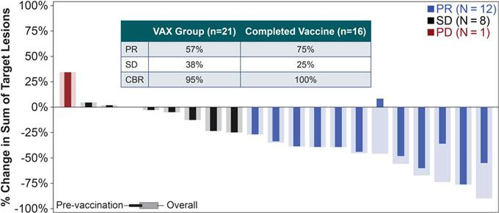

Waterfall plot of best radiographic change (%) in sum of target lesions by patients who received at least one dose of NEO-PV-01: narrow bars represent best change pre-NEO-PV-01; wider bars represent the overall best change on study.

Figure 4: Change in Sum of Target Lesions over Time in ITT Set

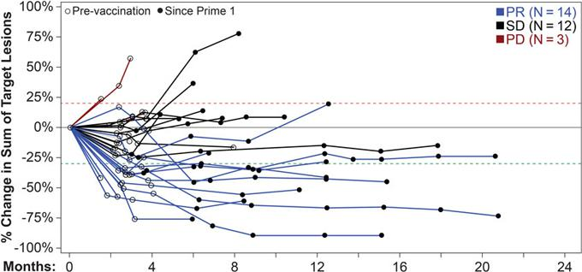

Spider plot of all radiographic changes (%) in sum of target lesions from initiation of pembrolizumab treatment by patient: unfilled circles represent imaging timepoints prior to receiving NEO-PV-01; filled circles represent imaging timepoints after initiating NEO-PV-01. Nine patients had no post-baseline tumor assessment (excluded from analysis).

Figure 5: Progression-Free and Overall Survival
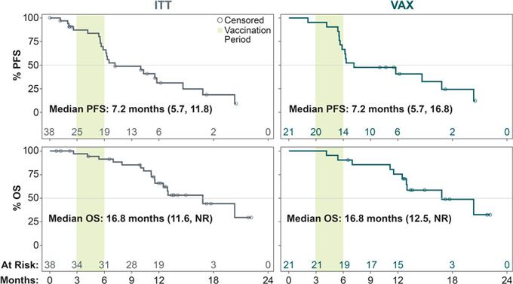

Kaplan-Meier (KM) estimates of PFS (top) and OS (bottom) in ITT set and VAX group. Green shading denotes the vaccination period. NR = not reached.

Table 3: Exploratory Analyses of Gender and TMB Subgroups
Sex | N | Female | Male | Hazard Ratio | P-value
 |  |  |  | (95% CI) | P-value
ITT | 38 | (N = 23) | (N = 15) | 1.3 (0.5, 3.2) | 0.56
ITT | 38 | Median = 6.5 months | Median = 11.8 months | 1.3 (0.5, 3.2) | 0.56
VAX | 21 | (N = 14) | (N=7) | 1.8 (0.6, 5.9) | 0.29
 |  | Median = 6.3 months | Median = 16.8 months
TMB | N | TMB < 200 | TMB ³ 200 | Hazard Ratio | P-value
 |  |  |  | (95% CI) | P-value
ITT | 38 | (N = 23) | (N = 15) | 4.1 (1.4, 11.7) | 0.005
ITT | 38 | Median = 6.3 months | Median = 16.8 months | 4.1 (1.4, 11.7) | 0.005
VAX | 21 | (N=9) | (N = 12) | 4.4 (1.3, 15.0) | 0.01
 |  | Median = 5.7 months | Median = 16.8 months

- Subgroup analysis of response rate and PFS in the ITT set and VAX group.

  - Higher TMB associates with longer PFS (p < 0.05).

  - Female patients have a trend for shorter PFS, although not significant.

NT-002: Immune Analysis Key Questions

- Does the combination of NEO-PV-01 and pembrolizumab/chemotherapy induce or expand neoantigen-specific T cells?

- What are the phenotypes of these neoantigen-specific T cells?

- Do neoantigen-specific T cells upregulate CD107a?

- Is there evidence of epitope spread?

- Are there any biomarkers that predict response to treatment?

Figure 6: NEO-PV-01 + Pembrolizumab/Chemotherapy Induced Durable Neoantigen-Specific Immune Responses Post-Vaccination

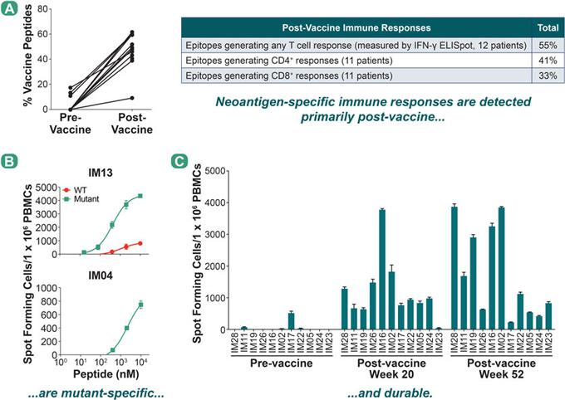

- IFN-g ELISpot analysis of 12 patients are summarized in terms of the percent of vaccinating peptides that generated an immune response either pre- or post-vaccination as a percentage of total vaccine peptides. Characteristics of immune responses are shown in the table. B: A total of 19 wild-type peptides were tested across 4 patients, and 18/19 (95%) of the peptides were mutant-specific. The example shown is from Patient 2L7. C:

Post-vaccination immune responses are durable (still detected at 52 weeks after start of treatment). The example shown is from patient 2L16, in which all responses seen at week 20 post-vaccination are still present at Week 52, and an additional response (IM23) is observed at Week 52 only.

Figure 7: Neoantigen-Specific CD4+ T cells Are Detected Ex Vivo and Have an Activated Antigen Experienced Phenotype: Patient 2L7
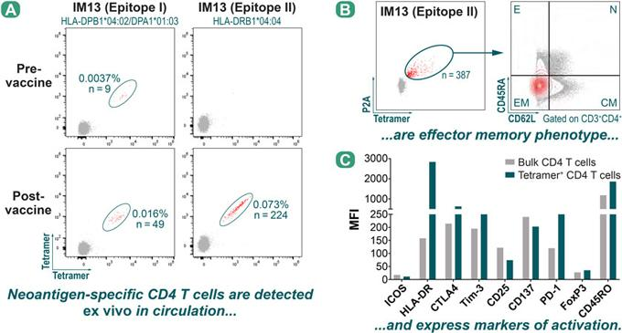

- MHC class II tetramer analysis for Epitope I and Epitope II from immunizing peptide IM13. Tetramer+CD4+ T cells are circled in green for each sample. Epitope I shows multimer-positive cells at both the pre- and post-vaccine timepoints, while Epitope II shows multimer-positive cells only at the post-vaccine timepoint. B: Post-vaccine, multimer-positive CD4+ T cells specific for Epitope II were further characterized based on CD45RA and CD62L expression into effector (E), naïve (N), central memory (CM) or effector memory (EM) subsets. The majority of the tetramer+CD4+ cells (shown in red) are effector memory cells. C: Tetramer+CD4+ T cells specific for Epitope II have an activated phenotype when compared to bulk CD4+ T cells, with upregulation of markers such as HLA-DR, CTLA-4, PD-1 and CD45RO.

Figure 8: NEO-PV-01 + Pembrolizumab/Chemotherapy Induced a Cytotoxic Phenotype in Both CD4+ and CD8+ Vaccine-Specific T cell Responses
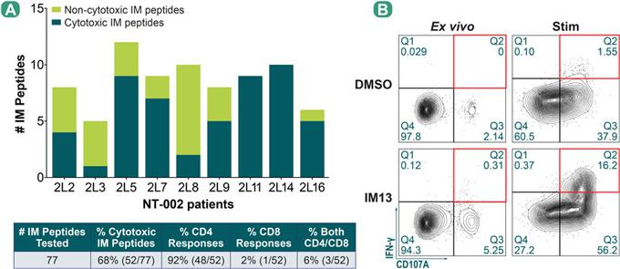

- Post-vaccine PBMCs were evaluated for their ability to induce a cytotoxic T cell phenotype as measured by surface expression of the cytolytic marker CD107a. The table summarizes the data for all 9 patients. Majority of cytotoxic responses are CD4+ T cell responses. B: Representative flow cytometry plots for the immunizing peptide IM13 for patient 2L7. The left two panels represent data from an ex vivo experiment, in which the patient PBMCs were recalled for 6 hours with peptide (or DMSO control), and the right two panels represent data from a 5-day stimulation. Quadrant 2 (red boxes) represents the double positive population indicative of a cytotoxic phenotype. The plots shown here are pre-gated on CD3+CD4+PD-1+ cells.

Figure 9: NEO-PV-01 + Pembrolizumab/Chemotherapy Induced Epitope Spread Responses That Are Cytotoxic and Durable

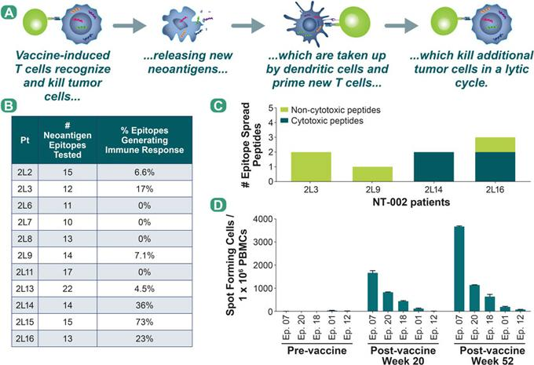

- Epitope spread, as defined in the schematic, was evaluated by measuring immune responses to RECON-predicted high quality neoantigens that were not incorporated into the NEO-PV-01 vaccine. B: Summary of epitope spread responses analyzed across 9 patients by IFN-g ELISpot. In total, epitope spread was observed in 7 out of 11 patients. C: Cytotoxic activity of epitope spread peptides was assessed by CD107a surface expression. PFS status at 9 months (PFS-9) was assessed for each of the 4 patients tested. Interestingly, the 2 patients in which no cytotoxic activity was observed for epitope spread peptides did not meet the PFS-9 cutoff, whereas the 2 patients who did reach PFS-9 showed cytotoxic activity from at least 1 epitope spread peptide tested. D: Epitope spread responses are durable (still detected at 52 weeks). The example shown is from patient 2L16, in which all epitope spread responses seen post-vaccination at Week 20 are still present at Week 52, and an additional response (Epitope 12) is observed at Week 52 only.

Figure 10: Increased Levels of Circulating CD8+ T cells and CD4+ and CD8+ T cell Infiltration in the Tumor Positively Correlate with PFS at Pre-Treatment
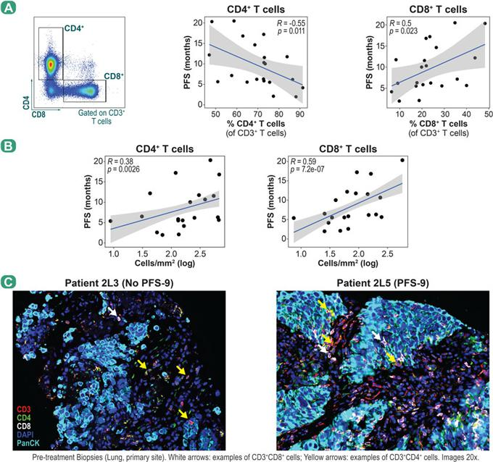

- Patient PBMCs from the pre-treatment timepoint were analyzed using flow cytometry to quantify CD4+ and CD8+ T cell subsets. The percent of CD4+ and CD8+ T cells were correlated to each patient’s PFS. B: Multiplex IHC analysis was performed on pre-treatment FFPE tumor biopsies to examine T cell infiltration. The levels of CD4+ and CD8+ T cells (cells per mm2) were correlated to each patient’s PFS. C: Representative images show multiplex IHC of pre-treatment FFPE tumor biopsies from two patients, one with no PFS-9 (2L3) and the other with PFS-9 (2L5).

Figure 11: Baseline Expression of PD-L1 in the Tumor Is Associated with Increased PFS
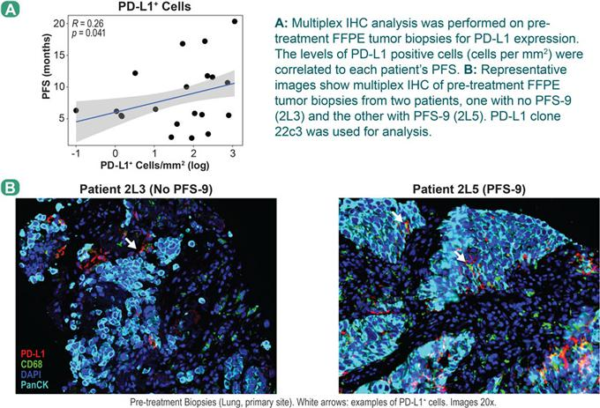

Key Takeaways


- NT-002, a Phase 1B clinical trial in first-line non-squamous NSCLC, met its primary safety endpoint, with RECIST ORR and PFS data consistent with prior first-line CPI+chemotherapy regimens.
- In the NT-002 trial, NEO-PV-01 combined with chemotherapy/pembrolizumab enhanced the immune response to neoantigens.

- Neoantigen-specific CD4 and CD8 T cell responses detected in all patients tested.

- Neoantigen-specific T cells are activated memory cells with a cytotoxic phenotype.

- Epitope spread is observed in 7 out of 11 patients who were tested.

- Multiple biomarkers correlating to PFS have been identified in periphery and tumor.

References: 1) Gandhi, et al. (2018). Pembrolizumab plus Chemotherapy in Metastatic Non-Small -Cell Lung Cancer. N Engl J Med 378, 2078-2092. 2) Luksza, et al. (2017). A neoantigen fitness model predicts tumour response to checkpoint blockade immunotherapy. Nature 551, 517-520.

- McGranahan, et al. (2016). Clonal neoantigens elicit T cell immunoreactivity and sensitivity to immune checkpoint blockade. Science 351, 1463-1469. 4) Rizvi, et al. (2015). Mutational landscape determines sensitivity to PD-1 blockade in non-small cell lung cancer. Science 348, 124-128. 5) Ott, et al. (2020). A Phase Ib trial of personalized neoantigen therapy plus anti-PD-1 in patients with advanced melanoma, non-small cell lung cancer or bladder cancer. Cell 183, 347-362.

Acknowledgments: Patients and their families, clinical investigators, and BioNTech US, Inc. The authors acknowledge the financial support for this study from Neon Therapeutics/BioNTech US. The authors received editorial assistance from Acumen Medical Communications.

Poster 627 | Presented at The Society for Immunotherapy of Cancer Annual Meeting | November 9-14, 2020


NEO-PTC-01 (BNT-221), an Autologous Neoantigen-Specific T cell Product for Adoptive Cell Therapy of Metastatic Melanoma

Divya Lenkala1, Jessica Kohler1, Brian McCarthy1, Michael Nelson, Jonathan McGee1, Daniel Kallin1, Janani Sridar, Paul Turcott1, Dewi Harjanto1, Cynthia Nijenhuis2, Joost H. van den Berg2, Richard B. Gaynor1, and Marit M. van Buuren1

1BioNTech US Inc., Cambridge, MA, USA; 2Netherlands Cancer Institute, Amsterdam, The Netherlands

Background

- Neoantigens are tumor-specific antigens that are important in eliciting and directing effective anti-tumor T cell responses.1-3 These tumor-specific neoantigens are not subject to central immune tolerance and are therefore potentially more immunogenic than shared tumor-associated antigens.1,2

- Adoptive T cell therapy has been proven to be successful in treating patients with solid tumors, and neoantigen-specific T cells are thought to play a critical role in conferring this clinical benefit.4,5

- BioNTech US (formerly Neon Therapeutics) has developed a novel induction process, NEO-STIM™, which primes, activates, and expands out multiple neoantigen-specific T cell responses. The characteristics of the drug product NEO-PTC-01 (BNT-221) – specificity, functionality, and phenotype – are expected to confer a clinical benefit and overcome challenges that other cell therapy modalities are facing (Figure 1).

- Here, we present the results of multiple successful process engineering runs using leukapheresis from metastatic melanoma patients and healthy donors. Using our proprietary ex vivo induction process, NEO-STIM, a neoantigen-specific T cell product (NEO-PTC-01) was generated that contains highly specific T cell responses targeting multiple neoantigens from each individual patient’s tumor; these T cell responses are polyfunctional and can recognize autologous tumor.

- NEO-PTC-01 is scheduled to begin clinical development in 4Q of 2020 as an adoptive T cell therapy for patients with metastatic melanoma.

Materials and Methods

- Five process engineering runs (Pilot, ENG-01, ENG-02, ENG-03, ENG-04) were performed by the Biotherapeutics Unit of Netherlands Cancer Institute - Antoni van Leeuwenhoek (NKI-AVL) using PBMCs from 2 healthy donors (HD108 [Pilot], HD115 [ENG-04]) and 3 melanoma patient samples that were obtained under IRB approval (N16NEON-23-111961 [ENG-01], N16NEON-24-081951 [ENG-02], and N16NEON-25-111951 [ENG-03]).

- For the melanoma patients, patient-specific neoantigens were predicted using our bioinformatics engine, RECON®. This engine is also used to predict neo-antigens restricted to HD115 HLA alleles using patient mutanome (N16NEON-24-081951). For HD108, previously identified neoantigens and model antigens restricted to the donor HLA alleles were used to execute NEO-STIM.6-8 Synthetic peptides were generated of 8 to 25 aa in length.

- NEO-STIM was used to prime, activate, and expand memory and de novo T cell responses, using up to 50 x 106 PBMCs per vessel (Figure 1).

  - The specificity, phenotype, and functionality of these neoantigen-specific T cells were analyzed by characterizing these responses with the following assays:

– Combinatorial coding analysis using pMHC multimers.9

– Detailed flow characterization. Markers included but were not limited to CD3, CD4, CD8, CD45RA, and CD62L.

– A recall response assay using multiplexed, multiparameter flow cytometry10 to a) identify and validate CD4+ T cell responses, b) assess

the polyfunctionality of CD8+ and CD4+ T cell responses, and c) assess the ability to recognize autologous tumor. Pro-inflammatory cytokines IFN-Y and TNFa, and upregulation of CD107a as a marker of degranulation, were measured.

– A cytotoxicity assay using neoantigen-expressing tumor lines to understand the ability of neoantigen-specific CD8+ T cell responses to recognize and kill target cells in response to naturally processed and presented or exogenously loaded antigen.

Figure 1: NEO-PTC-01 Product Opportunity

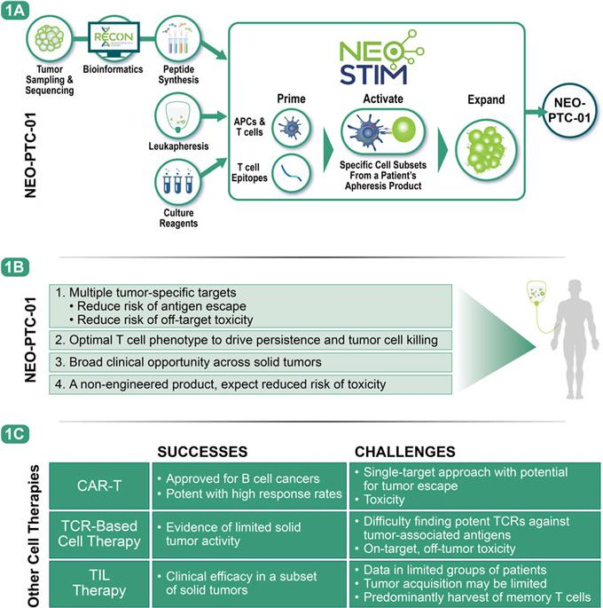

1A: NEO-PTC-01 manufacturing process overview. 1B: NEO-PTC-01 product characteristics. 1C: Successes and challenges of other cell therapy modalities.

Abbreviations: APC = antigen-presenting cell; CD = Cluster of Differentiation; DC = dendritic cell; FDR = false discovery rate; HLA = human leukocyte antigen; IFN-g = interferon-gamma; IRB = institutional review board; NK = natural killer; ORR = objective response rate; PBMC = peripheral blood mononuclear cell;

pMHC = peptide major histocompatibility complex; TCR = T cell receptor; TNFa = tumor necrosis factor alpha.

Results: Evaluation of the Process Engineering Runs

- Preclinical development activities to inform manufacturing of NEO-PTC-01 successfully resulted in the execution of 5 process engineering runs using leukapheresis material of 3 metastatic melanoma patients and 2 healthy donors.

- The final drug product generated met the release specifications for all 5 process engineering runs (Figure 2A). The majority of the final drug product consisted of CD3+ T cells (range: 60.0% to 90%). B cells, NK cells, and APCs made up the non-CD3+ fraction (Figure 2B).

Figure 2: NEO-PTC-01 is Successfully Manufactured in 5 Process Engineering Runs Using Melanoma Patient and Healthy Donor PBMCs
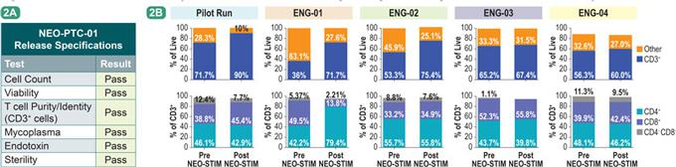

2A: Release specifications for NEO-PTC-01 in process engineering runs. 2B: Characterization of drug product by flow cytometry: CD3+ as a fraction of live cells and CD8+ and CD4+ as a fraction of live CD3+ T cells. Highlighted colors identifying each run in Figure 2B are carried through Figures 2, 3, and 5.

- Twenty-nine CD8+ and 26 CD4+ T cell responses were induced from PBMCs (range 4-10 and 1-7 per patient for CD8+ and CD4+ T cells, respectively, Figures 3A, 3B, and 3D).

  - All the T cell responses induced in the PBMCs from the melanoma patients are presumed de novo T cell responses; no pre-existing responses were detected in the unmanipulated starting material.

  - This was also the case for the PBMCs from the healthy donors; however, one of the responses that was identified was toward MART1, which is known to have a high precursor frequency in peripheral blood.11

  - As such, this process successfully induced T cell responses from the naive compartment.

- Further characterization was performed to assess the polyfunctionality profile and the differentiation status of the NEO-STIM-induced CD8+ and CD4+ T cells.

  - Upon re-challenge with mutant peptide-loaded DCs, neoantigen-specific T cells exhibited 1, 2, and/or 3 functions (examples of the polyfunctionality profile of the CD8+ and CD4+ T cell responses are shown in Figures 3C and 3E, respectively).

  - Additionally, the differentiation status of the drug product was assessed. The majority of the NEO-STIM-induced T cells were of the effector memory and central memory phenotypes (Figure 3F).

Figure 3: NEO-STIM Successfully Induces CD8+ and CD4+ T cell Responses
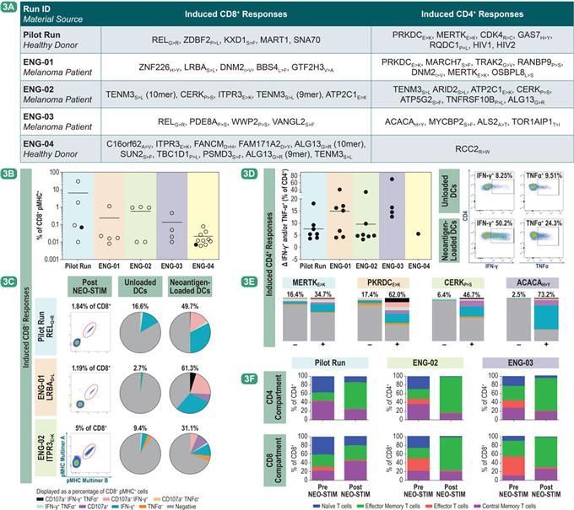

3A: Summary of induced CD8+ and CD4+ T cell responses post NEO-STIM. Patient-specific neoantigens were used for melanoma patients. Model

(neo)antigens were used for the healthy donor. 3B/3D: Each datapoint in the graph represents the frequency of antigen-specific T cells (% of pMHC+ CD8+ or delta of IFN-g and/or TNFa [% of CD4+]) of an induced response in the final drug product (open symbols) and final NEO-STIM, pre-pooled product (closed symbols). Average values are depicted with horizontal lines (average value for ENG-03 in Figure 3D not shown as this value falls within the y-axis cutout). Example flow cytometry plots of functionality assessment of CD4+ T cells are shown in 3D. 3C/3E: Flow cytometry plots indicating the pMHC+ fraction (% of CD8+). Pie charts and bar charts depict the polyfunctionality of identified pMHC+ CD8+ T cells

(3C) and identified CD4+ T cells (3E), respectively, upon re-challenge with mutant neoantigen-loaded DCs (+) as compared to unloaded DCs (-). 3F: Bar graphs indicate fraction of T cells with specified differentiation status. Central memory T cells (Tcm): CD62L+ CD45RA-, Effector Memory T cells (Tem): CD62L- CD45RA-, Effector T cells (Teff): CD62L- CD45RA+, naive T cells (Tnaïive): CD62L+ CD45RA+.

- The NEO-STIM-induced T cell responses were shown to be highly specific for the mutant epitope.

  - The specificities of the induced CD8+ and CD4+ T cell responses were assessed and assigned to 2 categories (Figures 4A and 4B):

– Mutant-reactive:

      - Mutant-specific: Shows a significant increase in IFN-g and/or TNFa toward mutant, but not wildtype, epitope.

      - Mutant-selective: Shows a significant increase in IFN-g and/or TNFa toward mutant and wildtype epitopes. However, the signal toward the mutant epitope is significantly higher compared to the wildtype epitope.

– Wildtype cross-reactive: Shows a significant increase in IFN-g and/or TNFa toward mutant and wildtype epitopes. There is no significant difference between the 2 signals.

  - In summary:

– For the CD4+ compartment, 13 responses were tested, and T cell responses were detected in both categories: 85% of CD4+ T cells were mutant-reactive and 15% were cross-reactive to the wildtype epitope.

– For the CD8+ compartment, 3 responses were tested, and 100% of all T cells were mutant-reactive (Figure 4C).

Figure 4: Induced CD8+ and CD4+ T cell Responses are Reactive to the Mutant Neoantigen Peptide
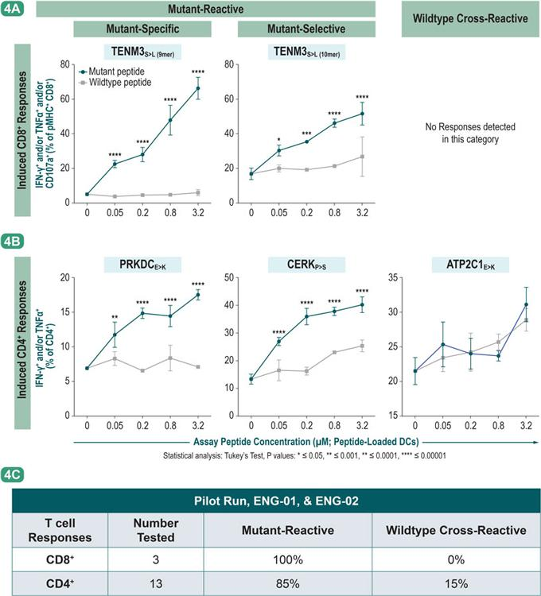

Functionality of T cells measured upon challenge with various concentrations of peptide-loaded DCs (Y axis). 4A: IFN-g+ and/or TNFa+ and/or

CD107a+ as a % of pMHC+ CD8+; 4B: IFN-g+ and/or TNFa+ as a % of CD4+ 4C: Summary of all tested responses, significance assigned using

Tukey’s test, P < 0.05.

- Finally, the cytotoxic capacity of the NEO-STIM-induced T cells was assessed for a subset of the identified T cell responses.

  - Transduced tumor cell lines were generated for the Pilot run and ENG-01, expressing the donorspecific HLA allele as well as the mutation studied. For ENG-02, peptide-loaded tumor cells were used expressing the donor-specific HLA allele (Figure 5A):

– For the transduced tumor targets, CD8+ T cell responses directed toward RELG>R (Pilot) and LRBAS>L (ENG-01) showed a significant upregulation of CD107a on the CD8+ T cells and active Caspase3 on the tumor cells transduced with the mutant construct after co-culture. This shows that the induced T cells are capable of recognizing endogenously processed and presented antigen.

– For the peptide-loaded tumor targets, CD8+ T cell responses directed toward TENM3S>L and ITPR3E>K (ENG-02) showed a significant upregulation of active Caspase3 on the tumor cells and, in the case of TENM3S>L, upregulation of CD107a on the CD8+ T cells, after co-culture with peptide-loaded tumor targets.

  - Importantly, co-culturing T cells generated from ENG-01 and ENG-02 with available autologous tumor digest proved that the induced T cells were capable of directly recognizing autologous tumor cells, based on upregulation of IFN-g and CD107a on the neoantigen-specific T cells (Figure 5B).

Figure 5: Induced CD8+ T cell Responses A) Have a Cytotoxic Phenotype and Can Kill Antigen Expressing Targets and B) Can Recognize Autologous Tumor
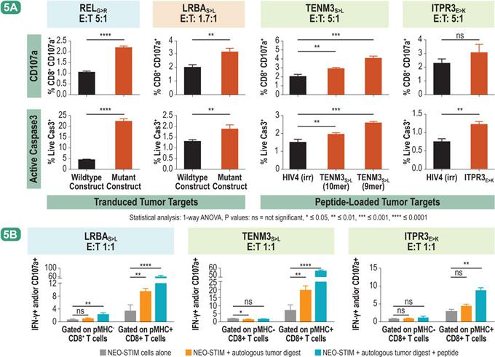

5A: Upregulation of CD107a (top row) on CD8+ T cells and active Caspase3 on tumor cells (bottom row) was measured upon co-culture with un-transduced or transduced with a 200 aa construct A375 tumor cell line or peptide-loaded or unloaded A375 tumor cell lines. 5B: Neoantigen-specific T cells were tested for recognition of autologous tumor digest or peptide-loaded autologous tumor digest through a recall response assay. Readout: IFN-g+ and/or CD107a+ % of pMHC+ CD8+ and pMHC- CD8+ T cells (Y axis). Significance assigned using a 1-way ANOVA, P < 0.05.

Figure 6: Clinical Study Design for NEO-PTC-01 in Metastatic Melanoma
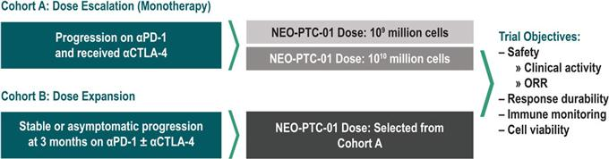

A dose-escalation study will be performed on Cohort A in a 3x3 design. Up to 20 patients will be treated in the Dose Expansion Cohort B.

Key Takeaways


- Using NEO-STIM, BioNTech’s proprietary T cell induction process, we have demonstrated that we can reproducibly generate a potent neoantigen-specific T cell product, NEO-PTC-01, from PBMCs of melanoma patients at a therapeutic scale:

  - NEO-STIM induces multiple neoantigen-specific CD8+ and CD4+ T cell responses.

  - The induced T cell responses are mutant-reactive, show a polyfunctional profile, and have central and effector memory phenotypes.

  - The induced T cell responses have cytotoxic capability, shown by the upregulation of cytotoxic function upon recognition of antigen-expressing tumor cell lines.

  - Importantly, we have shown that NEO-STIM-induced T cell cultures can directly recognize autologous tumor.

- NEO-PTC-01 (BNT-221), the neoantigen-specific T cell product generated from this process, is a potent adoptive cell therapy targeting multiple immunogenic neoantigens in patients with metastatic melanoma who are refractory to checkpoint inhibitor therapy (Figure 6).

References: 1) Yarchoan M, Johnson III BA, Lutz ER, et al. Nat Rev Cancer. 2017;17(4):209-222. 2) Martin SD, Coukos G, Holt RA, et al. Ann Oncol. 2015;26(12):2367-2374. 3) Ott PA, Hu-Lieskovan S, Chmielowski B, et al. Unpublished. 2020. 4) Tran E, Turcotte S, Gros A, et al. Science. 2014;344(6184):641-645. 5) Tran E, Robbins PF, Rosenberg SA. Nat Immunol. 2017;18(3):255-262. 6) van Buuren MM, Calis JJ, Schumacher TN. Oncoimmunology. 2014;3:e28836. 7) Fritsch EF, Rajasagi M, Ott PA, et al. Cancer Immunol Res. 2014;2(6):522-529.
- Ott PA, Hu Z, Keskin DB, et al. Nature. 2017;547(7662):217-221. 9) Andersen RS, Kvistborg P, FrØsig TM, et al. Nature Protoc. 2012;7(5):891-902. 10) Krutzik PO, Nolan GP. Nat Methods. 2006;3(5):361-368. 11) Pittet MJ, Valmori D, Dunbar PR, et al. J Exp Med. 1999;190(5):705-715.

Disclosures: DL, JK, BMc, JMc, DK, PT, DH, RBG, MMvB: employees of BioNTech US Inc. (formerly Neon Therapeutics). MN, JS: former employee of BioNTech US Inc. (formerly Neon

Therapeutics). CN, JHvdB (former): employees of the Netherlands Cancer Institute.

Acknowledgments: The authors are grateful for the contributions of Vikram Juneja, Christina Arieta, John Attanasio, Julia Papps, Diana Velez, Prerna Suri, Yvonne Ware, Yuting Huang, and Zakaria Khonder (employees of BioNTech US Inc.); Ed Fritsch, Matt Goldstein, Rachel DeBarge, Kaitlyn Izzo, Brian Sullivan, and Flavian Brown (former employees of BioNTech US Inc. [formerly Neon Therapeutics]); Rhianne Voogd, Maaike van Zon, Saskia Scheij, Brenda Raud, Noor Bakker, Renate de Boer, Maartje Rohaan, Ton Schumacher, and John Haanen (employees of the Netherlands Cancer Institute); and Myriam Armant (employee of Boston Children’s Hospital). The authors received editorial assistance from Acumen Medical Communications.

Poster 153 | Presented at The Society for Immunotherapy of Cancer Annual Meeting | November 9-14, 2020

