UNITED STATES
SECURITIES AND EXCHANGE COMMISSION
Washington, D.C. 20549
FORM 6-K

REPORT OF FOREIGN PRIVATE ISSUER PURSUANT TO RULE 13a-16 OR 15d-16
UNDER THE SECURITIES EXCHANGE ACT OF 1934
FOR THE MONTH OF AUGUST 2026

COMMISSION FILE NUMBER 001-39081
BioNTech SE
(Translation of registrant’s name into English)
An der Goldgrube 12
D-55131 Mainz
Germany
+49 6131-9084-0
(Address of principal executive offices)

Indicate by check mark whether the registrant files or will file annual reports under cover Form 20-F or Form 40-F: Form 20-F ☒ Form 40-F ☐
Indicate by check mark if the registrant is submitting the Form 6-K in paper as permitted by Regulation S-T Rule 101(b)(1): ☐
Indicate by check mark if the registrant is submitting the Form 6-K in paper as permitted by Regulation S-T Rule 101(b)(7): ☐

DOCUMENTS INCLUDED AS PART OF THIS FORM 6-K

On August 4, 2026, BioNTech SE (the “Company”) issued a press release announcing its second quarter 2026 financial results and corporate update and details of a conference call to be held at 8:00 am EDT on August 4, 2026 to discuss the results. The press release and the conference call presentation are attached as Exhibits 99.1 and 99.2, respectively, and incorporated by reference herein.
The information contained in Exhibits 99.1 and 99.2 shall not be deemed “filed” for purposes of Section 18 of the Securities Exchange Act of 1934, as amended (the “Exchange Act”), or incorporated by reference in any filing under the Securities Act of 1933, as amended, or the Exchange Act, unless expressly set forth by specific reference in such a filing.

SIGNATURE
Pursuant to the requirements of the Exchange Act, the registrant has duly caused this report to be signed on its behalf by the undersigned, thereunto duly authorized.

BioNTech SE
By: |  |  | /s/ Ramón Zapata-Gomez |  |  |  |  |  | By: |  |  | /s/ Dr. Sierk Poetting
 |  |  | Name: Ramón Zapata-Gomez |  |  |  |  |  |  |  |  | Name: Dr. Sierk Poetting
 |  |  | Title: Chief Financial Officer |  |  |  |  |  |  |  |  | Title: Chief Operating Officer
Date: August 4, 2026

EXHIBIT INDEX
Exhibit |  |  | Description of Exhibit
99.1 |  |  | BioNTech Announces Second Quarter 2026 Financial Results and Corporate Update
99.2 |  |  | Second Quarter 2026: Corporate Update and Financial Results

Exhibit 99.1


BioNTech Announces Second Quarter 2026 Financial Results and Corporate Update

•Guido Oelkers, Ph.D., appointed to BioNTech Management Board as Chief Executive Officer, taking office by February 1, 2027, at the latest
•Advanced diversified pipeline now with 14 ongoing pivotal clinical trials and more than ten novel-novel combinations across major tumor types
•Multiple milestones achieved in 2026, including initiation of six pivotal trials - five for pumitamig and one for B7-H3-targeting ADC candidate elfetabart drozuntecan; upcoming 2026 catalysts include three late-stage readouts expected across immunomodulators, antibody-drug conjugate and mRNA cancer immunotherapies
•Pumitamig in combination with chemotherapy showed encouraging efficacy in first line non-small cell lung cancer and results presented at 2026 ASCO Annual Meeting became the third global pumitamig data set consistently showing efficacy across PD-L1 expression levels
•Approval received for new variant-adapted COVID-19 vaccine by the European Commission; further launch preparation underway as recommended by regulators
•Second quarter 2026 revenues of €105.6 million1, adjusted2 R&D expenses of €477.1 million (IFRS R&D expenses of €551.0 million), and adjusted SG&A3 expenses of €197.8 million
•Revising full year 2026 financial guidance range for revenues to €1.6–1.9 billion, adjusted R&D expenses to €2.0–2.3 billion, and maintaining adjusted SG&A expenses of €700–800 million
•Maintained strong financial position with cash, cash equivalents and security investments of €16.6 billion4

Conference call and webcast scheduled for August 4, 2026, at 8:00 a.m. EDT
(2:00 p.m. CEST)

MAINZ, Germany, August 4, 2026 (GLOBE NEWSWIRE) -- BioNTech SE (Nasdaq: BNTX, “BioNTech” or “the Company”) today reported financial results for the three and six months ended June 30, 2026, and provided an update on its corporate progress.

“In the first half of 2026, we made important progress in turning our mission into reality. We significantly advanced our late-stage oncology pipeline, with six pivotal trials initiated; we pioneered the generation of first-in-class global Phase 2 data for an investigational PD-L1xVEGF bispecific antibody in first-line non-small cell lung cancer across PD-L1 expression levels and histologies; and we demonstrated at medical congresses that our novel-novel combination therapy strategy is gaining momentum,” said Prof. Ugur Sahin, M.D., Chief Executive Officer and Co-Founder of BioNTech. “We look forward to welcoming BioNTech's next CEO. Guido Oelkers will take office by February 1, 2027, at the latest, and, together with the Management Board and teams across the company, is expected to continue to write the BioNTech success story.”

Financial Review for Second Quarter and First Half of 2026
in millions €,  except per share data |  |  |  |  |  |  |  |  | Second Quarter 2026 |  |  |  |  |  |  |  |  |  |  |  |  |  |  |  |  |  | Second Quarter 2025
 |  |  |  |  |  |  |  |  | IFRS Results |  |  |  |  |  |  |  |  | Adjusted Results2 |  |  |  |  |  |  |  |  | IFRS Results |  |  |  |  |  | Adjusted Results2
Revenues |  |  |  |  |  |  |  |  | 105.6 |  |  |  |  |  |  |  |  | 105.6 |  |  |  |  |  |  |  |  | 260.8 |  |  |  |  |  | 260.8
Net loss |  |  |  |  |  |  |  |  | (820.8) |  |  |  |  |  |  |  |  | (562.3) |  |  |  |  |  |  |  |  | (386.6) |  |  |  |  |  | (348.8)
Diluted loss per share |  |  |  |  |  |  |  |  | (3.24) |  |  |  |  |  |  |  |  | (2.22) |  |  |  |  |  |  |  |  | (1.60) |  |  |  |  |  | (1.45)

1

in millions €,  except per share data |  |  |  |  |  |  |  |  | Year-to-date 2026 |  |  |  |  |  |  |  |  |  |  |  |  |  |  |  |  |  | Year-to-date 2025
 |  |  |  |  |  |  |  |  | IFRS Results |  |  |  |  |  |  |  |  | Adjusted Results2 |  |  |  |  |  |  |  |  | IFRS Results |  |  |  |  |  | Adjusted Results2
Revenues |  |  |  |  |  |  |  |  | 223.7 |  |  |  |  |  |  |  |  | 223.7 |  |  |  |  |  |  |  |  | 443.6 |  |  |  |  |  | 443.6
Net loss |  |  |  |  |  |  |  |  | (1,352.7) |  |  |  |  |  |  |  |  | (1,056.9) |  |  |  |  |  |  |  |  | (802.4) |  |  |  |  |  | (779.6)
Diluted loss per share |  |  |  |  |  |  |  |  | (5.34) |  |  |  |  |  |  |  |  | (4.17) |  |  |  |  |  |  |  |  | (3.33) |  |  |  |  |  | (3.23)
Below figures compare the second quarter of 2026 and the year-to-date period ended June 30, 2026, to the corresponding prior year periods, except as noted.

Revenues were €105.6 million for the second quarter of 2026, compared to €260.8 million. Year-to-date revenues were €223.7 million, compared to €443.6 million. The decreases in both quarterly and year-to-date revenues compared to the prior year were primarily driven by lower demand from BioNTech’s COVID-19 vaccines.

Research and development (“R&D”) expenses were €551.0 million for the second quarter of 2026, compared to €509.1 million. Year-to-date R&D expenses were €1,108.0 million, compared to €1,034.7 million. R&D expenses were mainly driven by higher expenses for the development of immuno-oncology (“IO”) and antibody-drug conjugate (“ADC”) programs, in particular pumitamig and gotistobart, impairment losses of intangible assets, and the inclusion of operations from CureVac, which was acquired in late 2025. The quarterly and year-to-date increases were partially offset by lower costs from non-focus programs and positive effects from cost shares with BioNTech’s collaboration partners.

Adjusted R&D expenses were €477.1 million for the second quarter of 2026, compared to €509.1 million. Year-to-date adjusted R&D expenses were €1,004.2 million, compared to €1,034.7 million. Adjusted R&D expenses for both the second quarter and year-to-date period in 2026 exclude impairment losses of intangible assets.

Sales, general and administrative (“SG&A”) expenses were €197.8 million for the second quarter of 2026, compared to €137.4 million. Year-to-date SG&A expenses were €348.6 million, compared to €258.0 million. The increases in both quarterly and year-to-date were mainly driven by the ongoing pre-launch activities and commercial build-up, the inclusion of operations from CureVac, and expenses associated with BioNTech’s global initiative on scaling processes and ERP infrastructure to strengthen operational execution. This was partly offset by cost reductions resulting from the execution of initiatives related to BioNTech’s pipeline prioritization and increased cost discipline.

Other operating result was negative €207.9 million for the second quarter of 2026, compared to negative €39.0 million. Year-to-date other operating result was negative €224.3 million, compared to negative €25.9 million. Both quarterly and year-to-date decreases were primarily driven by higher expenses in connection with BioNTech’s pipeline prioritization.

Adjusted other operating result was negative €23.3 million for the second quarter of 2026, compared to negative €1.2 million. Year-to-date adjusted other operating result was negative €32.3 million, compared to negative €3.1 million. Adjusted other operating results for both the second quarter and year-to-date periods in 2026 and 2025 exclude employee-related costs and impairment losses, both related to BioNTech’s pipeline prioritization.

Net loss was €820.8 million for the second quarter of 2026, compared to a net loss of €386.6 million. Year-to-date net loss was €1,352.7 million, compared to a net loss of €802.4 million.

2

Adjusted net loss was €562.3 million for the second quarter of 2026, compared to an adjusted net loss of €348.8 million. Year-to-date adjusted net loss was €1,056.9 million, compared to an adjusted net loss of €779.6 million.

Diluted loss per share was €3.24 for the second quarter of 2026, compared to a diluted loss per share of €1.60. Year-to-date diluted loss per share was €5.34, compared to a diluted loss per share of €3.33.

Adjusted diluted loss per share was €2.22 for the second quarter of 2026, compared to an adjusted diluted loss per share of €1.45. Year-to-date adjusted diluted loss per share was €4.17, compared to adjusted diluted loss per share of €3.23.

Cash, cash equivalents and security investments as of June 30, 2026, were €16,634.2 million, comprising €9,741.0 million in cash and cash equivalents, €5,035.1 million in current security investments disclosed as financial assets and €1,858.1 million in non-current security investments disclosed as financial assets.

Shares outstanding as of June 30, 2026, were 251,204,366, excluding 7,823,121 shares held in treasury.

In May 2026, BioNTech entered into a share repurchase program, pursuant to which the Company may purchase American Depositary Shares (“ADSs”), each representing one ordinary share of the Company, in the amount of up to $1.0 billion until and including May 6, 2027. During the second quarter of 2026, 1,693,056 ADSs were repurchased at an average price of $89.50 (€77.85), for total consideration of $151.6 million (€131.8 million).
“We are revising our full-year 2026 financial guidance in light of recently emerged external developments,” said Ramón Zapata, Chief Financial Officer at BioNTech. “Our capital allocation strategy is delivering results: our financial position is strong, our share repurchase program is well underway, and we continue to make meaningful progress across our pipeline. Moving forward, we continue to execute on our strategy to turn BioNTech into a multi-product biopharmaceutical company by 2030.”

Revised 2026 Financial Year Guidance5:
 |  |  |  |  |  | 2026 FY Guidance (March 2026) |  |  |  |  |  |  |  |  | 2026 FY Guidance (August 2026)
Revenues |  |  |  |  |  | €2,000 – €2,300 million |  |  |  |  |  |  |  |  | €1,600 – €1,900 million

BioNTech is revising its full-year 2026 financial guidance revenue range due to:

•COVID-19 vaccine market

◦Softer than anticipated global COVID-19 vaccine demand

◦In Germany existing vaccine inventory will be used in the 2026 vaccination season

•The timing of milestone-related revenues resulting from an out-licensed R&D program, which are no longer expected in 2026.

BioNTech continues to expect the majority of 2026 revenues to be realized in the second half of the year, specifically in the third quarter, when it also expects to recognize the €613 million Bristol Myers Squibb Company (“BMS”) collaboration revenue.
3

Planned 2026 Financial Year Adjusted Expenses5:
 |  |  |  |  |  | 2026 FY Guidance (March 2026) |  |  |  |  |  |  |  |  | 2026 FY Guidance (August 2026)
Adjusted R&D expenses |  |  |  |  |  | €2,200 – €2,500 million |  |  |  |  |  |  |  |  | €2,000 – €2,300 million
Adjusted SG&A expenses3 |  |  |  |  |  | €700 – €800 million |  |  |  |  |  |  |  |  | €700 – €800 million

BioNTech now expects adjusted R&D expenses in the range of €2.0 billion to €2.3 billion. Adjusted SG&A expenses remain unchanged in the range of €700 million to €800 million.

This reflects BioNTech’s focus on optimizing its R&D resources and continued cost discipline as it prioritizes the development of its late-stage clinical pipeline. The Company expects these cost savings based on prioritization and optimization to continue into future years.

BioNTech's strong balance sheet and continued cost discipline support the Company's ability to invest strategically.

The full interim unaudited condensed consolidated financial statements can be found in BioNTech’s Report on Form 6-K for the period ended June 30, 2026, filed today with the United States Securities and Exchange Commission (“SEC”) and available at www.sec.gov.

Endnotes
1 All numbers in this press release have been rounded.
2 In addition to BioNTech’s results determined in accordance with International Financial Reporting Standards (“IFRS”), or IFRS Accounting Standards, or IFRS results, BioNTech reports certain adjusted, non-IFRS measures used internally as a supplemental measure of the Company’s business performance (each referred to with the prefix “Adjusted” or, as a whole, “Adjusted Results”). The calculation of these measures and the adjusted results as a whole is based on the concepts of the applicable IFRS Accounting Standards, but includes certain adjustments. Reconciliation of the adjusted results to BioNTech’s measures based on IFRS Accounting Standards and more information can be found at the end of this press release and in BioNTech’s Report on Form 6-K for the period ended June 30, 2026, filed on August 4, 2026, which is available at www.sec.gov. While non-IFRS measures may offer additional insights, BioNTech’s non-IFRS measures are not, and should not be viewed as, a substitute for their most directly comparable IFRS Accounting Standards measures, and should always be considered alongside the Company’s financial statements prepared in accordance with IFRS Accounting Standards. Unless otherwise indicated, Adjusted Results are identical to IFRS Results.
3 Sales, general and administrative expenses (“SG&A”) include sales and marketing expenses as well as general and administrative expenses. Adjusted SG&A expenses include adjusted sales and marketing expenses as well as adjusted general and administrative expenses.
4 As of June 30, 2026.
5 Excludes risks that are not yet known and/or quantifiable and related activities. Includes effects identified from licensing arrangements, collaborations and Merger & Acquisitions (“M&A”) transactions to the extent disclosed. The guidance is based on non-IFRS measures and excludes certain effects compared to measures based on IFRS Accounting Standards. More information can be found in BioNTech’s Report on Form 6-K for the period ended June 30, 2026, filed on August 4, 2026, which is available at www.sec.gov.
6 An overview of abbreviations of target structures and indications is compiled in a directory at the end of this press release.

Corporate and Commercial Update for the Second Quarter 2026 and Post Period Events

•On August 3, 2026, BioNTech announced that the Supervisory Board has appointed Guido Oelkers, Ph.D., to the Management Board as Chief Executive Officer (“CEO”), who will take office by February 1, 2027, at the latest, succeeding Prof. Ugur Sahin, M.D. Guido Oelkers is a seasoned CEO and strategic leader with over 30 years of experience in the biotechnology and pharmaceutical industries. He has a strong track record of transforming and scaling global
4

organizations, driving sustainable growth through disciplined execution, focused capital allocation, and operational excellence. Throughout his career, Guido Oelkers has successfully built, prioritized and strengthened complex and innovative product portfolios across multiple areas, including oncology and immunology, while driving global business operations in key markets, notably in the United States. He will join BioNTech from the global Nasdaq Stockholm-listed biopharmaceutical company Swedish Orphan Biovitrum AB (“Sobi”), where he has served as CEO since 2017.

•In May 2026, the Company held its Annual General Meeting (“AGM”). Shareholders approved expanding the Supervisory Board from six to eight members and adding additional expertise: Prof. Iris Löw-Friedrich, M.D., Ph.D., and Susanne Schaffert, Ph.D., were elected as new members of the Supervisory Board.

Variant-adapted COVID-19 Vaccine

•BioNTech and Pfizer Inc. (“Pfizer”) have submitted regulatory applications to the European Medicines Agency (“EMA”) and to the United States Food and Drug Administration (“FDA”) for approval of their XFG variant-adapted monovalent COVID-19 vaccine for the 2026-2027 vaccination season.

•In July 2026, BioNTech and Pfizer’s XFG variant-adapted monovalent COVID-19 vaccine was approved by the European Commission following recommendation for marketing authorization by the EMA’s Committee for Medicinal Products for Human Use (“CHMP”).

Select Oncology Pipeline Updates

Next-Generation Immunomodulators and Combinations

Pumitamig (BNT327/BMS986545) is an investigational bispecific immunomodulator combining PD-L16 checkpoint inhibition with VEGF-A neutralization that is being developed in collaboration with BMS.

•Pumitamig is currently being evaluated in seven pivotal trials across the ROSETTA clinical development program, with five new global clinical trials initiated in the first half of 2026 spanning triple-negative breast cancer, colorectal cancer, gastric cancer, and non-small cell lung cancer, including two NSCLC clinical trials in patients with unresectable stage III disease and advanced PD-L1 ≥ 50% disease, respectively.

•A global Phase 2/3 clinical trial (ROSETTA Lung-02; NCT06712316) is ongoing to evaluate pumitamig in combination with chemotherapy compared to pembrolizumab and chemotherapy in patients with first-line NSCLC. The Phase 3 part of the trial is currently recruiting. In May 2026, data from the Phase 2 part of the trial was presented at the American Society of Clinical Oncology (“ASCO”) Annual Meeting 2026. The data showed encouraging anti-tumor activity, with high response rates observed in both non-squamous and squamous NSCLC and across PD-L1 expression levels.

•Pumitamig is also being evaluated in additional solid tumor indications, including first-line hepatocellular carcinoma (“HCC”), second-line glioblastoma (“GBM”), first-line pancreatic ductal adenocarcinoma (“PDAC”) and first-line renal cell carcinoma (“RCC”) in various Phase 1/2 and Phase 2 trials, both as monotherapy and in combination with standard of care.

•BioNTech has several signal-seeking clinical trials ongoing evaluating pumitamig in novel/novel combinations with the Company’s proprietary assets. These trials will inform the dose selection for
5

pumitamig and explore anti-tumor activity in multiple tumors for later-stage development. Multiple data readouts from these combinations are expected in 2026.

Gotistobart (BNT316/ONC-392) is a tumor microenvironment-selective regulatory T cell depletion candidate that targets CTLA-4 and is being developed in collaboration with OncoC4, Inc. (“OncoC4”).

•A global Phase 3 clinical trial (PRESERVE-003; NCT05671510) is ongoing to evaluate the efficacy and safety of gotistobart as monotherapy in patients with metastatic squamous NSCLC that progressed on previous platinum-based chemotherapy and PD-(L)1-inhibitor treatment.

•In March 2026, updated data from the non-pivotal dose-confirmation stage, the first of two stages of the global Phase 3 clinical trial, were presented at the European Lung Cancer Congress (“ELCC”). Gotistobart demonstrated a clinically meaningful overall survival benefit (hazard ratio: 0.46) compared to standard of care chemotherapy and a manageable safety profile in patients with squamous NSCLC whose disease had progressed following anti-PD-(L)1 therapy and platinum-based chemotherapy.

•Updated data from the Stage 1 of this trial are expected to be presented at the International Association for the Study of Lung Cancer (“IASLC”) 2026 World Conference on Lung Cancer (“WCLC”).

•Based on current event accrual projections, the first interim analysis from Stage 2 of the two-stage Phase 3 clinical trial is expected in 2026.

•A Phase 2 clinical trial (PRESERVE-004; NCT05446298) is being conducted to evaluate gotistobart in combination with pembrolizumab in patients with platinum-resistant ovarian cancer (“PROC”).

•In May 2026, data from the trial were presented at the ASCO Annual Meeting 2026. Gotistobart in combination with pembrolizumab demonstrated encouraging and durable antitumor activity in heavily pretreated patients with PROC.

Antibody-Drug Conjugates

Trastuzumab pamirtecan (BNT323/DB-1303) is an ADC candidate targeting HER2 that is being developed in collaboration with Duality Biologics (Suzhou) Co. Ltd. (“DualityBio”).

•A Phase 1/2 clinical trial (NCT05150691) is being conducted to evaluate trastuzumab pamirtecan in patients with advanced HER2-expressing tumors. A potentially registrational cohort with HER2-expressing (IHC3+, 2+, 1+ or ISH-positive) patients with recurrent endometrial cancer (“EC”) is fully recruited.

•In June 2026, additional data were presented from the Phase 2 portion of the trial at the ESMO Gynaecological Cancers Congress 2026 in Copenhagen, Denmark. Trastuzumab pamirtecan showed encouraging and durable anti-tumor activity and meaningful survival in patients with advanced HER2-expressing endometrial cancer. The safety profile was manageable and consistent with the known class effects of anti-HER2 ADCs.

•A Phase 3 clinical trial (FERN-EC-01, NCT06340568) is being conducted to evaluate trastuzumab pamirtecan compared to investigator’s choice of chemotherapy in patients with advanced and HER2-expressing recurrent EC.

6

•A Phase 3 clinical trial (DYNASTY-Breast02, NCT06018337) to evaluate trastuzumab pamirtecan in patients with HR-positive, HER2-low metastatic breast cancer is ongoing. Based on current event accrual projections, the primary analysis is expected in the fourth quarter 2026.

•While BioNTech and DualityBio plan to file a biologics license application (“BLA”) in 2026, the companies will determine the optimal regulatory path for trastuzumab pamirtecan based on the totality of clinical data in endometrial cancer and breast cancer. This approach is in line with the companies’ value-optimization strategy for the asset in an evolving treatment landscape and focuses on prioritizing opportunities where they can deliver significant benefit for patients.

Elfetabart drozuntecan (BNT324/DB-1311) is an ADC candidate targeting B7-H3 that is being developed in collaboration with DualityBio. More than one thousand patients have now been treated with elfetabart drozuntecan in clinical trials across more than ten tumor types, including 400 patients treated with elfetabart drozuntecan in combination with pumitamig.

•In May 2026, a Phase 3 clinical trial (NCT07365995) to evaluate elfetabart drozuntecan compared to docetaxel in patients with metastatic castration-resistant prostate cancer (“mCRPC”) was initiated.

Upcoming Investor and Analyst Events

•BioNTech Third Quarter 2026 Financial Results and Corporate Update: November 3, 2026

Conference Call and Webcast Information
BioNTech invites investors and the general public to join a conference call and webcast with investment analysts today, August 4, 2026, at 8:00 a.m. EDT (2:00 p.m. CEST) to report its financial results and provide a corporate update for the second quarter of 2026.

To access the live conference call via telephone, please register via this link. Once registered, dial-in numbers and a PIN number will be provided.

The slide presentation and audio of the webcast will be available via this link.

Participants may also access the slides and the webcast of the conference call via the “Events & Presentations” page of the Investor section of the Company’s website at www.BioNTech.com. A replay of the webcast will be made available shortly after the closing of the call and archived on the Company’s website for 30 days following the call.

About BioNTech
BioNTech is a global next generation biopharmaceutical company pioneering novel investigative therapies for cancer and other serious diseases. In oncology, BioNTech is committed to transforming how cancer is treated. Its ambition is to develop innovative medicines with pan-tumor or synergistic potential to address cancer from multiple angles and across the full continuum of the disease from early- to late-stage. Its growing late-stage oncology pipeline comprises complementary treatment approaches spanning immunomodulators, antibody drug conjugates, and mRNA cancer immunotherapies. BioNTech has partnered with multiple global and specialized pharmaceutical collaborators leveraging complementary expertise and resources to accelerate innovation and drive progress, including Bristol Myers Squibb, Duality Biologics, Genentech, a member of the Roche Group, Genmab, MediLink, OncoC4, and Pfizer.

For more information, please visit www.BioNTech.com.
Forward-Looking Statements
7

This press release contains forward-looking statements within the meaning of the Private Securities Litigation Reform Act of 1995, as amended, including, but not limited to, statements concerning: BioNTech’s expected revenues and net profit/(loss) related to sales of BioNTech’s COVID-19 vaccine in territories controlled by BioNTech’s collaboration partners, particularly for those figures that are derived from preliminary estimates provided by BioNTech’s partners; the rate and degree of market acceptance of BioNTech’s COVID-19 vaccine and, if approved, BioNTech’s investigational medicines; expectations regarding anticipated changes in COVID-19 vaccine demand, including changes to the ordering environment and expected regulatory recommendations to adapt vaccines to address new variants or sublineages; the initiation, timing, progress, results, and cost of BioNTech’s research and development programs, including BioNTech’s current and future preclinical studies and clinical trials, including statements regarding the expected timing of initiation, enrollment, and completion of studies or clinical trials and related preparatory work and the availability of results, and the timing and outcome of applications for regulatory approvals and marketing authorizations; BioNTech’s expectations regarding potential future commercialization in oncology, including goals regarding timing and indications; the targeted timing and number of additional potentially registrational clinical trials, and the registrational potential of any clinical trial BioNTech may initiate; BioNTech’s expectations regarding the impact of changes to its manufacturing operations; discussions with regulatory agencies; BioNTech’s expectations with respect to intellectual property; the impact of BioNTech’s collaboration and licensing agreements, including BioNTech’s partnership with Bristol Myers Squibb; BioNTech’s expectations with respect to developments in law, public policy, and international trade; BioNTech’s estimates of revenues, research and development expenses, selling, general and administrative expenses and capital expenditures for operating activities; BioNTech’s expectations for upcoming scientific and investor presentations; and BioNTech’s expectations of net profit/(loss). In some cases, forward-looking statements can be identified by terminology such as “will,” “may,” “should,” “expects,” “intends,” “plans,” “aims,” “anticipates,” “believes,” “estimates,” “predicts,” “potential,” “continue,” or the negative of these terms or other comparable terminology, although not all forward-looking statements contain these words.

The forward-looking statements in this press release are based on BioNTech’s current expectations and beliefs of future events, and are neither promises nor guarantees. You should not place undue reliance on these forward-looking statements because they involve known and unknown risks, uncertainties, and other factors, many of which are beyond BioNTech’s control and which could cause actual results to differ materially and adversely from those expressed or implied by these forward-looking statements. These risks and uncertainties include, but are not limited to: the uncertainties inherent in research and development, including the ability to meet anticipated clinical endpoints, commencement and/or completion dates for clinical trials, projected data release timelines, regulatory submission dates, regulatory approval dates and/or launch dates, as well as risks associated with preclinical and clinical data, including the data discussed in this release, and including the possibility of unfavorable new preclinical, clinical or safety data and further analyses of existing preclinical, clinical or safety data; the nature of the clinical data, which is subject to ongoing peer review, regulatory review and market interpretation; BioNTech’s pricing and coverage negotiations with governmental authorities, private health insurers and other third-party payors; the future commercial demand and medical need for initial or annual booster doses of a COVID-19 vaccine; the impact of tariffs and escalations in trade policy; competition from other COVID-19 vaccines or related to BioNTech’s other product candidates; the timing of and BioNTech’s ability to obtain and maintain regulatory approval for its product candidates; the ability of BioNTech’s COVID-19 vaccines to prevent COVID-19 caused by emerging virus variants; BioNTech’s ability to identify research opportunities and discover and develop investigational medicines; the ability and willingness of BioNTech’s third-party collaborators to continue research and development activities relating to BioNTech's development candidates and investigational medicines; unforeseen safety issues and potential claims that are alleged to arise from the use of products and product candidates developed or manufactured by BioNTech; BioNTech’s and its collaborators’ ability to commercialize and market its product candidates, if approved; BioNTech’s ability to manage its development and related expenses; regulatory and political developments; BioNTech’s ability to effectively scale its production capabilities
8

and manufacture its products and product candidates; expected changes to BioNTech’s leadership and the transition of responsibilities at the Management Board, including identification and recruitment of successors; risks relating to the global financial system and markets; and other factors not known to BioNTech at this time.

You should review the risks and uncertainties described under the heading “Risk Factors” in BioNTech’s Report on Form 6-K for the period ended June 30, 2026 and in subsequent filings made by BioNTech with the SEC, which are available on the SEC’s website at www.sec.gov. These forward-looking statements speak only as of the date hereof. Except as required by law, BioNTech disclaims any intention or responsibility for updating or revising any forward-looking statements contained in this press release in the event of new information, future developments or otherwise.

CONTACTS

Investor Relations
Douglas Maffei, PhD
Investors@biontech.de

Media Relations
Jasmina Alatovic
Media@biontech.de

9

Abbreviation Overview
ADC |  |  | Antibody-drug conjugate
B7-H3 |  |  | Also known as CD276, cluster of differentiation 276
BLA |  |  | Biologics license application
CTLA-4 |  |  | Cytotoxic T-lymphocyte-associated protein
EC |  |  | Endometrial cancer
GBM |  |  | Glioblastoma
HCC |  |  | Hepatocellular carcinoma
HER2 (or HER3) |  |  | Human epidermal growth factor receptor 2 (or 3)
HR |  |  | Hormone receptor
IHC3+, 2+, 1+ |  |  | Immunohistochemistry score 1+ (or 2+ or 3+)
IO |  |  | Immuno-oncology
ISH-positive |  |  | In-situ hybridization positive
mCRPC |  |  | Metastatic castration-resistant prostate cancer
mRNA |  |  | Messenger ribonucleic acid
NSCLC |  |  | Non-small cell lung cancer
PDAC |  |  | Pancreatic ductal adenocarcinoma
PD-(L)1 |  |  | Programmed cell death protein (death-ligand) 1
PROC |  |  | Platinum resistant ovarian cancer
RCC |  |  | Renal cell carcinoma
VEGF-A |  |  | Vascular endothelial growth factor A

10

Interim Condensed Consolidated Statements of Profit or Loss
 |  |  |  |  |  |  |  |  | Three months ended June 30, |  |  |  |  |  |  |  |  |  |  |  |  |  |  |  |  |  | Six months ended June 30,
 |  |  |  |  |  |  |  |  | 2026 |  |  |  |  |  |  |  |  | 2025 |  |  |  |  |  |  |  |  | 2026 |  |  |  |  |  |  |  |  | 2025
(in millions €, except per share data) |  |  |  |  |  |  |  |  | (unaudited) |  |  |  |  |  |  |  |  | (unaudited) |  |  |  |  |  |  |  |  | (unaudited) |  |  |  |  |  |  |  |  | (unaudited)
Revenues |  |  |  |  |  |  |  |  | 105.6 |  |  |  |  |  |  |  |  | 260.8 |  |  |  |  |  |  |  |  | 223.7 |  |  |  |  |  |  |  |  | 443.6
Cost of sales |  |  |  |  |  |  |  |  | (97.0) |  |  |  |  |  |  |  |  | (76.4) |  |  |  |  |  |  |  |  | (168.4) |  |  |  |  |  |  |  |  | (160.2)
Research and development expenses |  |  |  |  |  |  |  |  | (551.0) |  |  |  |  |  |  |  |  | (509.1) |  |  |  |  |  |  |  |  | (1,108.0) |  |  |  |  |  |  |  |  | (1,034.7)
Sales and marketing expenses |  |  |  |  |  |  |  |  | (40.1) |  |  |  |  |  |  |  |  | (19.7) |  |  |  |  |  |  |  |  | (68.0) |  |  |  |  |  |  |  |  | (33.4)
General and administrative expenses |  |  |  |  |  |  |  |  | (157.7) |  |  |  |  |  |  |  |  | (117.7) |  |  |  |  |  |  |  |  | (280.6) |  |  |  |  |  |  |  |  | (224.6)
Other operating expenses |  |  |  |  |  |  |  |  | (248.1) |  |  |  |  |  |  |  |  | (117.2) |  |  |  |  |  |  |  |  | (281.3) |  |  |  |  |  |  |  |  | (165.7)
Other operating income |  |  |  |  |  |  |  |  | 40.2 |  |  |  |  |  |  |  |  | 78.2 |  |  |  |  |  |  |  |  | 57.0 |  |  |  |  |  |  |  |  | 139.8
Operating loss |  |  |  |  |  |  |  |  | (948.1) |  |  |  |  |  |  |  |  | (501.1) |  |  |  |  |  |  |  |  | (1,625.6) |  |  |  |  |  |  |  |  | (1,035.2)
Finance income |  |  |  |  |  |  |  |  | 97.3 |  |  |  |  |  |  |  |  | 105.4 |  |  |  |  |  |  |  |  | 217.9 |  |  |  |  |  |  |  |  | 228.0
Finance expenses |  |  |  |  |  |  |  |  | (7.9) |  |  |  |  |  |  |  |  | (7.0) |  |  |  |  |  |  |  |  | (19.1) |  |  |  |  |  |  |  |  | (40.9)
Loss before tax |  |  |  |  |  |  |  |  | (858.7) |  |  |  |  |  |  |  |  | (402.7) |  |  |  |  |  |  |  |  | (1,426.8) |  |  |  |  |  |  |  |  | (848.1)
Income taxes |  |  |  |  |  |  |  |  | 37.9 |  |  |  |  |  |  |  |  | 16.1 |  |  |  |  |  |  |  |  | 74.1 |  |  |  |  |  |  |  |  | 45.7
Net loss |  |  |  |  |  |  |  |  | (820.8) |  |  |  |  |  |  |  |  | (386.6) |  |  |  |  |  |  |  |  | (1,352.7) |  |  |  |  |  |  |  |  | (802.4)
Loss per share
Basic and diluted loss per share |  |  |  |  |  |  |  |  | (3.24) |  |  |  |  |  |  |  |  | (1.60) |  |  |  |  |  |  |  |  | (5.34) |  |  |  |  |  |  |  |  | (3.33)

11

Interim Condensed Consolidated Statements of Financial Position
 |  |  |  |  |  |  |  |  | June 30 |  |  |  |  |  |  |  |  | December 31,
(in millions €) |  |  |  |  |  |  |  |  | 2026 |  |  |  |  |  |  |  |  | 2025
Assets |  |  |  |  |  |  |  |  | (unaudited)
Non-current assets
Goodwill |  |  |  |  |  |  |  |  | 373.3 |  |  |  |  |  |  |  |  | 367.9
Other intangible assets |  |  |  |  |  |  |  |  | 1,421.6 |  |  |  |  |  |  |  |  | 1,606.0
Property, plant and equipment |  |  |  |  |  |  |  |  | 1,036.1 |  |  |  |  |  |  |  |  | 1,080.9
Right-of-use assets |  |  |  |  |  |  |  |  | 182.2 |  |  |  |  |  |  |  |  | 210.2
Contract assets |  |  |  |  |  |  |  |  | — |  |  |  |  |  |  |  |  | 2.0
Other financial assets |  |  |  |  |  |  |  |  | 2,006.1 |  |  |  |  |  |  |  |  | 2,554.2
Other non-financial assets |  |  |  |  |  |  |  |  | 10.3 |  |  |  |  |  |  |  |  | 7.3
Deferred tax assets |  |  |  |  |  |  |  |  | 15.7 |  |  |  |  |  |  |  |  | 13.5
Total non-current assets |  |  |  |  |  |  |  |  | 5,045.3 |  |  |  |  |  |  |  |  | 5,842.0
Current assets
Inventories |  |  |  |  |  |  |  |  | 100.6 |  |  |  |  |  |  |  |  | 110.7
Trade and other receivables |  |  |  |  |  |  |  |  | 163.9 |  |  |  |  |  |  |  |  | 924.2
Contract assets |  |  |  |  |  |  |  |  | 10.4 |  |  |  |  |  |  |  |  | 8.1
Other financial assets |  |  |  |  |  |  |  |  | 5,037.8 |  |  |  |  |  |  |  |  | 7,201.8
Other non-financial assets |  |  |  |  |  |  |  |  | 172.7 |  |  |  |  |  |  |  |  | 173.8
Income tax assets |  |  |  |  |  |  |  |  | 70.9 |  |  |  |  |  |  |  |  | 52.6
Cash and cash equivalents |  |  |  |  |  |  |  |  | 9,741.0 |  |  |  |  |  |  |  |  | 7,675.4
Total current assets |  |  |  |  |  |  |  |  | 15,297.3 |  |  |  |  |  |  |  |  | 16,146.6
Total assets |  |  |  |  |  |  |  |  | 20,342.6 |  |  |  |  |  |  |  |  | 21,988.6
Equity and liabilities
Equity
Share capital |  |  |  |  |  |  |  |  | 259.0 |  |  |  |  |  |  |  |  | 259.0
Capital reserve |  |  |  |  |  |  |  |  | 2,339.1 |  |  |  |  |  |  |  |  | 2,473.3
Treasury shares |  |  |  |  |  |  |  |  | (7.8) |  |  |  |  |  |  |  |  | (7.7)
Retained earnings |  |  |  |  |  |  |  |  | 16,609.2 |  |  |  |  |  |  |  |  | 17,961.9
Other reserves |  |  |  |  |  |  |  |  | (1,442.0) |  |  |  |  |  |  |  |  | (1,462.3)
Total equity |  |  |  |  |  |  |  |  | 17,757.5 |  |  |  |  |  |  |  |  | 19,224.2
Non-current liabilities
Lease liabilities, loans and borrowings |  |  |  |  |  |  |  |  | 258.9 |  |  |  |  |  |  |  |  | 215.2
Other financial liabilities |  |  |  |  |  |  |  |  | 90.0 |  |  |  |  |  |  |  |  | 94.9
Provisions |  |  |  |  |  |  |  |  | 58.6 |  |  |  |  |  |  |  |  | 35.5
Contract liabilities |  |  |  |  |  |  |  |  | 87.6 |  |  |  |  |  |  |  |  | 88.0
Other non-financial liabilities |  |  |  |  |  |  |  |  | 107.5 |  |  |  |  |  |  |  |  | 104.2
Deferred tax liabilities |  |  |  |  |  |  |  |  | 33.3 |  |  |  |  |  |  |  |  | 84.3
Total non-current liabilities |  |  |  |  |  |  |  |  | 635.9 |  |  |  |  |  |  |  |  | 622.1
Current liabilities
Lease liabilities, loans and borrowings |  |  |  |  |  |  |  |  | 57.2 |  |  |  |  |  |  |  |  | 52.2
Trade payables and other payables |  |  |  |  |  |  |  |  | 646.7 |  |  |  |  |  |  |  |  | 534.9
Other financial liabilities |  |  |  |  |  |  |  |  | 78.3 |  |  |  |  |  |  |  |  | 351.7
Income tax liabilities |  |  |  |  |  |  |  |  | 21.2 |  |  |  |  |  |  |  |  | 65.6
Provisions |  |  |  |  |  |  |  |  | 234.9 |  |  |  |  |  |  |  |  | 145.3
Contract liabilities |  |  |  |  |  |  |  |  | 742.5 |  |  |  |  |  |  |  |  | 754.9
Other non-financial liabilities |  |  |  |  |  |  |  |  | 168.4 |  |  |  |  |  |  |  |  | 237.7
Total current liabilities |  |  |  |  |  |  |  |  | 1,949.2 |  |  |  |  |  |  |  |  | 2,142.3
Total liabilities |  |  |  |  |  |  |  |  | 2,585.1 |  |  |  |  |  |  |  |  | 2,764.4
Total equity and liabilities |  |  |  |  |  |  |  |  | 20,342.6 |  |  |  |  |  |  |  |  | 21,988.6

12

Interim Condensed Consolidated Statements of Cash Flows
 |  |  |  |  |  |  |  |  | Three months ended  June 30, |  |  |  |  |  |  |  |  |  |  |  |  |  |  |  |  |  | Six months ended  June 30,
 |  |  |  |  |  |  |  |  | 2026 |  |  |  |  |  |  |  |  | 2025 |  |  |  |  |  |  |  |  | 2026 |  |  |  |  |  |  |  |  | 2025
(in millions €) |  |  |  |  |  |  |  |  | (unaudited) |  |  |  |  |  |  |  |  | (unaudited) |  |  |  |  |  |  |  |  | (unaudited) |  |  |  |  |  |  |  |  | (unaudited)
Operating activities
Net loss |  |  |  |  |  |  |  |  | (820.8) |  |  |  |  |  |  |  |  | (386.6) |  |  |  |  |  |  |  |  | (1,352.7) |  |  |  |  |  |  |  |  | (802.4)
Income taxes |  |  |  |  |  |  |  |  | (37.9) |  |  |  |  |  |  |  |  | (16.1) |  |  |  |  |  |  |  |  | (74.1) |  |  |  |  |  |  |  |  | (45.7)
Loss before tax |  |  |  |  |  |  |  |  | (858.7) |  |  |  |  |  |  |  |  | (402.7) |  |  |  |  |  |  |  |  | (1,426.8) |  |  |  |  |  |  |  |  | (848.1)
Adjustments to reconcile loss before tax to net cash flows:
Depreciation, amortization and impairment of property, plant, equipment, intangible assets and right-of-use assets |  |  |  |  |  |  |  |  | 266.1 |  |  |  |  |  |  |  |  | 51.0 |  |  |  |  |  |  |  |  | 387.4 |  |  |  |  |  |  |  |  | 93.8
Share-based payment expenses |  |  |  |  |  |  |  |  | 20.9 |  |  |  |  |  |  |  |  | 32.1 |  |  |  |  |  |  |  |  | 43.7 |  |  |  |  |  |  |  |  | 54.2
Net foreign exchange differences |  |  |  |  |  |  |  |  | 17.3 |  |  |  |  |  |  |  |  | 12.2 |  |  |  |  |  |  |  |  | 17.7 |  |  |  |  |  |  |  |  | 60.5
Gain on disposal of property, plant and equipment |  |  |  |  |  |  |  |  | (0.9) |  |  |  |  |  |  |  |  | (0.3) |  |  |  |  |  |  |  |  | (1.0) |  |  |  |  |  |  |  |  | (0.4)
Finance income excluding foreign exchange differences |  |  |  |  |  |  |  |  | (94.6) |  |  |  |  |  |  |  |  | (105.4) |  |  |  |  |  |  |  |  | (205.6) |  |  |  |  |  |  |  |  | (228.0)
Finance expense excluding foreign exchange differences |  |  |  |  |  |  |  |  | 7.9 |  |  |  |  |  |  |  |  | 6.6 |  |  |  |  |  |  |  |  | 19.1 |  |  |  |  |  |  |  |  | 14.5
Government and similar grants |  |  |  |  |  |  |  |  | (14.5) |  |  |  |  |  |  |  |  | (18.5) |  |  |  |  |  |  |  |  | (32.1) |  |  |  |  |  |  |  |  | (33.0)
Other non-cash income |  |  |  |  |  |  |  |  | — |  |  |  |  |  |  |  |  | — |  |  |  |  |  |  |  |  | — |  |  |  |  |  |  |  |  | (15.0)
Working capital adjustments:
Decrease / (Increase) in trade and other receivables, contract assets and other assets |  |  |  |  |  |  |  |  | 366.0 |  |  |  |  |  |  |  |  | (412.6) |  |  |  |  |  |  |  |  | 797.1 |  |  |  |  |  |  |  |  | 108.4
Decrease in inventories |  |  |  |  |  |  |  |  | 3.2 |  |  |  |  |  |  |  |  | 22.8 |  |  |  |  |  |  |  |  | 10.2 |  |  |  |  |  |  |  |  | 56.6
(Decrease) / Increase in trade payables, other financial liabilities, other liabilities, contract liabilities, refund liabilities and provisions |  |  |  |  |  |  |  |  | 224.7 |  |  |  |  |  |  |  |  | 909.5 |  |  |  |  |  |  |  |  | (147.2) |  |  |  |  |  |  |  |  | (72.4)
Interest received and realized gains from cash and cash equivalents |  |  |  |  |  |  |  |  | 70.8 |  |  |  |  |  |  |  |  | 73.1 |  |  |  |  |  |  |  |  | 157.4 |  |  |  |  |  |  |  |  | 191.7
Interest paid and realized losses from cash and cash equivalents |  |  |  |  |  |  |  |  | (2.3) |  |  |  |  |  |  |  |  | (2.7) |  |  |  |  |  |  |  |  | (5.6) |  |  |  |  |  |  |  |  | (5.8)
Income tax paid, net |  |  |  |  |  |  |  |  | (16.1) |  |  |  |  |  |  |  |  | (14.9) |  |  |  |  |  |  |  |  | (57.7) |  |  |  |  |  |  |  |  | (27.1)
Share-based payments |  |  |  |  |  |  |  |  | (13.0) |  |  |  |  |  |  |  |  | (11.5) |  |  |  |  |  |  |  |  | (15.1) |  |  |  |  |  |  |  |  | (15.1)
Government and similar grants received |  |  |  |  |  |  |  |  | 33.7 |  |  |  |  |  |  |  |  | 7.8 |  |  |  |  |  |  |  |  | 48.0 |  |  |  |  |  |  |  |  | 31.0
Net cash flows from / (used in) operating activities |  |  |  |  |  |  |  |  | 10.5 |  |  |  |  |  |  |  |  | 146.5 |  |  |  |  |  |  |  |  | (410.5) |  |  |  |  |  |  |  |  | (634.2)
Investing activities
Purchase of property, plant and equipment |  |  |  |  |  |  |  |  | (54.6) |  |  |  |  |  |  |  |  | (27.1) |  |  |  |  |  |  |  |  | (111.4) |  |  |  |  |  |  |  |  | (76.0)
Proceeds from sale of property, plant and equipment |  |  |  |  |  |  |  |  | 3.4 |  |  |  |  |  |  |  |  | 0.5 |  |  |  |  |  |  |  |  | 5.0 |  |  |  |  |  |  |  |  | 1.0
Purchase of intangible assets |  |  |  |  |  |  |  |  | (0.8) |  |  |  |  |  |  |  |  | (3.1) |  |  |  |  |  |  |  |  | (22.9) |  |  |  |  |  |  |  |  | (572.3)
Acquisition of subsidiaries and businesses, net of cash acquired |  |  |  |  |  |  |  |  | — |  |  |  |  |  |  |  |  | — |  |  |  |  |  |  |  |  | — |  |  |  |  |  |  |  |  | (78.5)
Investment in other financial assets |  |  |  |  |  |  |  |  | (2,055.9) |  |  |  |  |  |  |  |  | (1,670.0) |  |  |  |  |  |  |  |  | (3,606.1) |  |  |  |  |  |  |  |  | (4,177.7)
Proceeds from maturity of other financial assets |  |  |  |  |  |  |  |  | 2,007.8 |  |  |  |  |  |  |  |  | 1,635.3 |  |  |  |  |  |  |  |  | 6,285.9 |  |  |  |  |  |  |  |  | 6,085.9
Net cash flows from / (used in) investing activities |  |  |  |  |  |  |  |  | (100.1) |  |  |  |  |  |  |  |  | (64.4) |  |  |  |  |  |  |  |  | 2,550.5 |  |  |  |  |  |  |  |  | 1,182.4
Financing activities
Proceeds from loans and borrowings |  |  |  |  |  |  |  |  | 37.8 |  |  |  |  |  |  |  |  | — |  |  |  |  |  |  |  |  | 76.2 |  |  |  |  |  |  |  |  | —
Repayment of loans and borrowings |  |  |  |  |  |  |  |  | (5.8) |  |  |  |  |  |  |  |  | (3.7) |  |  |  |  |  |  |  |  | (5.9) |  |  |  |  |  |  |  |  | (8.2)
Payments related to lease liabilities |  |  |  |  |  |  |  |  | (11.3) |  |  |  |  |  |  |  |  | (9.6) |  |  |  |  |  |  |  |  | (23.2) |  |  |  |  |  |  |  |  | (18.9)
Share repurchase program |  |  |  |  |  |  |  |  | (129.2) |  |  |  |  |  |  |  |  | — |  |  |  |  |  |  |  |  | (129.2) |  |  |  |  |  |  |  |  | —
Net cash flows used in financing activities |  |  |  |  |  |  |  |  | (108.5) |  |  |  |  |  |  |  |  | (13.3) |  |  |  |  |  |  |  |  | (82.1) |  |  |  |  |  |  |  |  | (27.1)
Net increase / (decrease) in cash and cash equivalents |  |  |  |  |  |  |  |  | (198.1) |  |  |  |  |  |  |  |  | 68.8 |  |  |  |  |  |  |  |  | 2,057.9 |  |  |  |  |  |  |  |  | 521.1
Change in cash and cash equivalents resulting from exchange rate differences |  |  |  |  |  |  |  |  | (3.3) |  |  |  |  |  |  |  |  | 9.2 |  |  |  |  |  |  |  |  | (6.7) |  |  |  |  |  |  |  |  | (6.9)
Change in cash and cash equivalents resulting from other valuation effects |  |  |  |  |  |  |  |  | 3.0 |  |  |  |  |  |  |  |  | 6.6 |  |  |  |  |  |  |  |  | 14.4 |  |  |  |  |  |  |  |  | (6.6)
Cash and cash equivalents at the beginning of the period |  |  |  |  |  |  |  |  | 9,939.4 |  |  |  |  |  |  |  |  | 10,184.9 |  |  |  |  |  |  |  |  | 7,675.4 |  |  |  |  |  |  |  |  | 9,761.9
Cash and cash equivalents as of June 30 |  |  |  |  |  |  |  |  | 9,741.0 |  |  |  |  |  |  |  |  | 10,269.5 |  |  |  |  |  |  |  |  | 9,741.0 |  |  |  |  |  |  |  |  | 10,269.5
13

Certain prior period lines were aggregated to conform to current period presentation and to improve readability.
14

Non-IFRS Reconciliation

Non-IFRS Reconciliation for the three months ended June 30, 2026
 |  |  |  |  |  |  |  |  |  |  |  |  |  |  | non-IFRS adjustments (unaudited)
(in millions €, except per share data) |  |  |  |  |  |  |  |  | IFRS  Results |  |  |  |  |  | Expenses and income from legal proceedings |  |  |  |  |  | Impairment and reversal |  |  |  |  |  | Employee-related expenses from restructuring |  |  |  |  |  | Income from bargain purchase and income and expenses from divestiture related items |  |  |  |  |  | Adjusted  Results
 |  |  |  |  |  |  |  |  | (unaudited) |  |  |  |  |  |  |  |  |  |  |  |  |  |  |  |  |  |  |  |  |  |  |  |  |  |  |  |  |  | (unaudited)
Research and development expenses |  |  |  |  |  |  |  |  | (551.0) |  |  |  |  |  | — |  |  |  |  |  | 73.9 |  |  |  |  |  | — |  |  |  |  |  | — |  |  |  |  |  | (477.1)
Other operating expenses |  |  |  |  |  |  |  |  | (248.1) |  |  |  |  |  | — |  |  |  |  |  | 87.0 |  |  |  |  |  | 97.6 |  |  |  |  |  | — |  |  |  |  |  | (63.5)
Operating loss |  |  |  |  |  |  |  |  | (948.1) |  |  |  |  |  | — |  |  |  |  |  | 160.9 |  |  |  |  |  | 97.6 |  |  |  |  |  | — |  |  |  |  |  | (689.6)
Loss before tax |  |  |  |  |  |  |  |  | (858.7) |  |  |  |  |  | — |  |  |  |  |  | 160.9 |  |  |  |  |  | 97.6 |  |  |  |  |  | — |  |  |  |  |  | (600.2)
Net loss1 |  |  |  |  |  |  |  |  | (820.8) |  |  |  |  |  | — |  |  |  |  |  | 160.9 |  |  |  |  |  | 97.6 |  |  |  |  |  | — |  |  |  |  |  | (562.3)
Loss per share
Basic and diluted loss per share |  |  |  |  |  |  |  |  | (3.24) |  |  |  |  |  |  |  |  |  |  |  |  |  |  |  |  |  |  |  |  |  |  |  |  |  |  |  |  |  | (2.22)
1 Tax effects are not considered as part of BioNTech's non-IFRS adjustments.
Non-IFRS Reconciliation for the three months ended June 30, 2025
 |  |  |  |  |  |  |  |  |  |  |  |  |  |  | non-IFRS adjustments (unaudited)
(in millions €, except per share data) |  |  |  |  |  |  |  |  | IFRS  Results |  |  |  |  |  | Expenses and income from legal proceedings |  |  |  |  |  | Impairment and reversal |  |  |  |  |  | Employee-related expenses from restructuring |  |  |  |  |  | Income from bargain purchase and income and expenses from divestiture related items |  |  |  |  |  | Adjusted  Results
 |  |  |  |  |  |  |  |  | (unaudited) |  |  |  |  |  |  |  |  |  |  |  |  |  |  |  |  |  |  |  |  |  |  |  |  |  |  |  |  |  | (unaudited)
Other operating expenses |  |  |  |  |  |  |  |  | (117.2) |  |  |  |  |  | — |  |  |  |  |  | 10.0 |  |  |  |  |  | 27.8 |  |  |  |  |  | — |  |  |  |  |  | (79.4)
Operating loss |  |  |  |  |  |  |  |  | (501.1) |  |  |  |  |  | — |  |  |  |  |  | 10.0 |  |  |  |  |  | 27.8 |  |  |  |  |  | — |  |  |  |  |  | (463.3)
Loss before tax |  |  |  |  |  |  |  |  | (402.7) |  |  |  |  |  | — |  |  |  |  |  | 10.0 |  |  |  |  |  | 27.8 |  |  |  |  |  | — |  |  |  |  |  | (364.9)
Net loss1 |  |  |  |  |  |  |  |  | (386.6) |  |  |  |  |  | — |  |  |  |  |  | 10.0 |  |  |  |  |  | 27.8 |  |  |  |  |  | — |  |  |  |  |  | (348.8)
Loss per share
Basic and diluted loss per share |  |  |  |  |  |  |  |  | (1.60) |  |  |  |  |  |  |  |  |  |  |  |  |  |  |  |  |  |  |  |  |  |  |  |  |  |  |  |  |  | (1.45)
1 Tax effects are not considered as part of BioNTech's non-IFRS adjustments.
Non-IFRS Reconciliation for the six months ended June 30, 2026
 |  |  |  |  |  |  |  |  |  |  |  |  |  |  | non-IFRS adjustments (unaudited)
(in millions €, except per share data) |  |  |  |  |  |  |  |  | IFRS  Results |  |  |  |  |  | Expenses and income from legal proceedings |  |  |  |  |  | Impairment and reversal |  |  |  |  |  | Employee-related expenses from restructuring |  |  |  |  |  | Income from bargain purchase and income and expenses from divestiture related items |  |  |  |  |  | Adjusted  Results
 |  |  |  |  |  |  |  |  | (unaudited) |  |  |  |  |  |  |  |  |  |  |  |  |  |  |  |  |  |  |  |  |  |  |  |  |  |  |  |  |  | (unaudited)
Research and development expenses |  |  |  |  |  |  |  |  | (1,108.0) |  |  |  |  |  | — |  |  |  |  |  | 103.8 |  |  |  |  |  | — |  |  |  |  |  | — |  |  |  |  |  | (1,004.2)
Other operating expenses |  |  |  |  |  |  |  |  | (281.3) |  |  |  |  |  | — |  |  |  |  |  | 87.0 |  |  |  |  |  | 105.0 |  |  |  |  |  | — |  |  |  |  |  | (89.3)
Operating loss |  |  |  |  |  |  |  |  | (1,625.6) |  |  |  |  |  | — |  |  |  |  |  | 190.8 |  |  |  |  |  | 105.0 |  |  |  |  |  | — |  |  |  |  |  | (1,329.8)
Loss before tax |  |  |  |  |  |  |  |  | (1,426.8) |  |  |  |  |  | — |  |  |  |  |  | 190.8 |  |  |  |  |  | 105.0 |  |  |  |  |  | — |  |  |  |  |  | (1,131.0)
Net loss1 |  |  |  |  |  |  |  |  | (1,352.7) |  |  |  |  |  | — |  |  |  |  |  | 190.8 |  |  |  |  |  | 105.0 |  |  |  |  |  | — |  |  |  |  |  | (1,056.9)
Loss per share
Basic and diluted loss per share |  |  |  |  |  |  |  |  | (5.34) |  |  |  |  |  |  |  |  |  |  |  |  |  |  |  |  |  |  |  |  |  |  |  |  |  |  |  |  |  | (4.17)
15

1 Tax effects are not considered as part of BioNTech's non-IFRS adjustments.
Non-IFRS Reconciliation for the six months ended June 30, 2025
 |  |  |  |  |  |  |  |  |  |  |  |  |  |  | non-IFRS adjustments (unaudited)
(in millions €, except per share data) |  |  |  |  |  |  |  |  | IFRS  Results |  |  |  |  |  | Expenses and income from legal proceedings |  |  |  |  |  | Impairment and reversal |  |  |  |  |  | Employee-related expenses from restructuring |  |  |  |  |  | Income from bargain purchase and income and expenses from divestiture related items |  |  |  |  |  | Adjusted  Results
 |  |  |  |  |  |  |  |  | (unaudited) |  |  |  |  |  |  |  |  |  |  |  |  |  |  |  |  |  |  |  |  |  |  |  |  |  |  |  |  |  | (unaudited)
Other operating expenses |  |  |  |  |  |  |  |  | (165.7) |  |  |  |  |  | — |  |  |  |  |  | 10.0 |  |  |  |  |  | 27.8 |  |  |  |  |  | — |  |  |  |  |  | (127.9)
Other operating income |  |  |  |  |  |  |  |  | 139.8 |  |  |  |  |  | — |  |  |  |  |  | — |  |  |  |  |  | — |  |  |  |  |  | (15.0) |  |  |  |  |  | 124.8
Operating loss |  |  |  |  |  |  |  |  | (1,035.2) |  |  |  |  |  | — |  |  |  |  |  | 10.0 |  |  |  |  |  | 27.8 |  |  |  |  |  | (15.0) |  |  |  |  |  | (1,012.4)
Loss before tax |  |  |  |  |  |  |  |  | (848.1) |  |  |  |  |  | — |  |  |  |  |  | 10.0 |  |  |  |  |  | 27.8 |  |  |  |  |  | (15.0) |  |  |  |  |  | (825.3)
Net loss1 |  |  |  |  |  |  |  |  | (802.4) |  |  |  |  |  | — |  |  |  |  |  | 10.0 |  |  |  |  |  | 27.8 |  |  |  |  |  | (15.0) |  |  |  |  |  | (779.6)
Loss per share
Basic and diluted loss per share |  |  |  |  |  |  |  |  | (3.33) |  |  |  |  |  |  |  |  |  |  |  |  |  |  |  |  |  |  |  |  |  |  |  |  |  |  |  |  |  | (3.23)
1 Tax effects are not considered as part of BioNTech's non-IFRS adjustments.
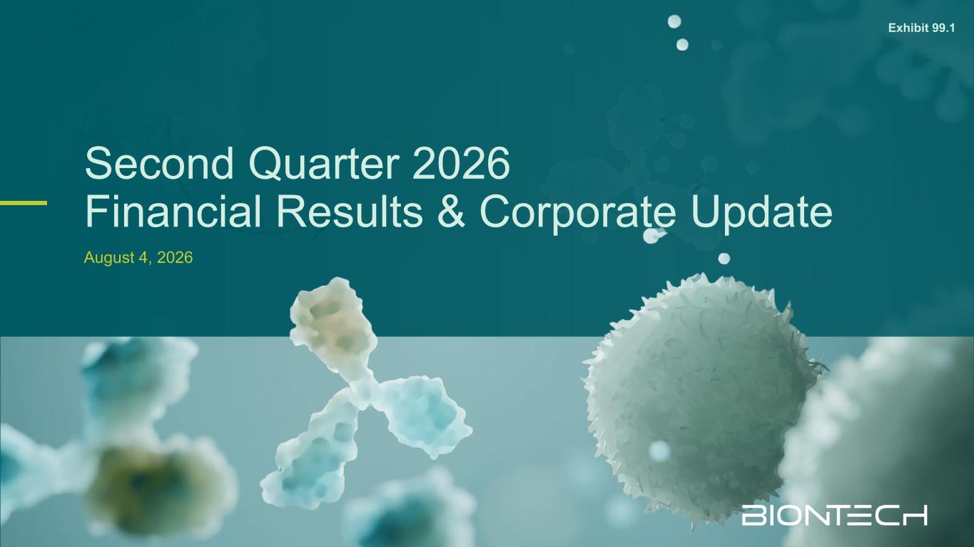
16

Second Quarter 2026 Financial Results & Corporate Update August 4, 2026 Exhibit 99.1

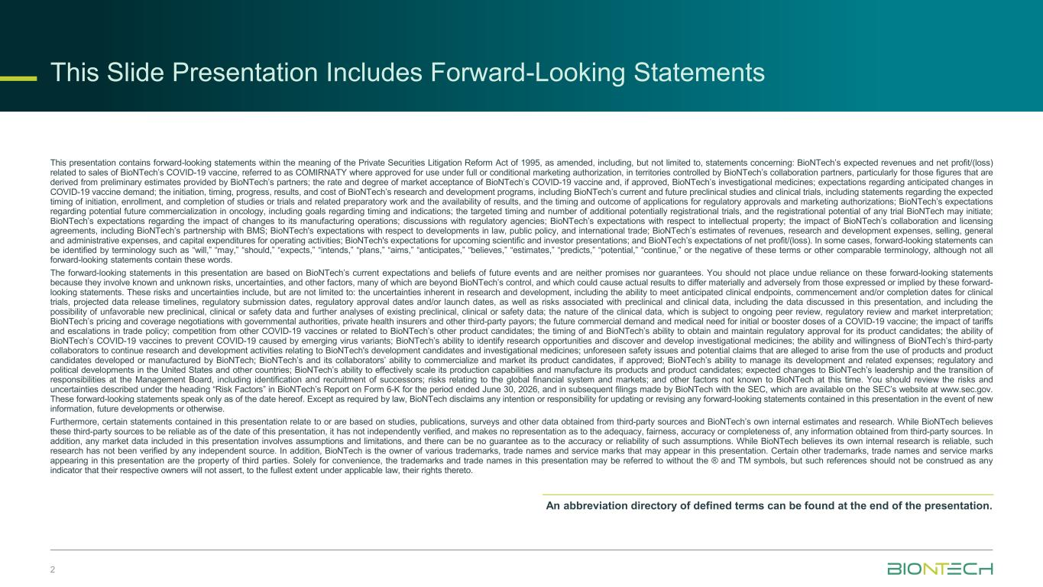
This presentation contains forward-looking statements within the meaning of the Private Securities Litigation Reform Act of 1995, as amended, including, but not limited to, statements concerning: BioNTech’s expected revenues and net profit/(loss) related to sales of BioNTech’s COVID-19 vaccine, referred to as COMIRNATY where approved for use under full or conditional marketing authorization, in territories controlled by BioNTech’s collaboration partners, particularly for those figures that are derived from preliminary estimates provided by BioNTech’s partners; the rate and degree of market acceptance of BioNTech’s COVID-19 vaccine and, if approved, BioNTech’s investigational medicines; expectations regarding anticipated changes in COVID-19 vaccine demand; the initiation, timing, progress, results, and cost of BioNTech’s research and development programs, including BioNTech’s current and future preclinical studies and clinical trials, including statements regarding the expected timing of initiation, enrollment, and completion of studies or trials and related preparatory work and the availability of results, and the timing and outcome of applications for regulatory approvals and marketing authorizations; BioNTech’s expectations regarding potential future commercialization in oncology, including goals regarding timing and indications; the targeted timing and number of additional potentially registrational trials, and the registrational potential of any trial BioNTech may initiate; BioNTech’s expectations regarding the impact of changes to its manufacturing operations; discussions with regulatory agencies; BioNTech’s expectations with respect to intellectual property; the impact of BioNTech’s collaboration and licensing agreements, including BioNTech’s partnership with BMS; BioNTech's expectations with respect to developments in law, public policy, and international trade; BioNTech’s estimates of revenues, research and development expenses, selling, general and administrative expenses, and capital expenditures for operating activities; BioNTech's expectations for upcoming scientific and investor presentations; and BioNTech’s expectations of net profit/(loss). In some cases, forward-looking statements can be identified by terminology such as “will,” “may,” “should,” “expects,” “intends,” “plans,” “aims,” “anticipates,” “believes,” “estimates,” “predicts,” “potential,” “continue,” or the negative of these terms or other comparable terminology, although not all forward-looking statements contain these words. The forward-looking statements in this presentation are based on BioNTech’s current expectations and beliefs of future events and are neither promises nor guarantees. You should not place undue reliance on these forward-looking statements because they involve known and unknown risks, uncertainties, and other factors, many of which are beyond BioNTech’s control, and which could cause actual results to differ materially and adversely from those expressed or implied by these forward- looking statements. These risks and uncertainties include, but are not limited to: the uncertainties inherent in research and development, including the ability to meet anticipated clinical endpoints, commencement and/or completion dates for clinical trials, projected data release timelines, regulatory submission dates, regulatory approval dates and/or launch dates, as well as risks associated with preclinical and clinical data, including the data discussed in this presentation, and including the possibility of unfavorable new preclinical, clinical or safety data and further analyses of existing preclinical, clinical or safety data; the nature of the clinical data, which is subject to ongoing peer review, regulatory review and market interpretation; BioNTech’s pricing and coverage negotiations with governmental authorities, private health insurers and other third-party payors; the future commercial demand and medical need for initial or booster doses of a COVID-19 vaccine; the impact of tariffs and escalations in trade policy; competition from other COVID-19 vaccines or related to BioNTech’s other product candidates; the timing of and BioNTech’s ability to obtain and maintain regulatory approval for its product candidates; the ability of BioNTech’s COVID-19 vaccines to prevent COVID-19 caused by emerging virus variants; BioNTech’s ability to identify research opportunities and discover and develop investigational medicines; the ability and willingness of BioNTech’s third-party collaborators to continue research and development activities relating to BioNTech's development candidates and investigational medicines; unforeseen safety issues and potential claims that are alleged to arise from the use of products and product candidates developed or manufactured by BioNTech; BioNTech’s and its collaborators’ ability to commercialize and market its product candidates, if approved; BioNTech’s ability to manage its development and related expenses; regulatory and political developments in the United States and other countries; BioNTech’s ability to effectively scale its production capabilities and manufacture its products and product candidates; expected changes to BioNTech’s leadership and the transition of responsibilities at the Management Board, including identification and recruitment of successors; risks relating to the global financial system and markets; and other factors not known to BioNTech at this time. You should review the risks and uncertainties described under the heading “Risk Factors” in BioNTech’s Report on Form 6-K for the period ended June 30, 2026, and in subsequent filings made by BioNTech with the SEC, which are available on the SEC’s website at www.sec.gov. These forward-looking statements speak only as of the date hereof. Except as required by law, BioNTech disclaims any intention or responsibility for updating or revising any forward-looking statements contained in this presentation in the event of new information, future developments or otherwise. Furthermore, certain statements contained in this presentation relate to or are based on studies, publications, surveys and other data obtained from third-party sources and BioNTech’s own internal estimates and research. While BioNTech believes these third-party sources to be reliable as of the date of this presentation, it has not independently verified, and makes no representation as to the adequacy, fairness, accuracy or completeness of, any information obtained from third-party sources. In addition, any market data included in this presentation involves assumptions and limitations, and there can be no guarantee as to the accuracy or reliability of such assumptions. While BioNTech believes its own internal research is reliable, such research has not been verified by any independent source. In addition, BioNTech is the owner of various trademarks, trade names and service marks that may appear in this presentation. Certain other trademarks, trade names and service marks appearing in this presentation are the property of third parties. Solely for convenience, the trademarks and trade names in this presentation may be referred to without the ® and TM symbols, but such references should not be construed as any indicator that their respective owners will not assert, to the fullest extent under applicable law, their rights thereto. 2 An abbreviation directory of defined terms can be found at the end of the presentation. To be updated by Legal This Slide Presentation Includes Forward-Looking Statements


CEO Appointment Helmut Jeggle, Supervisory Board Chairman1 2 Progress Highlights Prof. Uğur Şahin, M.D., Co-Founder & Chief Executive Officer 3 Oncology Execution Prof. Özlem Türeci, M.D., Co-Founder & Chief Medical Officer 4 Financial Performance Ramón Zapata, Chief Financial Officer


4 CEO Appointment Helmut Jeggle, Supervisory Board Chairman 1

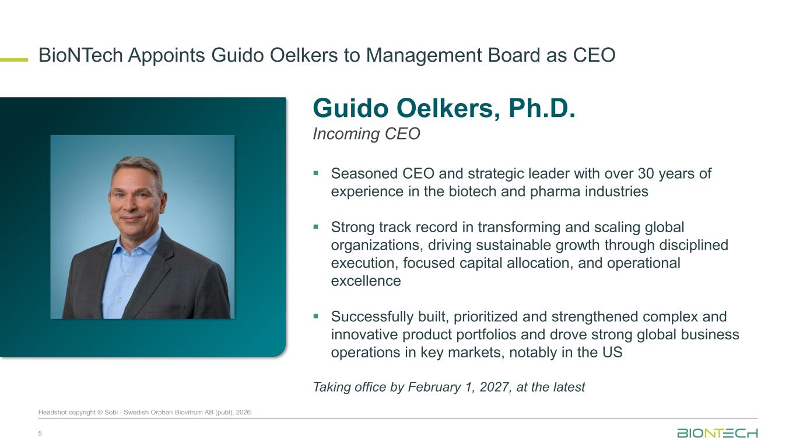
BioNTech Appoints Guido Oelkers to Management Board as CEO 5 Guido Oelkers, Ph.D. Incoming CEO ▪ Seasoned CEO and strategic leader with over 30 years of experience in the biotech and pharma industries ▪ Strong track record in transforming and scaling global organizations, driving sustainable growth through disciplined execution, focused capital allocation, and operational excellence ▪ Successfully built, prioritized and strengthened complex and innovative product portfolios and drove strong global business operations in key markets, notably in the US Taking office by February 1, 2027, at the latest Headshot Headshot copyright © Sobi - Swedish Orphan Biovitrum AB (publ), 2026.


Progress Highlights Prof. Uğur Şahin, M.D., Co-Founder & Chief Executive Officer 2 6

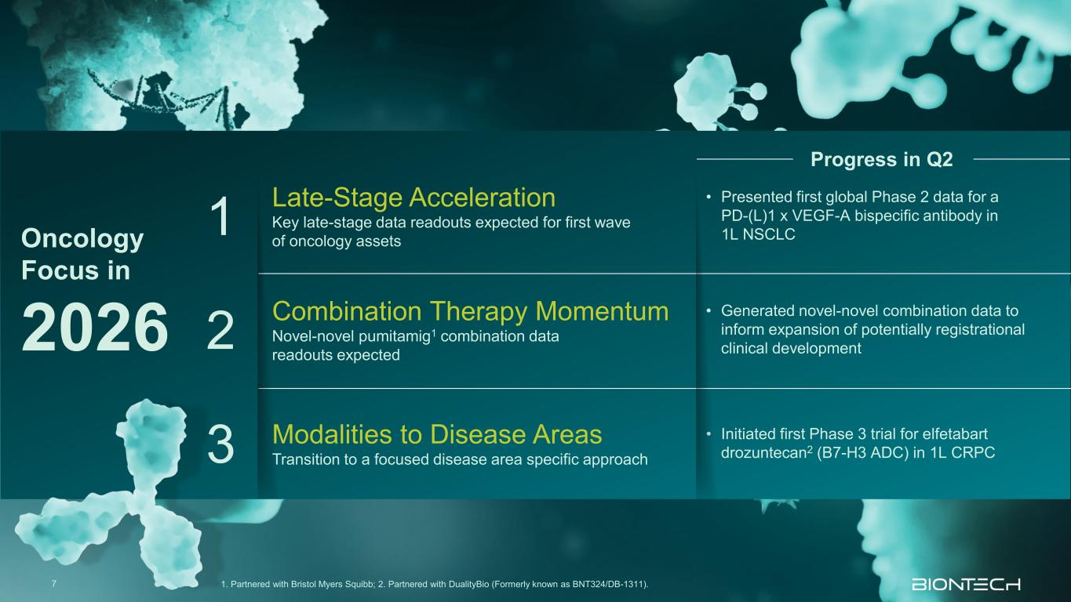
7 1. Partnered with Bristol Myers Squibb; 2. Partnered with DualityBio (Formerly known as BNT324/DB-1311). 1 Late-Stage Acceleration Key late-stage data readouts expected for first wave of oncology assets • Presented first global Phase 2 data for a PD-(L)1 x VEGF-A bispecific antibody in 1L NSCLC 2 Combination Therapy Momentum Novel-novel pumitamig1 combination data readouts expected • Generated novel-novel combination data to inform expansion of potentially registrational clinical development 3 Modalities to Disease Areas Transition to a focused disease area specific approach • Initiated first Phase 3 trial for elfetabart drozuntecan2 (B7-H3 ADC) in 1L CRPC Oncology Focus in 2026 Progress in Q2

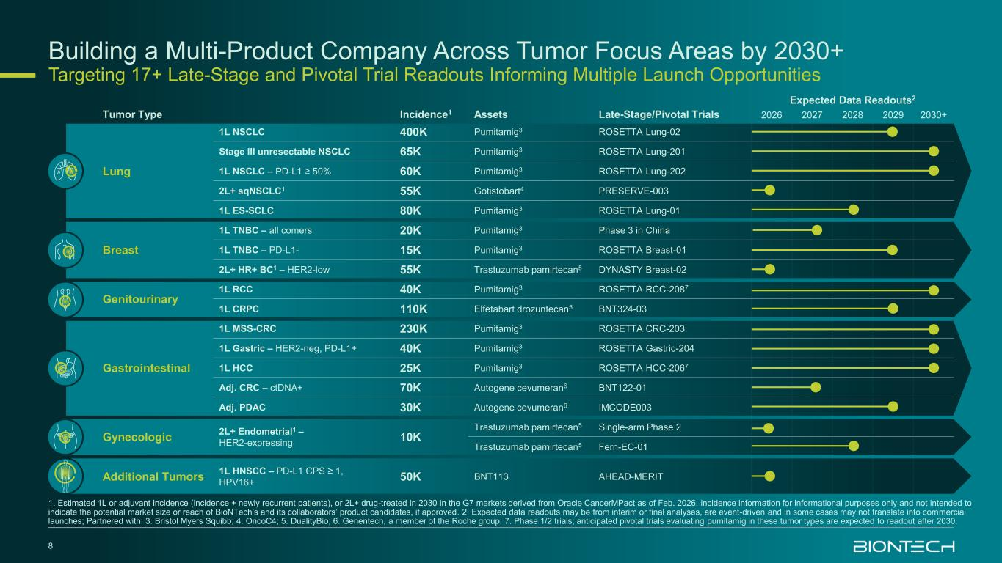
Building a Multi-Product Company Across Tumor Focus Areas by 2030+ Targeting 17+ Late-Stage and Pivotal Trial Readouts Informing Multiple Launch Opportunities 8 Tumor Type Incidence1 Assets Late-Stage/Pivotal Trials Expected Data Readouts2 2026 2027 2028 2029 2030+ Lung 1L NSCLC 400K Pumitamig3 ROSETTA Lung-02 Stage III unresectable NSCLC 65K Pumitamig3 ROSETTA Lung-201 1L NSCLC – PD-L1 ≥ 50% 60K Pumitamig3 ROSETTA Lung-202 2L+ sqNSCLC1 55K Gotistobart4 PRESERVE-003 1L ES-SCLC 80K Pumitamig3 ROSETTA Lung-01 Breast 1L TNBC – all comers 20K Pumitamig3 Phase 3 in China 1L TNBC – PD-L1- 15K Pumitamig3 ROSETTA Breast-01 2L+ HR+ BC1 – HER2-low 55K Trastuzumab pamirtecan5 DYNASTY Breast-02 Genitourinary 1L RCC 40K Pumitamig3 ROSETTA RCC-2087 1L CRPC 110K Elfetabart drozuntecan5 BNT324-03 Gastrointestinal 1L MSS-CRC 230K Pumitamig3 ROSETTA CRC-203 1L Gastric – HER2-neg, PD-L1+ 40K Pumitamig3 ROSETTA Gastric-204 1L HCC 25K Pumitamig3 ROSETTA HCC-2067 Adj. CRC – ctDNA+ 70K Autogene cevumeran6 BNT122-01 Adj. PDAC 30K Autogene cevumeran6 IMCODE003 Gynecologic 2L+ Endometrial1 – HER2-expressing 10K Trastuzumab pamirtecan5 Single-arm Phase 2 Trastuzumab pamirtecan5 Fern-EC-01 Additional Tumors 1L HNSCC – PD-L1 CPS ≥ 1, HPV16+ 50K BNT113 AHEAD-MERIT 1. Estimated 1L or adjuvant incidence (incidence + newly recurrent patients), or 2L+ drug-treated in 2030 in the G7 markets derived from Oracle CancerMPact as of Feb. 2026; incidence information for informational purposes only and not intended to indicate the potential market size or reach of BioNTech’s and its collaborators’ product candidates, if approved. 2. Expected data readouts may be from interim or final analyses, are event-driven and in some cases may not translate into commercial launches; Partnered with: 3. Bristol Myers Squibb; 4. OncoC4; 5. DualityBio; 6. Genentech, a member of the Roche group; 7. Phase 1/2 trials; anticipated pivotal trials evaluating pumitamig in these tumor types are expected to readout after 2030.


Oncology Execution Prof. Özlem Türeci, M.D., Co-Founder & Chief Medical Officer 3 9

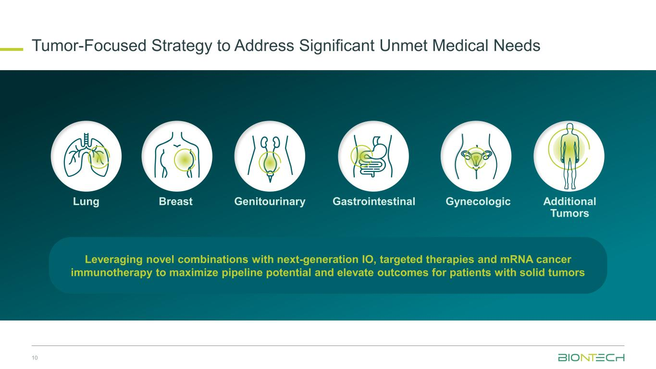
Tumor-Focused Strategy to Address Significant Unmet Medical Needs 10 GastrointestinalBreastLung Genitourinary Gynecologic Additional Tumors Leveraging novel combinations with next-generation IO, targeted therapies and mRNA cancer immunotherapy to maximize pipeline potential and elevate outcomes for patients with solid tumors

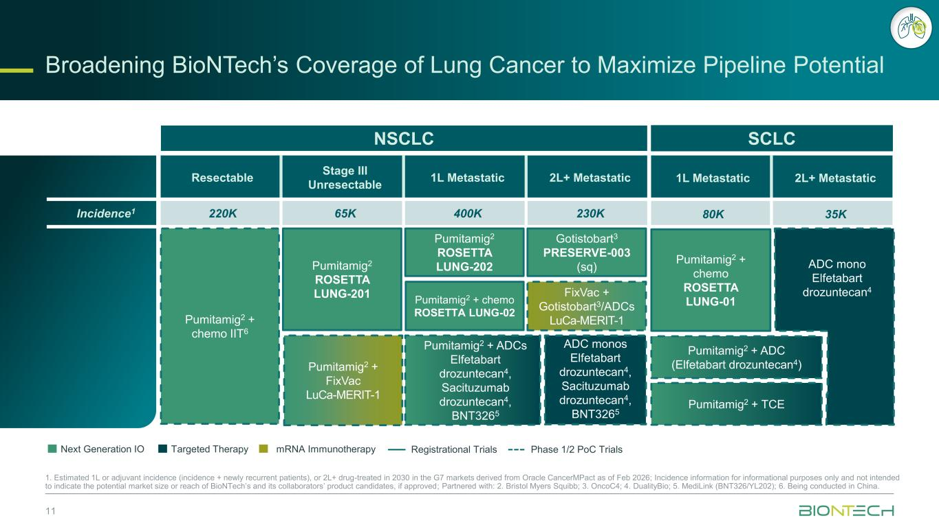
1L Metastatic 2L+ Metastatic 80K 35K Resectable Stage III Unresectable 1L Metastatic 2L+ Metastatic Incidence1 220K 65K 400K 230K Broadening BioNTech’s Coverage of Lung Cancer to Maximize Pipeline Potential 11 1. Estimated 1L or adjuvant incidence (incidence + newly recurrent patients), or 2L+ drug-treated in 2030 in the G7 markets derived from Oracle CancerMPact as of Feb 2026; Incidence information for informational purposes only and not intended to indicate the potential market size or reach of BioNTech’s and its collaborators’ product candidates, if approved; Partnered with: 2. Bristol Myers Squibb; 3. OncoC4; 4. DualityBio; 5. MediLink (BNT326/YL202); 6. Being conducted in China. Next Generation IO Targeted Therapy mRNA Immunotherapy Registrational Trials Phase 1/2 PoC Trials NSCLC SCLC Gotistobart3 PRESERVE-003 (sq) FixVac + Gotistobart3/ADCs LuCa-MERIT-1Pumitamig2 + chemo IIT6 Pumitamig2 + chemo ROSETTA LUNG-02 ADC monos Elfetabart drozuntecan4, Sacituzumab drozuntecan4, BNT3265 Pumitamig2 + ADCs Elfetabart drozuntecan4, Sacituzumab drozuntecan4, BNT3265 Pumitamig2 ROSETTA LUNG-201 Pumitamig2 + FixVac LuCa-MERIT-1 Pumitamig2 ROSETTA LUNG-202 Pumitamig2 + chemo ROSETTA LUNG-01 ADC mono Elfetabart drozuntecan4 Pumitamig2 + ADC (Elfetabart drozuntecan4) Pumitamig2 + TCE

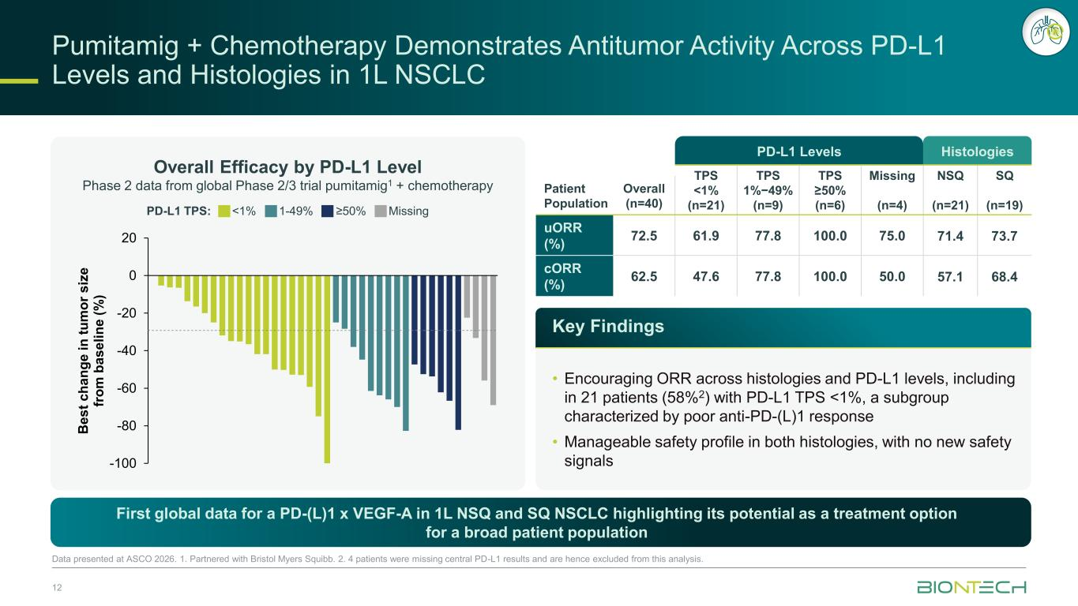
Pumitamig + Chemotherapy Demonstrates Antitumor Activity Across PD-L1 Levels and Histologies in 1L NSCLC 12 Data presented at ASCO 2026. 1. Partnered with Bristol Myers Squibb. 2. 4 patients were missing central PD-L1 results and are hence excluded from this analysis. First global data for a PD-(L)1 x VEGF-A in 1L NSQ and SQ NSCLC highlighting its potential as a treatment option for a broad patient population Overall Efficacy by PD-L1 Level Phase 2 data from global Phase 2/3 trial pumitamig1 + chemotherapy PD-L1 TPS: <1% 1-49% ≥50% Missing -100 -80 -60 -40 -20 0 20 B e s t c h a n g e i n t u m o r s iz e fr o m b a s e li n e ( % ) PD-L1 Levels Histologies TPS <1% (n=21) TPS 1%−49% (n=9) TPS ≥50% (n=6) Missing (n=4) NSQ (n=21) SQ (n=19) Patient Population Overall (n=40) uORR (%) 72.5 61.9 77.8 100.0 75.0 71.4 73.7 cORR (%) 62.5 47.6 77.8 100.0 50.0 57.1 68.4 Key Findings • Encouraging ORR across histologies and PD-L1 levels, including in 21 patients (58%2) with PD-L1 TPS <1%, a subgroup characterized by poor anti-PD-(L)1 response • Manageable safety profile in both histologies, with no new safety signals

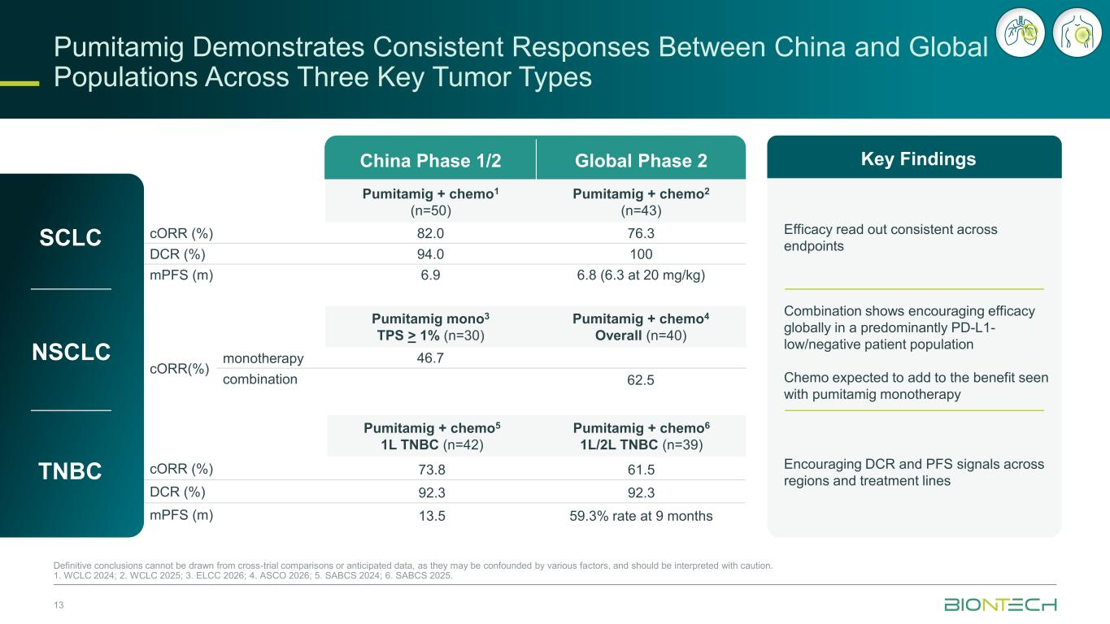
Pumitamig mono3 TPS > 1% (n=30) Pumitamig + chemo4 Overall (n=40) cORR(%) monotherapy 46.7 combination 62.5 Pumitamig + chemo5 1L TNBC (n=42) Pumitamig + chemo6 1L/2L TNBC (n=39) cORR (%) 73.8 61.5 DCR (%) 92.3 92.3 mPFS (m) 13.5 59.3% rate at 9 months Pumitamig Demonstrates Consistent Responses Between China and Global Populations Across Three Key Tumor Types 13 Definitive conclusions cannot be drawn from cross-trial comparisons or anticipated data, as they may be confounded by various factors, and should be interpreted with caution. 1. WCLC 2024; 2. WCLC 2025; 3. ELCC 2026; 4. ASCO 2026; 5. SABCS 2024; 6. SABCS 2025. SCLC NSCLC TNBC China Phase 1/2 Global Phase 2 Pumitamig + chemo1 (n=50) Pumitamig + chemo2 (n=43) cORR (%) 82.0 76.3 DCR (%) 94.0 100 mPFS (m) 6.9 6.8 (6.3 at 20 mg/kg) Key Findings Efficacy read out consistent across endpoints Combination shows encouraging efficacy globally in a predominantly PD-L1- low/negative patient population Chemo expected to add to the benefit seen with pumitamig monotherapy Encouraging DCR and PFS signals across regions and treatment lines

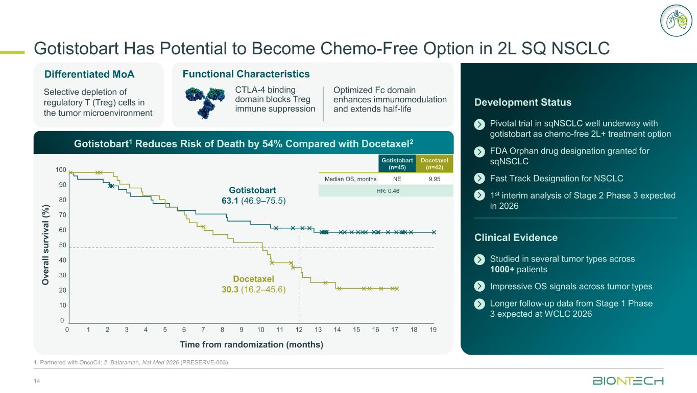
Differentiated MoA Functional Characteristics Gotistobart Has Potential to Become Chemo-Free Option in 2L SQ NSCLC 14 1. Partnered with OncoC4; 2. Balaraman, Nat Med 2026 (PRESERVE-003). Studied in several tumor types across 1000+ patients Impressive OS signals across tumor types Longer follow-up data from Stage 1 Phase 3 expected at WCLC 2026 Pivotal trial in sqNSCLC well underway with gotistobart as chemo-free 2L+ treatment option FDA Orphan drug designation granted for sqNSCLC Fast Track Designation for NSCLC 1st interim analysis of Stage 2 Phase 3 expected in 2026 Development Status Clinical Evidence Gotistobart1 Reduces Risk of Death by 54% Compared with Docetaxel2 Selective depletion of regulatory T (Treg) cells in the tumor microenvironment CTLA-4 binding domain blocks Treg immune suppression Optimized Fc domain enhances immunomodulation and extends half-life Time from randomization (months) Docetaxel 30.3 (16.2–45.6) Gotistobart 63.1 (46.9–75.5) 0 10 20 30 40 50 60 70 80 90 100 0 1 2 3 4 5 6 7 8 9 10 11 12 13 14 15 16 17 18 19 O v e ra ll s u rv iv a l (% ) Gotistobart (n=45) Docetaxel (n=42) Median OS, months NE 9.95 HR: 0.46

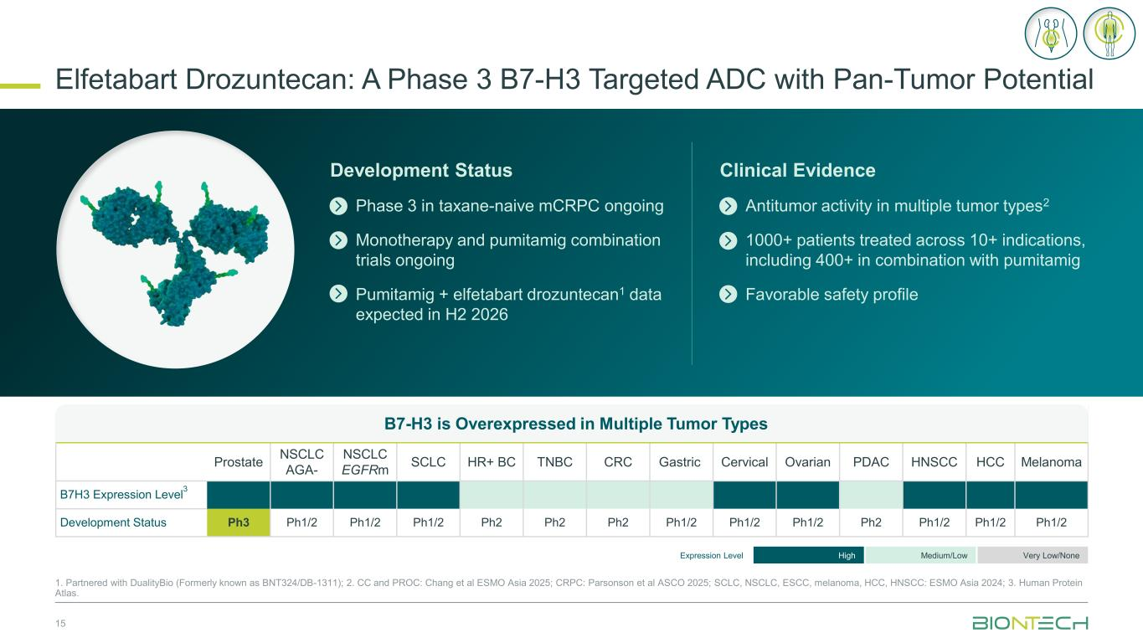
B7-H3 is Overexpressed in Multiple Tumor Types Prostate NSCLC AGA- NSCLC EGFRm SCLC HR+ BC TNBC CRC Gastric Cervical Ovarian PDAC HNSCC HCC Melanoma B7H3 Expression Level 3 Development Status Ph3 Ph1/2 Ph1/2 Ph1/2 Ph2 Ph2 Ph2 Ph1/2 Ph1/2 Ph1/2 Ph2 Ph1/2 Ph1/2 Ph1/2 Elfetabart Drozuntecan: A Phase 3 B7-H3 Targeted ADC with Pan-Tumor Potential 15 1. Partnered with DualityBio (Formerly known as BNT324/DB-1311); 2. CC and PROC: Chang et al ESMO Asia 2025; CRPC: Parsonson et al ASCO 2025; SCLC, NSCLC, ESCC, melanoma, HCC, HNSCC: ESMO Asia 2024; 3. Human Protein Atlas. Expression Level High Medium/Low Very Low/None Development Status Phase 3 in taxane-naive mCRPC ongoing Monotherapy and pumitamig combination trials ongoing Pumitamig + elfetabart drozuntecan1 data expected in H2 2026 Clinical Evidence Antitumor activity in multiple tumor types2 1000+ patients treated across 10+ indications, including 400+ in combination with pumitamig Favorable safety profile

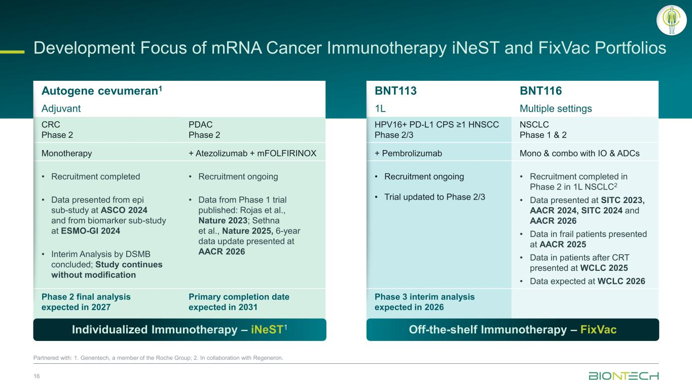
Development Focus of mRNA Cancer Immunotherapy iNeST and FixVac Portfolios 16 Partnered with: 1. Genentech, a member of the Roche Group; 2. In collaboration with Regeneron. Autogene cevumeran1 BNT113 BNT116 Adjuvant 1L Multiple settings CRC Phase 2 PDAC Phase 2 HPV16+ PD-L1 CPS ≥1 HNSCC Phase 2/3 NSCLC Phase 1 & 2 Monotherapy + Atezolizumab + mFOLFIRINOX + Pembrolizumab Mono & combo with IO & ADCs • Recruitment completed • Data presented from epi sub-study at ASCO 2024 and from biomarker sub-study at ESMO-GI 2024 • Interim Analysis by DSMB concluded; Study continues without modification • Recruitment ongoing • Data from Phase 1 trial published: Rojas et al., Nature 2023; Sethna et al., Nature 2025, 6-year data update presented at AACR 2026 • Recruitment ongoing • Trial updated to Phase 2/3 • Recruitment completed in Phase 2 in 1L NSCLC2 • Data presented at SITC 2023, AACR 2024, SITC 2024 and AACR 2026 • Data in frail patients presented at AACR 2025 • Data in patients after CRT presented at WCLC 2025 • Data expected at WCLC 2026 Phase 2 final analysis expected in 2027 Primary completion date expected in 2031 Phase 3 interim analysis expected in 2026 Individualized Immunotherapy – iNeST1 Off-the-shelf Immunotherapy – FixVac

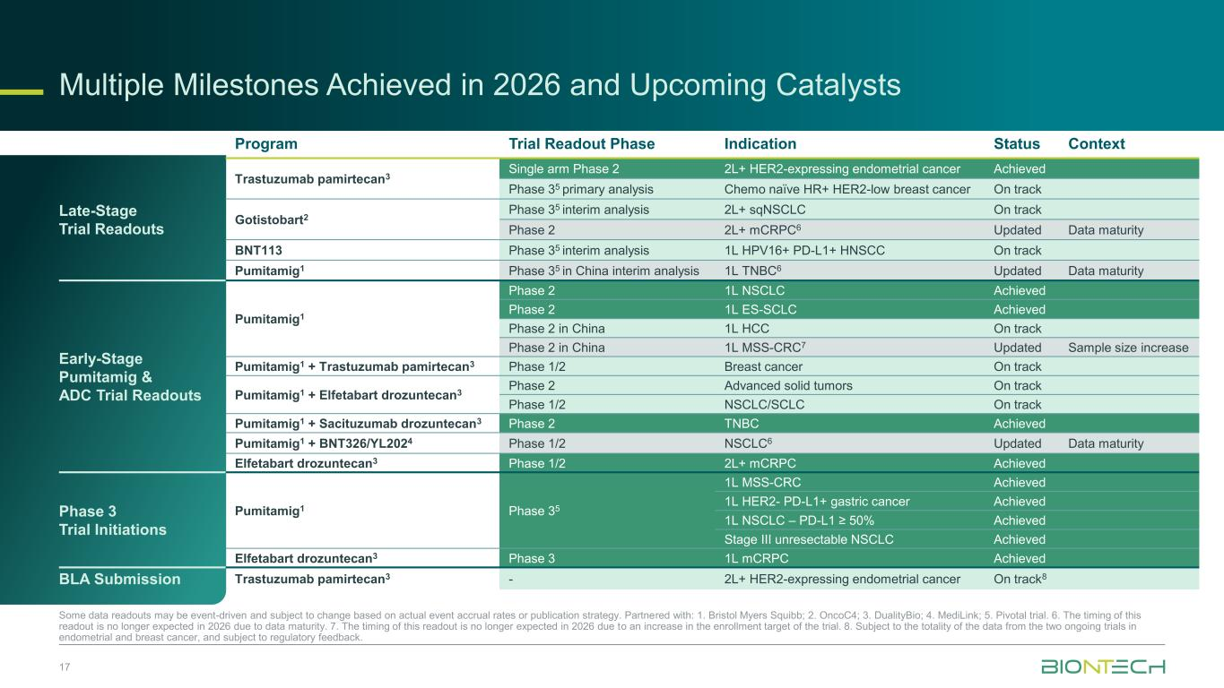
Multiple Milestones Achieved in 2026 and Upcoming Catalysts 17 Some data readouts may be event-driven and subject to change based on actual event accrual rates or publication strategy. Partnered with: 1. Bristol Myers Squibb; 2. OncoC4; 3. DualityBio; 4. MediLink; 5. Pivotal trial. 6. The timing of this readout is no longer expected in 2026 due to data maturity. 7. The timing of this readout is no longer expected in 2026 due to an increase in the enrollment target of the trial. 8. Subject to the totality of the data from the two ongoing trials in endometrial and breast cancer, and subject to regulatory feedback. Program Trial Readout Phase Indication Status Context Late-Stage Trial Readouts Trastuzumab pamirtecan3 Single arm Phase 2 2L+ HER2-expressing endometrial cancer Achieved Phase 35 primary analysis Chemo naïve HR+ HER2-low breast cancer On track Gotistobart2 Phase 35 interim analysis 2L+ sqNSCLC On track Phase 2 2L+ mCRPC6 Updated Data maturity BNT113 Phase 35 interim analysis 1L HPV16+ PD-L1+ HNSCC On track Pumitamig1 Phase 35 in China interim analysis 1L TNBC6 Updated Data maturity Early-Stage Pumitamig & ADC Trial Readouts Pumitamig1 Phase 2 1L NSCLC Achieved Phase 2 1L ES-SCLC Achieved Phase 2 in China 1L HCC On track Phase 2 in China 1L MSS-CRC7 Updated Sample size increase Pumitamig1 + Trastuzumab pamirtecan3 Phase 1/2 Breast cancer On track Pumitamig1 + Elfetabart drozuntecan3 Phase 2 Advanced solid tumors On track Phase 1/2 NSCLC/SCLC On track Pumitamig1 + Sacituzumab drozuntecan3 Phase 2 TNBC Achieved Pumitamig1 + BNT326/YL2024 Phase 1/2 NSCLC6 Updated Data maturity Elfetabart drozuntecan3 Phase 1/2 2L+ mCRPC Achieved Phase 3 Trial Initiations Pumitamig1 Phase 35 1L MSS-CRC Achieved 1L HER2- PD-L1+ gastric cancer Achieved 1L NSCLC – PD-L1 ≥ 50% Achieved Stage III unresectable NSCLC Achieved Elfetabart drozuntecan3 Phase 3 1L mCRPC Achieved BLA Submission Trastuzumab pamirtecan3 - 2L+ HER2-expressing endometrial cancer On track8

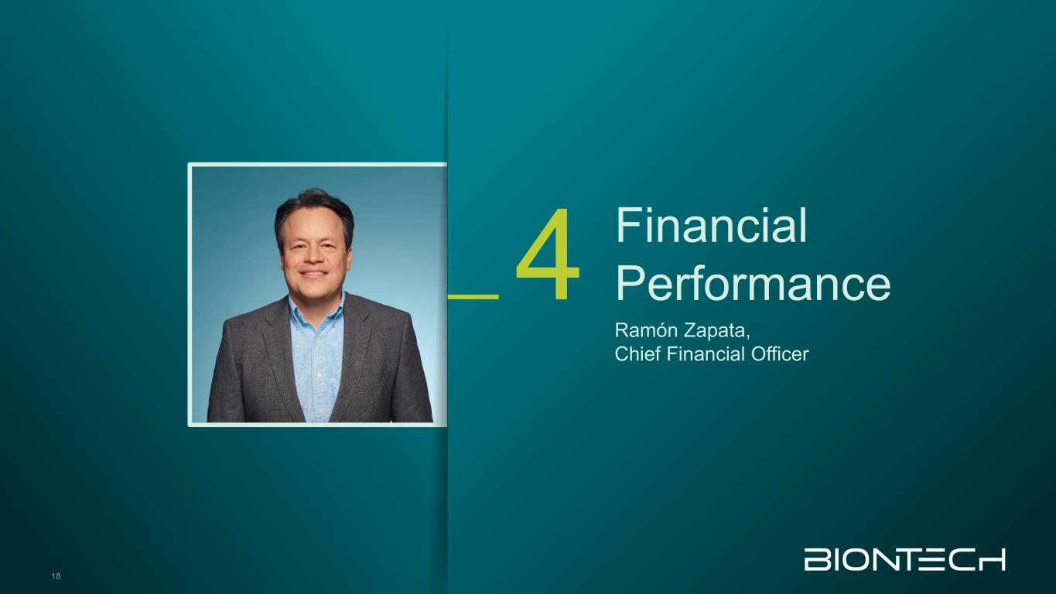
Financial Performance Ramón Zapata, Chief Financial Officer 4 18

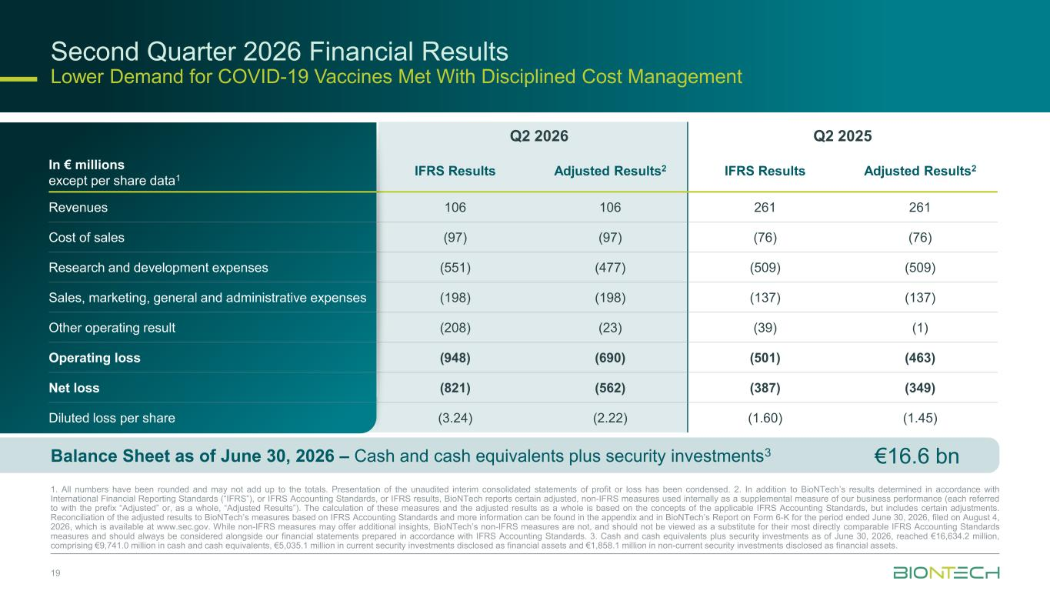
Second Quarter 2026 Financial Results Lower Demand for COVID-19 Vaccines Met With Disciplined Cost Management 19 1. All numbers have been rounded and may not add up to the totals. Presentation of the unaudited interim consolidated statements of profit or loss has been condensed. 2. In addition to BioNTech’s results determined in accordance with International Financial Reporting Standards (“IFRS”), or IFRS Accounting Standards, or IFRS results, BioNTech reports certain adjusted, non-IFRS measures used internally as a supplemental measure of our business performance (each referred to with the prefix “Adjusted” or, as a whole, “Adjusted Results”). The calculation of these measures and the adjusted results as a whole is based on the concepts of the applicable IFRS Accounting Standards, but includes certain adjustments. Reconciliation of the adjusted results to BioNTech’s measures based on IFRS Accounting Standards and more information can be found in the appendix and in BioNTech’s Report on Form 6-K for the period ended June 30, 2026, filed on August 4, 2026, which is available at www.sec.gov. While non-IFRS measures may offer additional insights, BioNTech’s non-IFRS measures are not, and should not be viewed as a substitute for their most directly comparable IFRS Accounting Standards measures and should always be considered alongside our financial statements prepared in accordance with IFRS Accounting Standards. 3. Cash and cash equivalents plus security investments as of June 30, 2026, reached €16,634.2 million, comprising €9,741.0 million in cash and cash equivalents, €5,035.1 million in current security investments disclosed as financial assets and €1,858.1 million in non-current security investments disclosed as financial assets. In € millions except per share data1 Q2 2026 Q2 2025 IFRS Results Adjusted Results2 IFRS Results Adjusted Results2 Revenues 106 106 261 261 Cost of sales (97) (97) (76) (76) Research and development expenses (551) (477) (509) (509) Sales, marketing, general and administrative expenses (198) (198) (137) (137) Other operating result (208) (23) (39) (1) Operating loss (948) (690) (501) (463) Net loss (821) (562) (387) (349) Diluted loss per share (3.24) (2.22) (1.60) (1.45) €16.6 bnBalance Sheet as of June 30, 2026 – Cash and cash equivalents plus security investments3

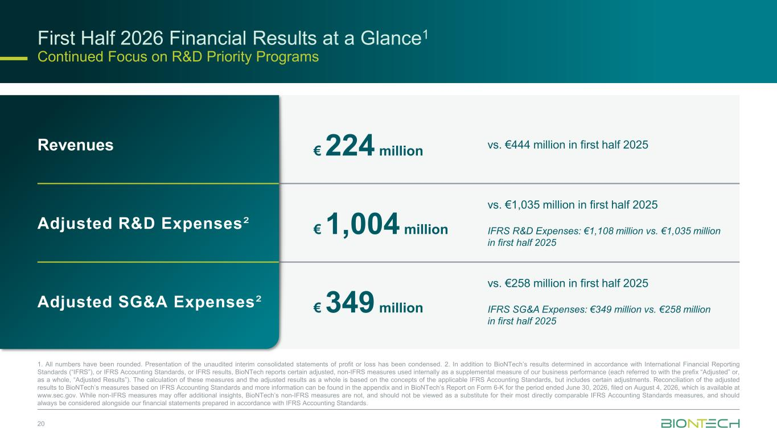
20 First Half 2026 Financial Results at a Glance1 Continued Focus on R&D Priority Programs Revenues € 224 million vs. €444 million in first half 2025 Adjusted R&D Expenses² € 1,004 million vs. €1,035 million in first half 2025 IFRS R&D Expenses: €1,108 million vs. €1,035 million in first half 2025 Adjusted SG&A Expenses² € 349 million vs. €258 million in first half 2025 IFRS SG&A Expenses: €349 million vs. €258 million in first half 2025 1. All numbers have been rounded. Presentation of the unaudited interim consolidated statements of profit or loss has been condensed. 2. In addition to BioNTech’s results determined in accordance with International Financial Reporting Standards (“IFRS”), or IFRS Accounting Standards, or IFRS results, BioNTech reports certain adjusted, non-IFRS measures used internally as a supplemental measure of our business performance (each referred to with the prefix “Adjusted” or, as a whole, “Adjusted Results”). The calculation of these measures and the adjusted results as a whole is based on the concepts of the applicable IFRS Accounting Standards, but includes certain adjustments. Reconciliation of the adjusted results to BioNTech’s measures based on IFRS Accounting Standards and more information can be found in the appendix and in BioNTech’s Report on Form 6-K for the period ended June 30, 2026, filed on August 4, 2026, which is available at www.sec.gov. While non-IFRS measures may offer additional insights, BioNTech’s non-IFRS measures are not, and should not be viewed as a substitute for their most directly comparable IFRS Accounting Standards measures, and should always be considered alongside our financial statements prepared in accordance with IFRS Accounting Standards.

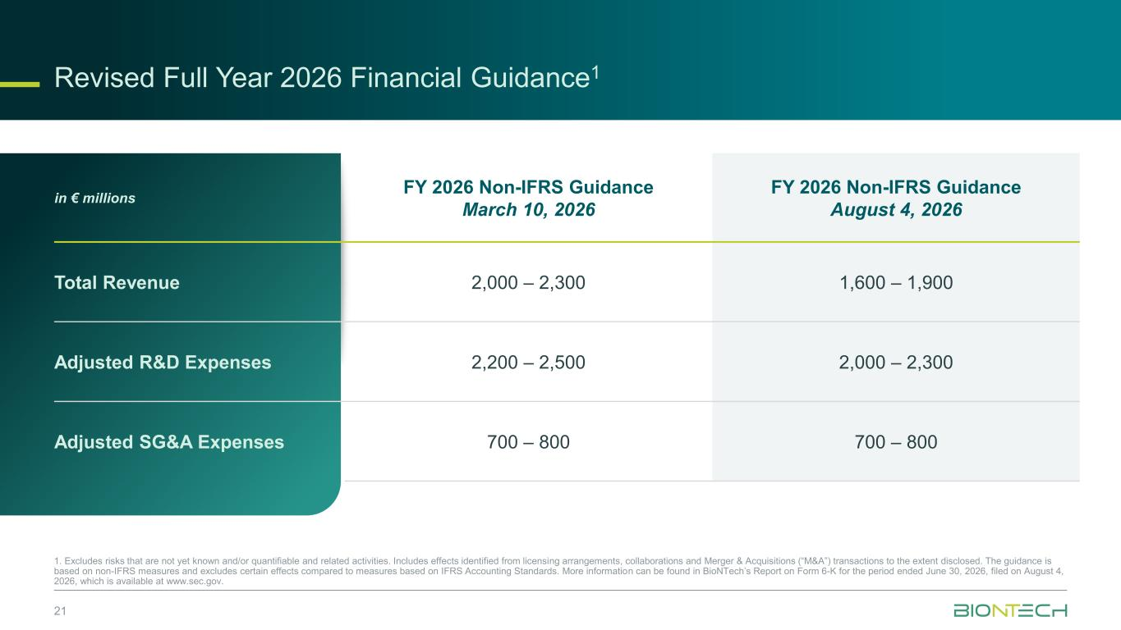
Revised Full Year 2026 Financial Guidance1 21 1. Excludes risks that are not yet known and/or quantifiable and related activities. Includes effects identified from licensing arrangements, collaborations and Merger & Acquisitions (“M&A”) transactions to the extent disclosed. The guidance is based on non-IFRS measures and excludes certain effects compared to measures based on IFRS Accounting Standards. More information can be found in BioNTech’s Report on Form 6-K for the period ended June 30, 2026, filed on August 4, 2026, which is available at www.sec.gov. in € millions FY 2026 Non-IFRS Guidance March 10, 2026 FY 2026 Non-IFRS Guidance August 4, 2026 Total Revenue 2,000 – 2,300 1,600 – 1,900 Adjusted R&D Expenses 2,200 – 2,500 2,000 – 2,300 Adjusted SG&A Expenses 700 – 800 700 – 800

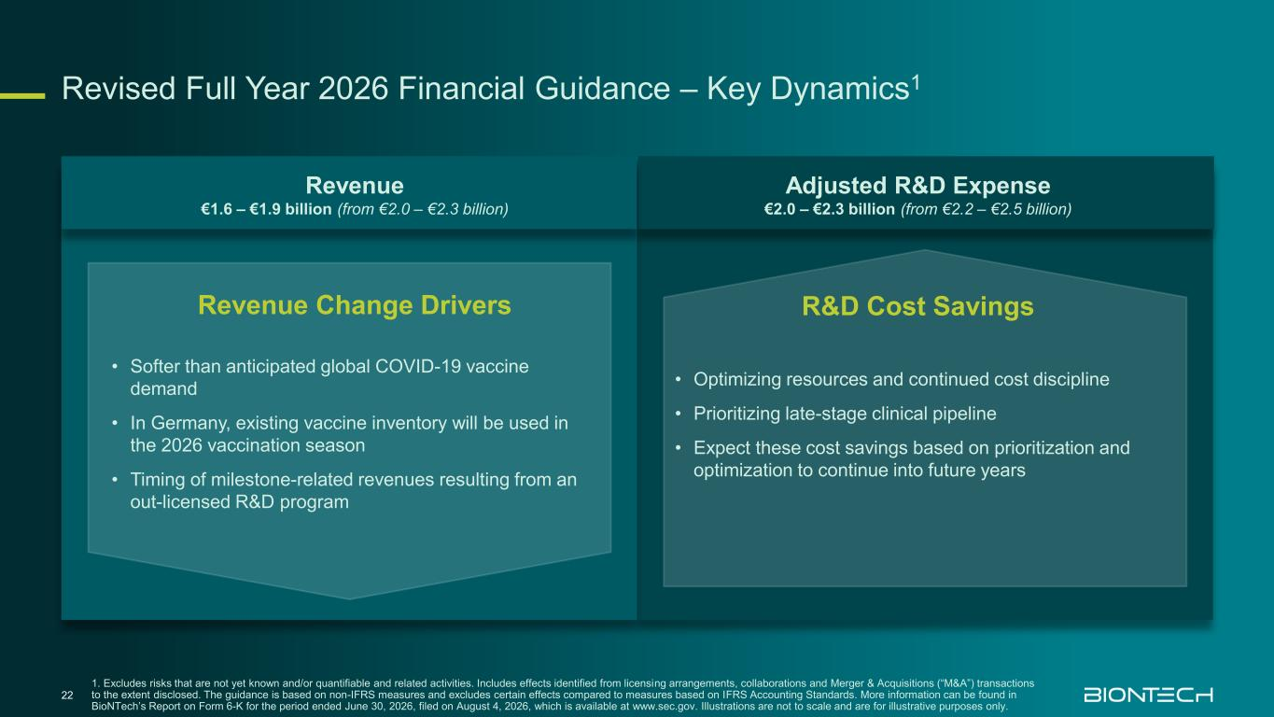
Revised Full Year 2026 Financial Guidance – Key Dynamics1 22 1. Excludes risks that are not yet known and/or quantifiable and related activities. Includes effects identified from licensing arrangements, collaborations and Merger & Acquisitions (“M&A”) transactions to the extent disclosed. The guidance is based on non-IFRS measures and excludes certain effects compared to measures based on IFRS Accounting Standards. More information can be found in BioNTech’s Report on Form 6-K for the period ended June 30, 2026, filed on August 4, 2026, which is available at www.sec.gov. Illustrations are not to scale and are for illustrative purposes only. Revenue €1.6 – €1.9 billion (from €2.0 – €2.3 billion) Adjusted R&D Expense €2.0 – €2.3 billion (from €2.2 – €2.5 billion) Revenue Change Drivers • Softer than anticipated global COVID-19 vaccine demand • In Germany, existing vaccine inventory will be used in the 2026 vaccination season • Timing of milestone-related revenues resulting from an out-licensed R&D program R&D Cost Savings • Optimizing resources and continued cost discipline • Prioritizing late-stage clinical pipeline • Expect these cost savings based on prioritization and optimization to continue into future years

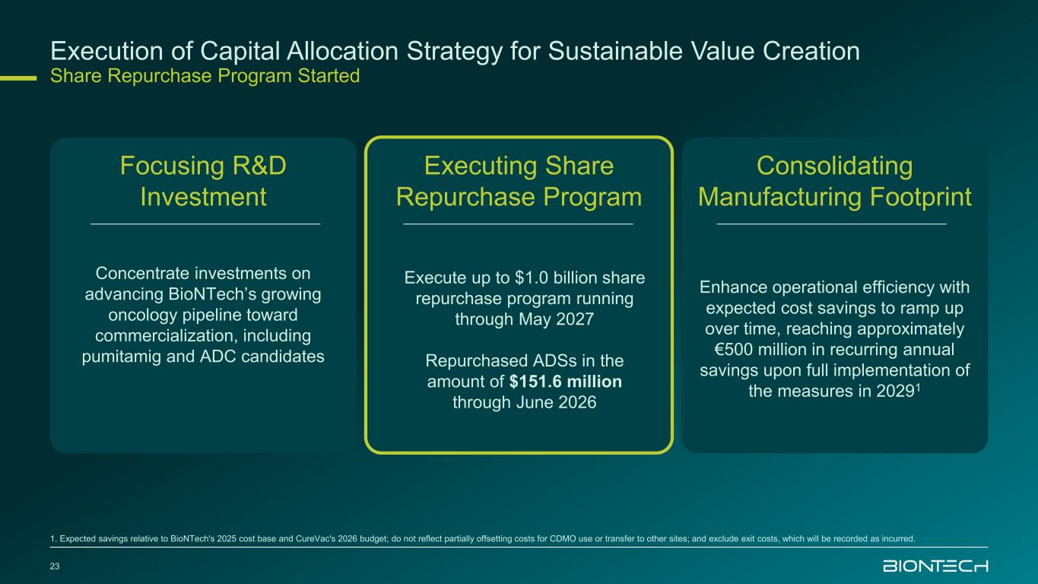
23 Concentrate investments on advancing BioNTech’s growing oncology pipeline toward commercialization, including pumitamig and ADC candidates Focusing R&D Investment Execution of Capital Allocation Strategy for Sustainable Value Creation Share Repurchase Program Started Execute up to $1.0 billion share repurchase program running through May 2027 Repurchased ADSs in the amount of $151.6 million through June 2026 Executing Share Repurchase Program Enhance operational efficiency with expected cost savings to ramp up over time, reaching approximately €500 million in recurring annual savings upon full implementation of the measures in 20291 Consolidating Manufacturing Footprint 1. Expected savings relative to BioNTech's 2025 cost base and CureVac's 2026 budget; do not reflect partially offsetting costs for CDMO use or transfer to other sites; and exclude exit costs, which will be recorded as incurred.


Thank you


Appendix

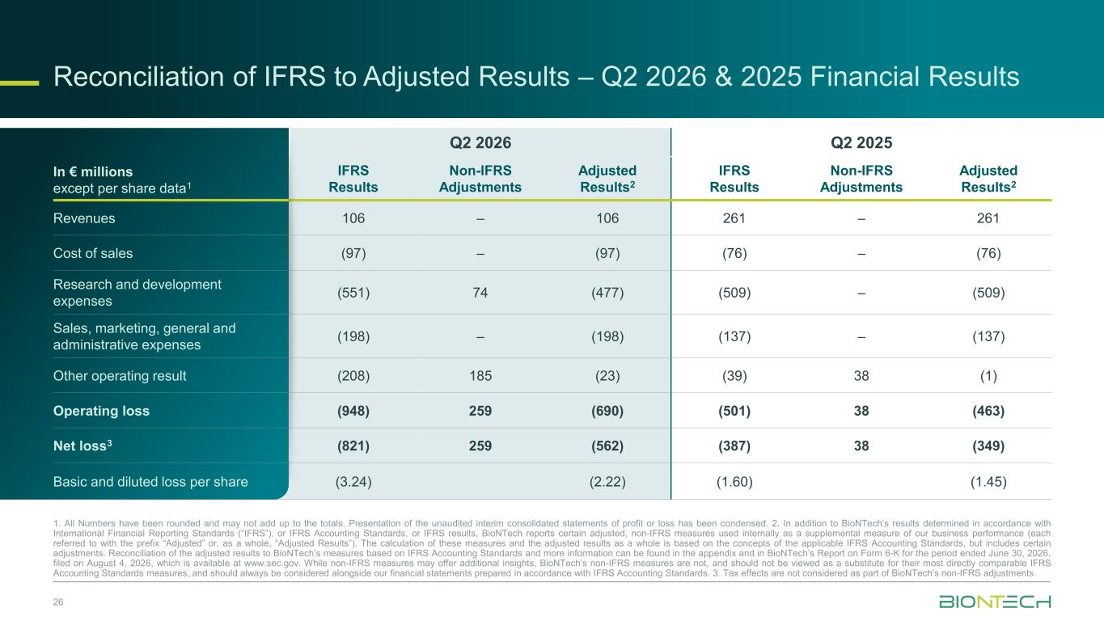
Reconciliation of IFRS to Adjusted Results – Q2 2026 & 2025 Financial Results In € millions except per share data1 Q2 2026 Q2 2025 IFRS Results Non-IFRS Adjustments Adjusted Results2 IFRS Results Non-IFRS Adjustments Adjusted Results2 Revenues 106 – 106 261 – 261 Cost of sales (97) – (97) (76) – (76) Research and development expenses (551) 74 (477) (509) – (509) Sales, marketing, general and administrative expenses (198) – (198) (137) – (137) Other operating result (208) 185 (23) (39) 38 (1) Operating loss (948) 259 (690) (501) 38 (463) Net loss3 (821) 259 (562) (387) 38 (349) Basic and diluted loss per share (3.24) (2.22) (1.60) (1.45) 1. All Numbers have been rounded and may not add up to the totals. Presentation of the unaudited interim consolidated statements of profit or loss has been condensed. 2. In addition to BioNTech’s results determined in accordance with International Financial Reporting Standards (“IFRS”), or IFRS Accounting Standards, or IFRS results, BioNTech reports certain adjusted, non-IFRS measures used internally as a supplemental measure of our business performance (each referred to with the prefix “Adjusted” or, as a whole, “Adjusted Results”). The calculation of these measures and the adjusted results as a whole is based on the concepts of the applicable IFRS Accounting Standards, but includes certain adjustments. Reconciliation of the adjusted results to BioNTech’s measures based on IFRS Accounting Standards and more information can be found in the appendix and in BioNTech’s Report on Form 6-K for the period ended June 30, 2026, filed on August 4, 2026, which is available at www.sec.gov. While non-IFRS measures may offer additional insights, BioNTech’s non-IFRS measures are not, and should not be viewed as a substitute for their most directly comparable IFRS Accounting Standards measures, and should always be considered alongside our financial statements prepared in accordance with IFRS Accounting Standards. 3. Tax effects are not considered as part of BioNTech’s non-IFRS adjustments. 26

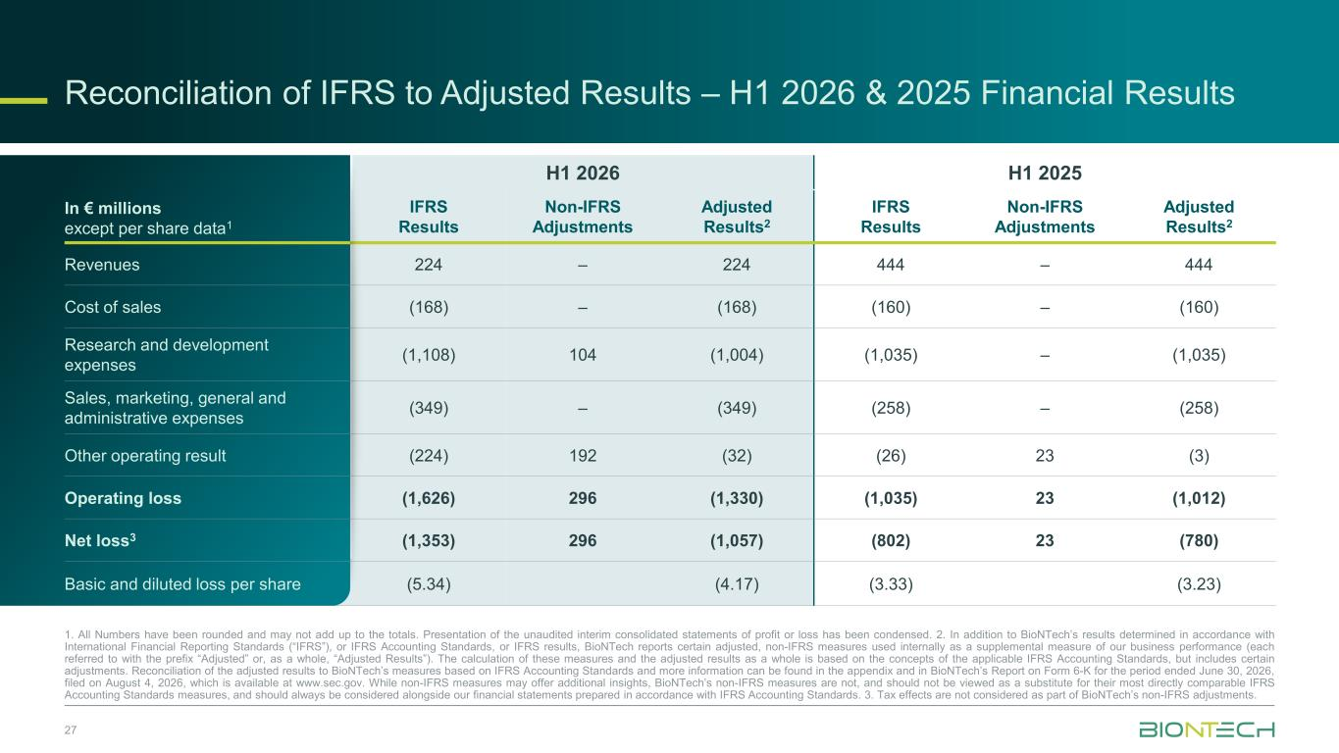
Reconciliation of IFRS to Adjusted Results – H1 2026 & 2025 Financial Results In € millions except per share data1 H1 2026 H1 2025 IFRS Results Non-IFRS Adjustments Adjusted Results2 IFRS Results Non-IFRS Adjustments Adjusted Results2 Revenues 224 – 224 444 – 444 Cost of sales (168) – (168) (160) – (160) Research and development expenses (1,108) 104 (1,004) (1,035) – (1,035) Sales, marketing, general and administrative expenses (349) – (349) (258) – (258) Other operating result (224) 192 (32) (26) 23 (3) Operating loss (1,626) 296 (1,330) (1,035) 23 (1,012) Net loss3 (1,353) 296 (1,057) (802) 23 (780) Basic and diluted loss per share (5.34) (4.17) (3.33) (3.23) 1. All Numbers have been rounded and may not add up to the totals. Presentation of the unaudited interim consolidated statements of profit or loss has been condensed. 2. In addition to BioNTech’s results determined in accordance with International Financial Reporting Standards (“IFRS”), or IFRS Accounting Standards, or IFRS results, BioNTech reports certain adjusted, non-IFRS measures used internally as a supplemental measure of our business performance (each referred to with the prefix “Adjusted” or, as a whole, “Adjusted Results”). The calculation of these measures and the adjusted results as a whole is based on the concepts of the applicable IFRS Accounting Standards, but includes certain adjustments. Reconciliation of the adjusted results to BioNTech’s measures based on IFRS Accounting Standards and more information can be found in the appendix and in BioNTech’s Report on Form 6-K for the period ended June 30, 2026, filed on August 4, 2026, which is available at www.sec.gov. While non-IFRS measures may offer additional insights, BioNTech’s non-IFRS measures are not, and should not be viewed as a substitute for their most directly comparable IFRS Accounting Standards measures, and should always be considered alongside our financial statements prepared in accordance with IFRS Accounting Standards. 3. Tax effects are not considered as part of BioNTech’s non-IFRS adjustments. 27

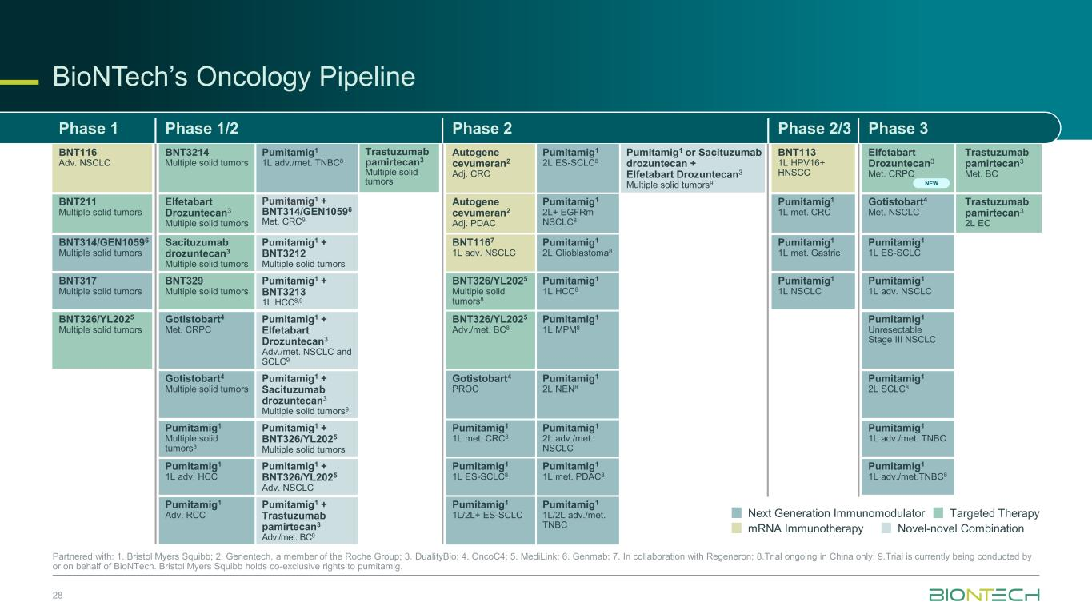
BioNTech’s Oncology Pipeline 28 Partnered with: 1. Bristol Myers Squibb; 2. Genentech, a member of the Roche Group; 3. DualityBio; 4. OncoC4; 5. MediLink; 6. Genmab; 7. In collaboration with Regeneron; 8.Trial ongoing in China only; 9.Trial is currently being conducted by or on behalf of BioNTech. Bristol Myers Squibb holds co-exclusive rights to pumitamig. Phase 1 Phase 1/2 Phase 2 Phase 2/3 Phase 3 BNT116 Adv. NSCLC BNT3214 Multiple solid tumors Pumitamig1 1L adv./met. TNBC8 Trastuzumab pamirtecan3 Multiple solid tumors Autogene cevumeran2 Adj. CRC Pumitamig1 2L ES-SCLC8 Pumitamig1 or Sacituzumab drozuntecan + Elfetabart Drozuntecan3 Multiple solid tumors9 BNT113 1L HPV16+ HNSCC Elfetabart Drozuntecan3 Met. CRPC Trastuzumab pamirtecan3 Met. BC BNT211 Multiple solid tumors Elfetabart Drozuntecan3 Multiple solid tumors Pumitamig1 + BNT314/GEN10596 Met. CRC9 Autogene cevumeran2 Adj. PDAC Pumitamig1 2L+ EGFRm NSCLC8 Pumitamig1 1L met. CRC Gotistobart4 Met. NSCLC Trastuzumab pamirtecan3 2L EC BNT314/GEN10596 Multiple solid tumors Sacituzumab drozuntecan3 Multiple solid tumors Pumitamig1 + BNT3212 Multiple solid tumors BNT1167 1L adv. NSCLC Pumitamig1 2L Glioblastoma8 Pumitamig1 1L met. Gastric Pumitamig1 1L ES-SCLC BNT317 Multiple solid tumors BNT329 Multiple solid tumors Pumitamig1 + BNT3213 1L HCC8,9 BNT326/YL2025 Multiple solid tumors8 Pumitamig1 1L HCC8 Pumitamig1 1L NSCLC Pumitamig1 1L adv. NSCLC BNT326/YL2025 Multiple solid tumors Gotistobart4 Met. CRPC Pumitamig1 + Elfetabart Drozuntecan3 Adv./met. NSCLC and SCLC9 BNT326/YL2025 Adv./met. BC8 Pumitamig1 1L MPM8 Pumitamig1 Unresectable Stage III NSCLC Gotistobart4 Multiple solid tumors Pumitamig1 + Sacituzumab drozuntecan3 Multiple solid tumors9 Gotistobart4 PROC Pumitamig1 2L NEN8 Pumitamig1 2L SCLC8 Pumitamig1 Multiple solid tumors8 Pumitamig1 + BNT326/YL2025 Multiple solid tumors Pumitamig1 1L met. CRC8 Pumitamig1 2L adv./met. NSCLC Pumitamig1 1L adv./met. TNBC Pumitamig1 1L adv. HCC Pumitamig1 + BNT326/YL2025 Adv. NSCLC Pumitamig1 1L ES-SCLC8 Pumitamig1 1L met. PDAC8 Pumitamig1 1L adv./met.TNBC8 Pumitamig1 Adv. RCC Pumitamig1 + Trastuzumab pamirtecan3 Adv./met. BC9 Pumitamig1 1L/2L+ ES-SCLC Pumitamig1 1L/2L adv./met. TNBC mRNA Immunotherapy Next Generation Immunomodulator Targeted Therapy Novel-novel Combination NEW

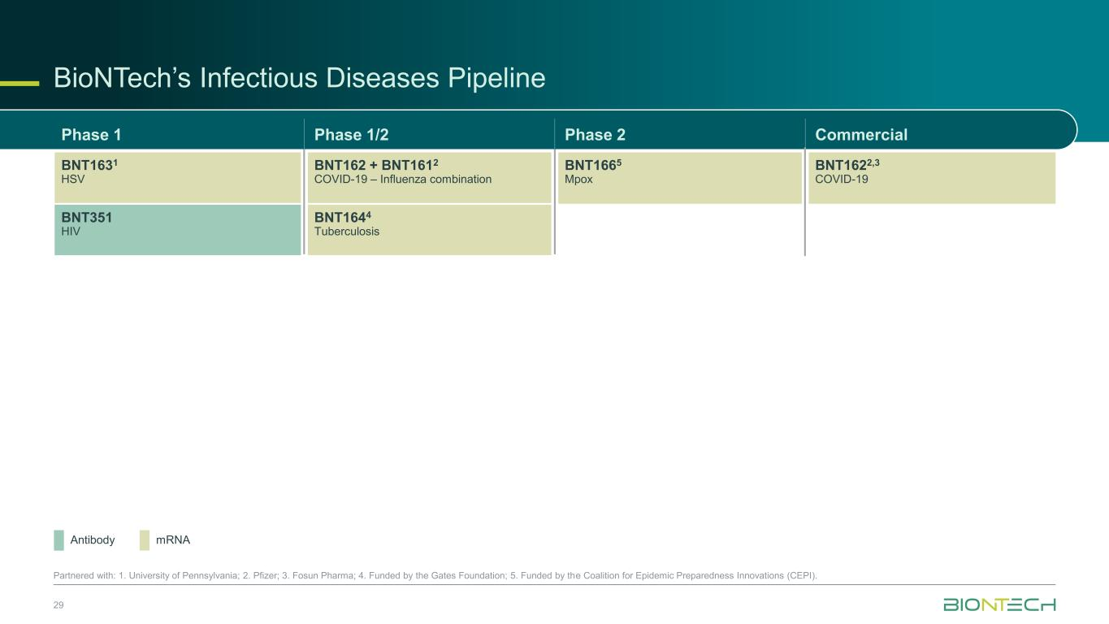
29 Partnered with: 1. University of Pennsylvania; 2. Pfizer; 3. Fosun Pharma; 4. Funded by the Gates Foundation; 5. Funded by the Coalition for Epidemic Preparedness Innovations (CEPI). mRNAAntibody BioNTech’s Infectious Diseases Pipeline Phase 1 Phase 1/2 Phase 2 Commercial BNT1631 HSV BNT162 + BNT1612 COVID-19 – Influenza combination BNT1665 Mpox BNT1622,3 COVID-19 BNT351 HIV BNT1644 Tuberculosis

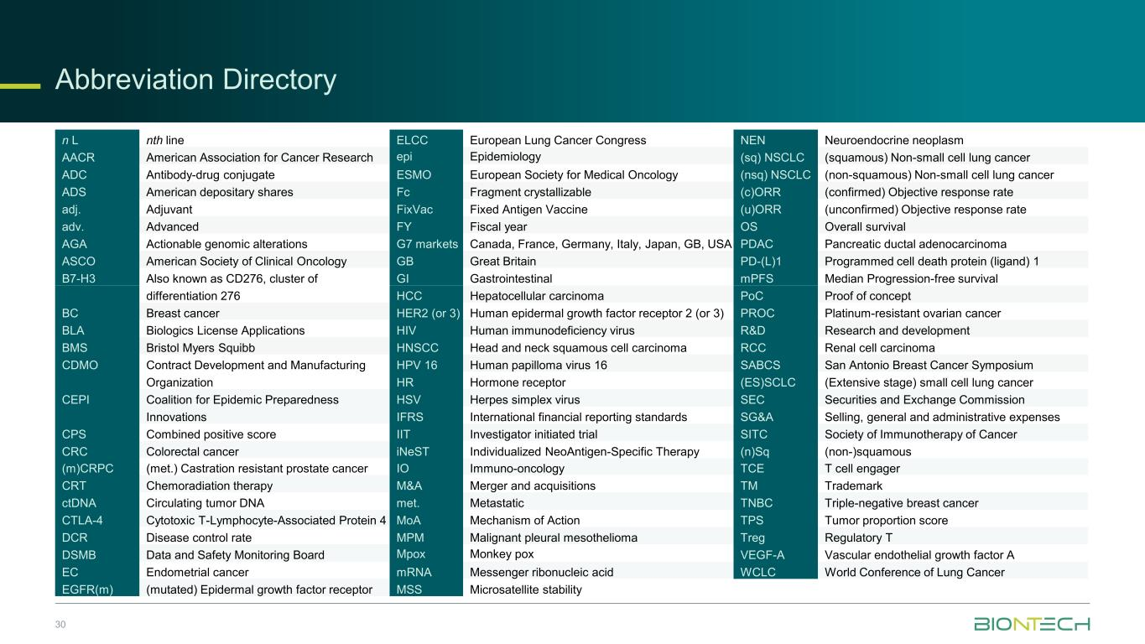
Abbreviation Directory 30 n L nth line ELCC European Lung Cancer Congress NEN Neuroendocrine neoplasm AACR American Association for Cancer Research epi Epidemiology (sq) NSCLC (squamous) Non-small cell lung cancer ADC Antibody-drug conjugate ESMO European Society for Medical Oncology (nsq) NSCLC (non-squamous) Non-small cell lung cancer ADS American depositary shares Fc Fragment crystallizable (c)ORR (confirmed) Objective response rate adj. Adjuvant FixVac Fixed Antigen Vaccine (u)ORR (unconfirmed) Objective response rate adv. Advanced FY Fiscal year OS Overall survival AGA Actionable genomic alterations G7 markets Canada, France, Germany, Italy, Japan, GB, USA PDAC Pancreatic ductal adenocarcinoma ASCO American Society of Clinical Oncology GB Great Britain PD-(L)1 Programmed cell death protein (ligand) 1 B7-H3 Also known as CD276, cluster of GI Gastrointestinal mPFS Median Progression-free survival differentiation 276 HCC Hepatocellular carcinoma PoC Proof of concept BC Breast cancer HER2 (or 3) Human epidermal growth factor receptor 2 (or 3) PROC Platinum-resistant ovarian cancer BLA Biologics License Applications HIV Human immunodeficiency virus R&D Research and development BMS Bristol Myers Squibb HNSCC Head and neck squamous cell carcinoma RCC Renal cell carcinoma CDMO Contract Development and Manufacturing HPV 16 Human papilloma virus 16 SABCS San Antonio Breast Cancer Symposium Organization HR Hormone receptor (ES)SCLC (Extensive stage) small cell lung cancer CEPI Coalition for Epidemic Preparedness HSV Herpes simplex virus SEC Securities and Exchange Commission Innovations IFRS International financial reporting standards SG&A Selling, general and administrative expenses CPS Combined positive score IIT Investigator initiated trial SITC Society of Immunotherapy of Cancer CRC Colorectal cancer iNeST Individualized NeoAntigen-Specific Therapy (n)Sq (non-)squamous (m)CRPC (met.) Castration resistant prostate cancer IO Immuno-oncology TCE T cell engager CRT Chemoradiation therapy M&A Merger and acquisitions TM Trademark ctDNA Circulating tumor DNA met. Metastatic TNBC Triple-negative breast cancer CTLA-4 Cytotoxic T-Lymphocyte-Associated Protein 4 MoA Mechanism of Action TPS Tumor proportion score DCR Disease control rate MPM Malignant pleural mesothelioma Treg Regulatory T DSMB Data and Safety Monitoring Board Mpox Monkey pox VEGF-A Vascular endothelial growth factor A EC Endometrial cancer mRNA Messenger ribonucleic acid WCLC World Conference of Lung Cancer EGFR(m) (mutated) Epidermal growth factor receptor MSS Microsatellite stability

