UNITED STATES
SECURITIES AND EXCHANGE COMMISSION
Washington, D.C. 20549
FORM 6-K

REPORT OF FOREIGN PRIVATE ISSUER PURSUANT TO RULE 13a-16 OR 15d-16
UNDER THE SECURITIES EXCHANGE ACT OF 1934
FOR THE MONTH OF MAY 2025

COMMISSION FILE NUMBER 001-39081
BioNTech SE
(Translation of registrant’s name into English)
An der Goldgrube 12
D-55131 Mainz
Germany
+49 6131-9084-0
(Address of principal executive offices)

Indicate by check mark whether the registrant files or will file annual reports under cover Form 20-F or Form 40-F: Form 20-F ☒ Form 40-F ☐
Indicate by check mark if the registrant is submitting the Form 6-K in paper as permitted by Regulation S-T Rule 101(b)(1): ☐
Indicate by check mark if the registrant is submitting the Form 6-K in paper as permitted by Regulation S-T Rule 101(b)(7): ☐

DOCUMENTS INCLUDED AS PART OF THIS FORM 6-K
On May 16, 2025, BioNTech SE held the Annual General Meeting (“AGM”) 2025. The AGM presentation is attached hereto as Exhibit 99.1. The voting results are attached hereto as Exhibit 99.2.

SIGNATURE
Pursuant to the requirements of the Exchange Act, the registrant has duly caused this report to be signed on its behalf by the undersigned, thereunto duly authorized.

BioNTech SE
By: |  |  | /s/ Jens Holstein |  |  |  |  |  | By: |  |  | /s/ Dr. Sierk Poetting
 |  |  | Name: Jens Holstein |  |  |  |  |  |  |  |  | Name: Dr. Sierk Poetting
 |  |  | Title: Chief Financial Officer |  |  |  |  |  |  |  |  | Title: Chief Operating Officer
Date: May 16, 2025

EXHIBIT INDEX
Exhibit |  |  | Description of Exhibit
99.1 |  |  | Annual General Meeting 2025 Presentation
99.2 |  |  | Annual General Meeting 2025 Voting Results



Annual General Meeting 16 May 2025, 14:00 CET Exhibit 99.1

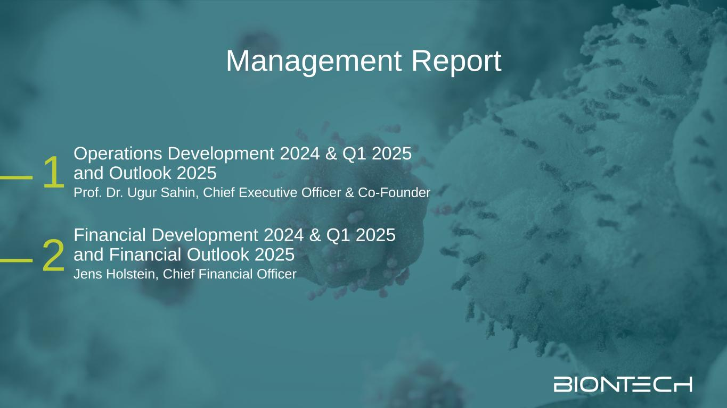
Management Report 2 1 Operations Development 2024 & Q1 2025 and Outlook 2025 Prof. Dr. Ugur Sahin, Chief Executive Officer & Co-Founder Financial Development 2024 & Q1 2025 and Financial Outlook 2025 Jens Holstein, Chief Financial Officer

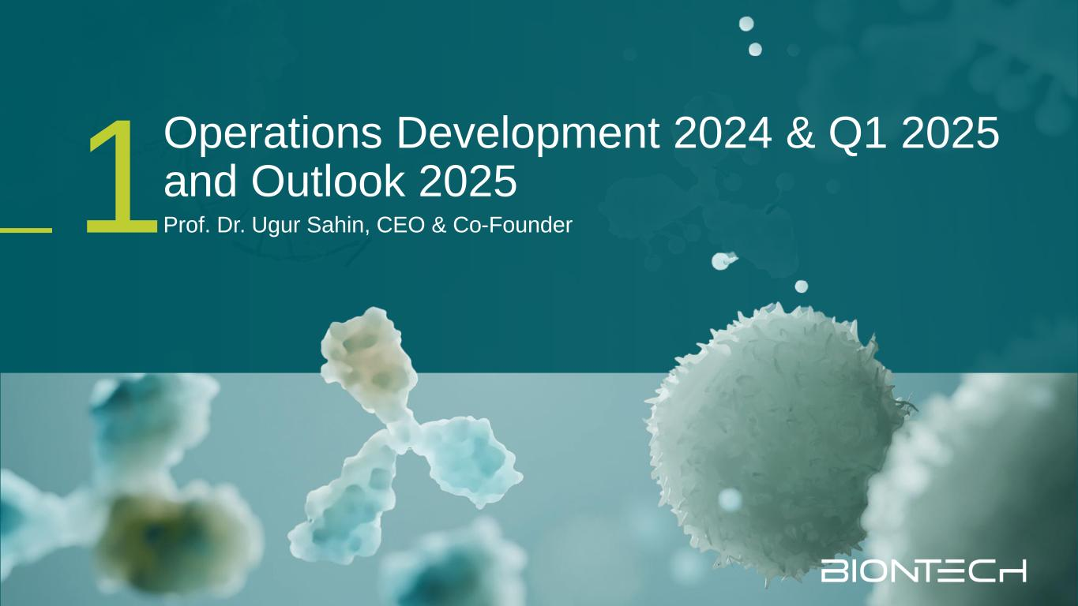
Operations Development 2024 & Q1 2025 and Outlook 2025 Prof. Dr. Ugur Sahin, CEO & Co-Founder1

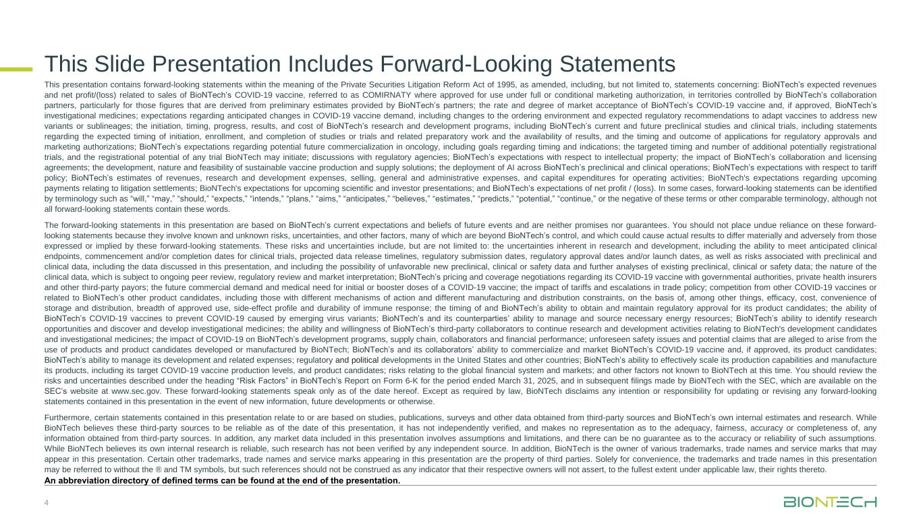
4 This Slide Presentation Includes Forward-Looking Statements This presentation contains forward-looking statements within the meaning of the Private Securities Litigation Reform Act of 1995, as amended, including, but not limited to, statements concerning: BioNTech’s expected revenues and net profit/(loss) related to sales of BioNTech’s COVID-19 vaccine, referred to as COMIRNATY where approved for use under full or conditional marketing authorization, in territories controlled by BioNTech’s collaboration partners, particularly for those figures that are derived from preliminary estimates provided by BioNTech’s partners; the rate and degree of market acceptance of BioNTech’s COVID-19 vaccine and, if approved, BioNTech’s investigational medicines; expectations regarding anticipated changes in COVID-19 vaccine demand, including changes to the ordering environment and expected regulatory recommendations to adapt vaccines to address new variants or sublineages; the initiation, timing, progress, results, and cost of BioNTech’s research and development programs, including BioNTech’s current and future preclinical studies and clinical trials, including statements regarding the expected timing of initiation, enrollment, and completion of studies or trials and related preparatory work and the availability of results, and the timing and outcome of applications for regulatory approvals and marketing authorizations; BioNTech’s expectations regarding potential future commercialization in oncology, including goals regarding timing and indications; the targeted timing and number of additional potentially registrational trials, and the registrational potential of any trial BioNTech may initiate; discussions with regulatory agencies; BioNTech’s expectations with respect to intellectual property; the impact of BioNTech’s collaboration and licensing agreements; the development, nature and feasibility of sustainable vaccine production and supply solutions; the deployment of AI across BioNTech’s preclinical and clinical operations; BioNTech’s expectations with respect to tariff policy; BioNTech’s estimates of revenues, research and development expenses, selling, general and administrative expenses, and capital expenditures for operating activities; BioNTech's expectations regarding upcoming payments relating to litigation settlements; BioNTech's expectations for upcoming scientific and investor presentations; and BioNTech’s expectations of net profit / (loss). In some cases, forward-looking statements can be identified by terminology such as “will,” “may,” “should,” “expects,” “intends,” “plans,” “aims,” “anticipates,” “believes,” “estimates,” “predicts,” “potential,” “continue,” or the negative of these terms or other comparable terminology, although not all forward-looking statements contain these words. The forward-looking statements in this presentation are based on BioNTech’s current expectations and beliefs of future events and are neither promises nor guarantees. You should not place undue reliance on these forward- looking statements because they involve known and unknown risks, uncertainties, and other factors, many of which are beyond BioNTech’s control, and which could cause actual results to differ materially and adversely from those expressed or implied by these forward-looking statements. These risks and uncertainties include, but are not limited to: the uncertainties inherent in research and development, including the ability to meet anticipated clinical endpoints, commencement and/or completion dates for clinical trials, projected data release timelines, regulatory submission dates, regulatory approval dates and/or launch dates, as well as risks associated with preclinical and clinical data, including the data discussed in this presentation, and including the possibility of unfavorable new preclinical, clinical or safety data and further analyses of existing preclinical, clinical or safety data; the nature of the clinical data, which is subject to ongoing peer review, regulatory review and market interpretation; BioNTech’s pricing and coverage negotiations regarding its COVID-19 vaccine with governmental authorities, private health insurers and other third-party payors; the future commercial demand and medical need for initial or booster doses of a COVID-19 vaccine; the impact of tariffs and escalations in trade policy; competition from other COVID-19 vaccines or related to BioNTech’s other product candidates, including those with different mechanisms of action and different manufacturing and distribution constraints, on the basis of, among other things, efficacy, cost, convenience of storage and distribution, breadth of approved use, side-effect profile and durability of immune response; the timing of and BioNTech’s ability to obtain and maintain regulatory approval for its product candidates; the ability of BioNTech’s COVID-19 vaccines to prevent COVID-19 caused by emerging virus variants; BioNTech’s and its counterparties’ ability to manage and source necessary energy resources; BioNTech’s ability to identify research opportunities and discover and develop investigational medicines; the ability and willingness of BioNTech’s third-party collaborators to continue research and development activities relating to BioNTech's development candidates and investigational medicines; the impact of COVID-19 on BioNTech’s development programs, supply chain, collaborators and financial performance; unforeseen safety issues and potential claims that are alleged to arise from the use of products and product candidates developed or manufactured by BioNTech; BioNTech’s and its collaborators’ ability to commercialize and market BioNTech’s COVID-19 vaccine and, if approved, its product candidates; BioNTech’s ability to manage its development and related expenses; regulatory and political developments in the United States and other countries; BioNTech’s ability to effectively scale its production capabilities and manufacture its products, including its target COVID-19 vaccine production levels, and product candidates; risks relating to the global financial system and markets; and other factors not known to BioNTech at this time. You should review the risks and uncertainties described under the heading “Risk Factors” in BioNTech’s Report on Form 6-K for the period ended March 31, 2025, and in subsequent filings made by BioNTech with the SEC, which are available on the SEC’s website at www.sec.gov. These forward-looking statements speak only as of the date hereof. Except as required by law, BioNTech disclaims any intention or responsibility for updating or revising any forward-looking statements contained in this presentation in the event of new information, future developments or otherwise. Furthermore, certain statements contained in this presentation relate to or are based on studies, publications, surveys and other data obtained from third-party sources and BioNTech’s own internal estimates and research. While BioNTech believes these third-party sources to be reliable as of the date of this presentation, it has not independently verified, and makes no representation as to the adequacy, fairness, accuracy or completeness of, any information obtained from third-party sources. In addition, any market data included in this presentation involves assumptions and limitations, and there can be no guarantee as to the accuracy or reliability of such assumptions. While BioNTech believes its own internal research is reliable, such research has not been verified by any independent source. In addition, BioNTech is the owner of various trademarks, trade names and service marks that may appear in this presentation. Certain other trademarks, trade names and service marks appearing in this presentation are the property of third parties. Solely for convenience, the trademarks and trade names in this presentation may be referred to without the ® and TM symbols, but such references should not be construed as any indicator that their respective owners will not assert, to the fullest extent under applicable law, their rights thereto. An abbreviation directory of defined terms can be found at the end of the presentation.

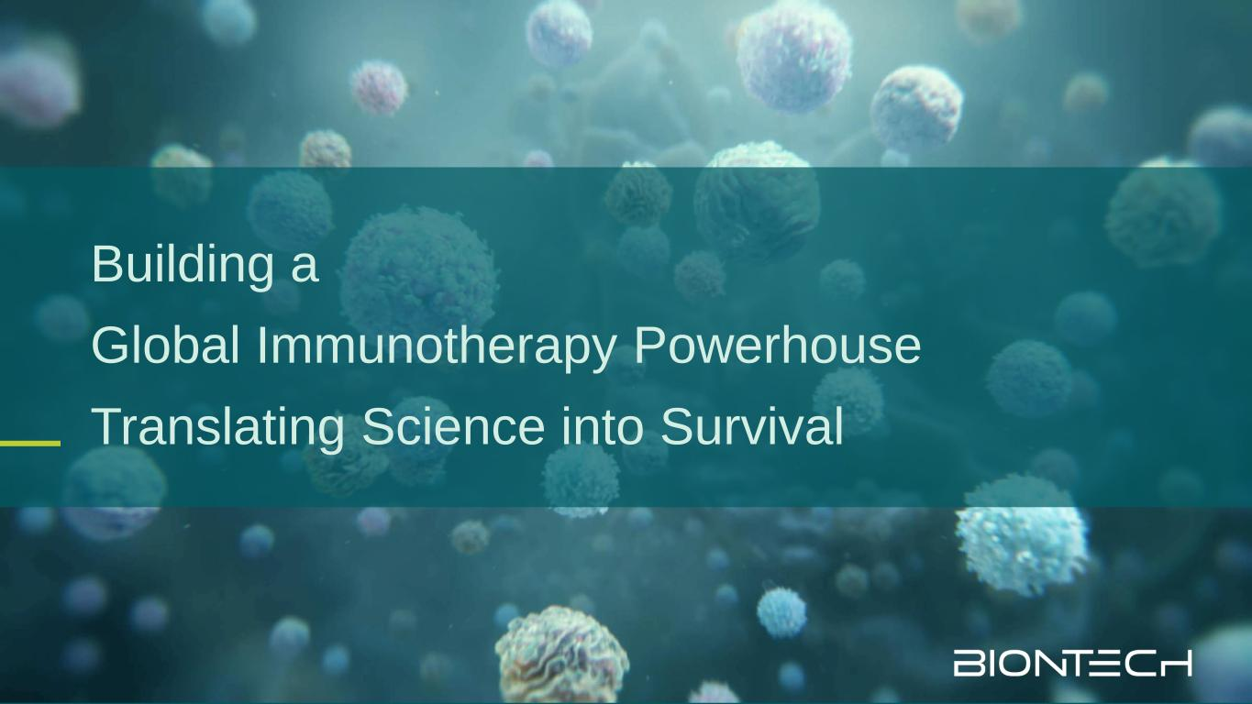
Building a Global Immunotherapy Powerhouse Translating Science into Survival

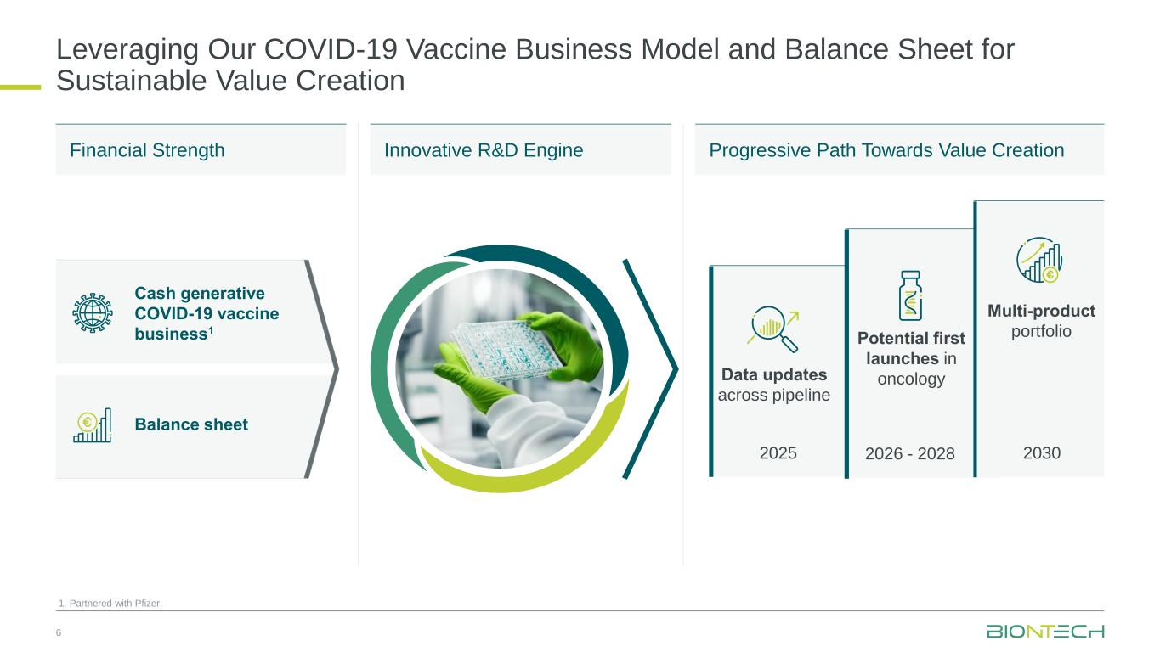
Leveraging Our COVID-19 Vaccine Business Model and Balance Sheet for Sustainable Value Creation 6 1. Partnered with Pfizer. Multi-product portfolioPotential first launches in oncologyData updates across pipeline Cash generative COVID-19 vaccine business1 Balance sheet Financial Strength Progressive Path Towards Value CreationInnovative R&D Engine 2025 2026 - 2028 2030


Diversified Oncology Pipeline

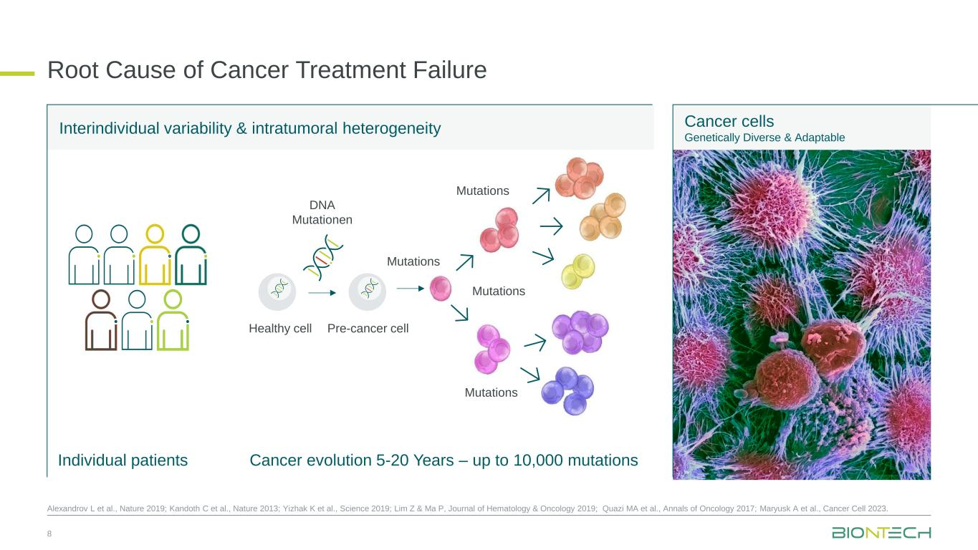
Interindividual variability & intratumoral heterogeneity Root Cause of Cancer Treatment Failure Cancer cells Genetically Diverse & Adaptable Cancer evolution 5-20 Years – up to 10,000 mutationsIndividual patients 8 Alexandrov L et al., Nature 2019; Kandoth C et al., Nature 2013; Yizhak K et al., Science 2019; Lim Z & Ma P, Journal of Hematology & Oncology 2019; Quazi MA et al., Annals of Oncology 2017; Maryusk A et al., Cancer Cell 2023. DNA Mutationen Healthy cell Mutations Pre-cancer cell Mutations Mutations Mutations

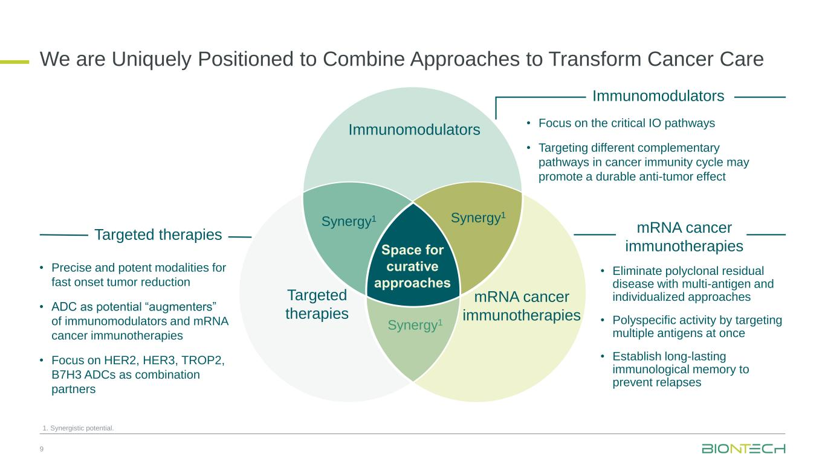
Space for curative approaches Immunomodulators mRNA cancer immunotherapies Targeted therapies Synergy1 Synergy1 Synergy1 • Focus on the critical IO pathways • Targeting different complementary pathways in cancer immunity cycle may promote a durable anti-tumor effect • Eliminate polyclonal residual disease with multi-antigen and individualized approaches • Polyspecific activity by targeting multiple antigens at once • Establish long-lasting immunological memory to prevent relapses • Precise and potent modalities for fast onset tumor reduction • ADC as potential “augmenters” of immunomodulators and mRNA cancer immunotherapies • Focus on HER2, HER3, TROP2, B7H3 ADCs as combination partners 9 Immunomodulators Targeted therapies mRNA cancer immunotherapies We are Uniquely Positioned to Combine Approaches to Transform Cancer Care 1. Synergistic potential.

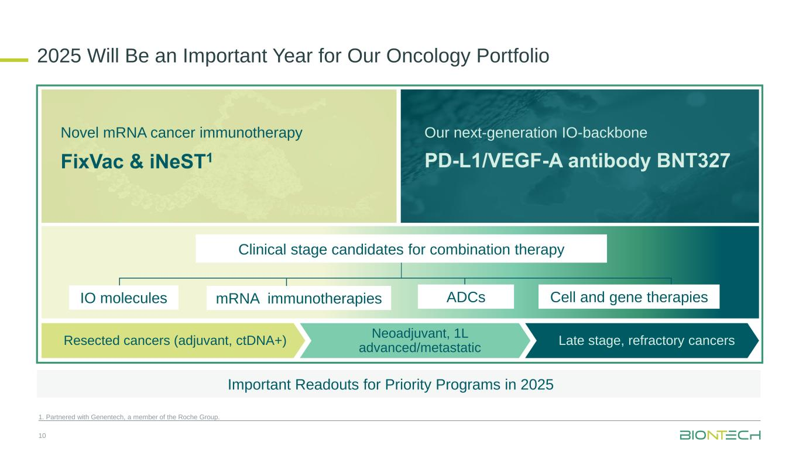
10 1. Partnered with Genentech, a member of the Roche Group. 2025 Will Be an Important Year for Our Oncology Portfolio PD-L1/VEGF-A antibody BNT327 Novel mRNA cancer immunotherapy FixVac & iNeST1 Our next-generation IO-backbone Resected cancers (adjuvant, ctDNA+) Neoadjuvant, 1L advanced/metastatic Late stage, refractory cancers Clinical stage candidates for combination therapy ADCs Cell and gene therapiesIO molecules mRNA immunotherapies Important Readouts for Priority Programs in 2025

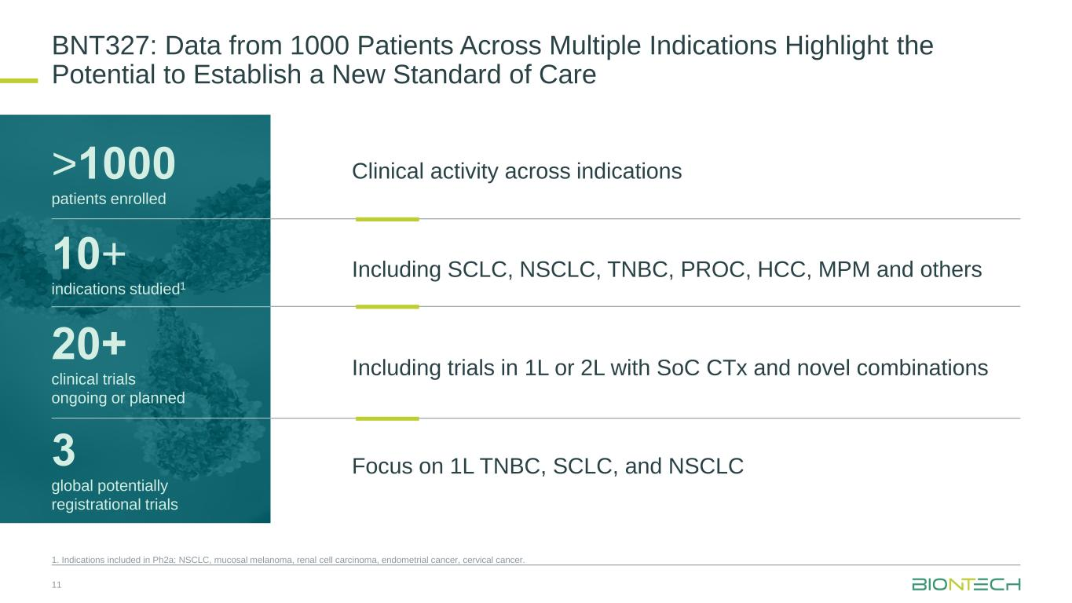
BNT327: Data from 1000 Patients Across Multiple Indications Highlight the Potential to Establish a New Standard of Care 11 10+ indications studied1 >1000 patients enrolled 20+ clinical trials ongoing or planned 3 global potentially registrational trials Clinical activity across indications Including SCLC, NSCLC, TNBC, PROC, HCC, MPM and others Including trials in 1L or 2L with SoC CTx and novel combinations Focus on 1L TNBC, SCLC, and NSCLC 1. Indications included in Ph2a: NSCLC, mucosal melanoma, renal cell carcinoma, endometrial cancer, cervical cancer.

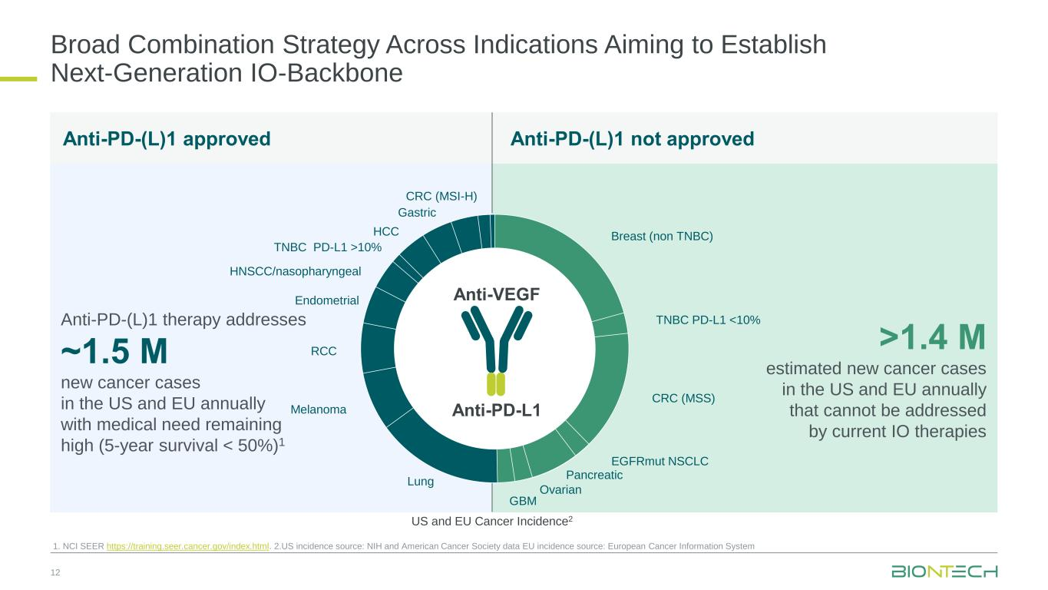
Broad Combination Strategy Across Indications Aiming to Establish Next-Generation IO-Backbone 12 1. NCI SEER https://training.seer.cancer.gov/index.html. 2.US incidence source: NIH and American Cancer Society data EU incidence source: European Cancer Information System Anti-PD-L1 Anti-VEGF Anti-PD-(L)1 therapy addresses ~1.5 M new cancer cases in the US and EU annually with medical need remaining high (5-year survival < 50%)1 >1.4 M estimated new cancer cases in the US and EU annually that cannot be addressed by current IO therapies Anti-PD-(L)1 approved Anti-PD-(L)1 not approved US and EU Cancer Incidence2 Breast (non TNBC) TNBC PD-L1 <10% CRC (MSS) EGFRmut NSCLC Pancreatic Ovarian GBM Lung Melanoma RCC Endometrial HNSCC/nasopharyngeal TNBC PD-L1 >10% HCC Gastric CRC (MSI-H)

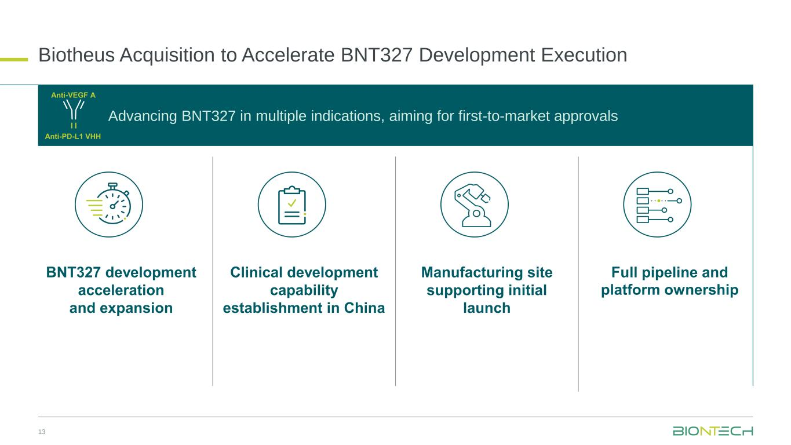
Advancing BNT327 in multiple indications, aiming for first-to-market approvals Biotheus Acquisition to Accelerate BNT327 Development Execution 13 Anti-VEGF A Anti-PD-L1 VHH BNT327 development acceleration and expansion Clinical development capability establishment in China Full pipeline and platform ownership Manufacturing site supporting initial launch

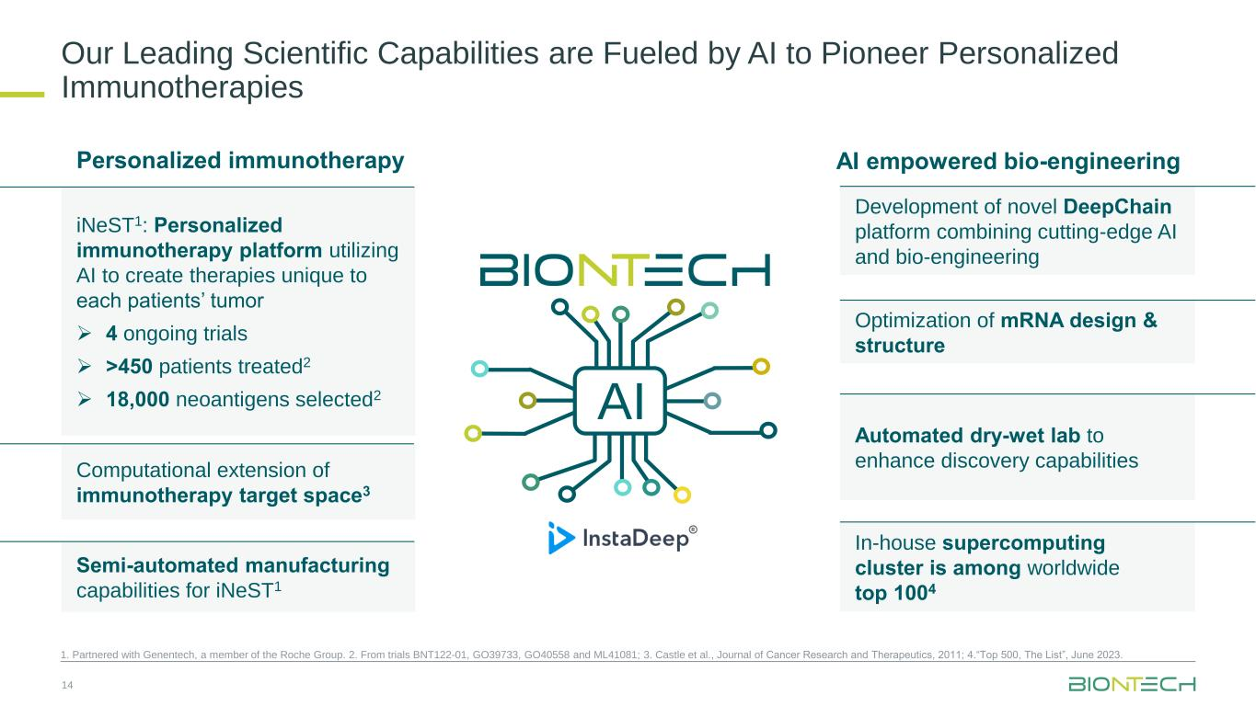
Our Leading Scientific Capabilities are Fueled by AI to Pioneer Personalized Immunotherapies 14 1. Partnered with Genentech, a member of the Roche Group. 2. From trials BNT122-01, GO39733, GO40558 and ML41081; 3. Castle et al., Journal of Cancer Research and Therapeutics, 2011; 4.“Top 500, The List”, June 2023. Semi-automated manufacturing capabilities for iNeST1 iNeST1: Personalized immunotherapy platform utilizing AI to create therapies unique to each patients’ tumor ➢ 4 ongoing trials ➢ >450 patients treated2 ➢ 18,000 neoantigens selected2 Development of novel DeepChain platform combining cutting-edge AI and bio-engineering Automated dry-wet lab to enhance discovery capabilities In-house supercomputing cluster is among worldwide top 1004 AI empowered bio-engineeringPersonalized immunotherapy Optimization of mRNA design & structure Computational extension of immunotherapy target space3 AI


COVID-19 Vaccine Business

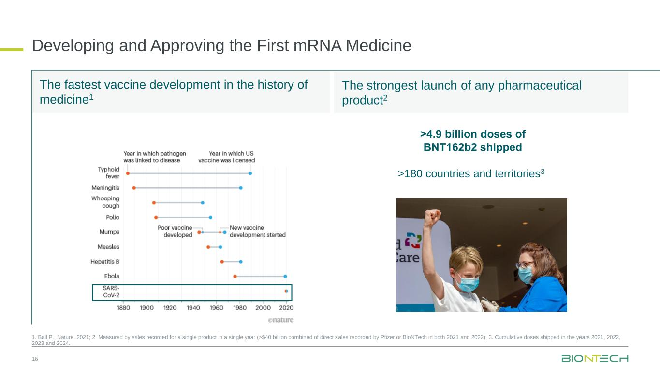
16 >4.9 billion doses of BNT162b2 shipped >180 countries and territories3 The fastest vaccine development in the history of medicine1 The strongest launch of any pharmaceutical product2 Developing and Approving the First mRNA Medicine 1. Ball P., Nature. 2021; 2. Measured by sales recorded for a single product in a single year (>$40 billion combined of direct sales recorded by Pfizer or BioNTech in both 2021 and 2022); 3. Cumulative doses shipped in the years 2021, 2022, 2023 and 2024.

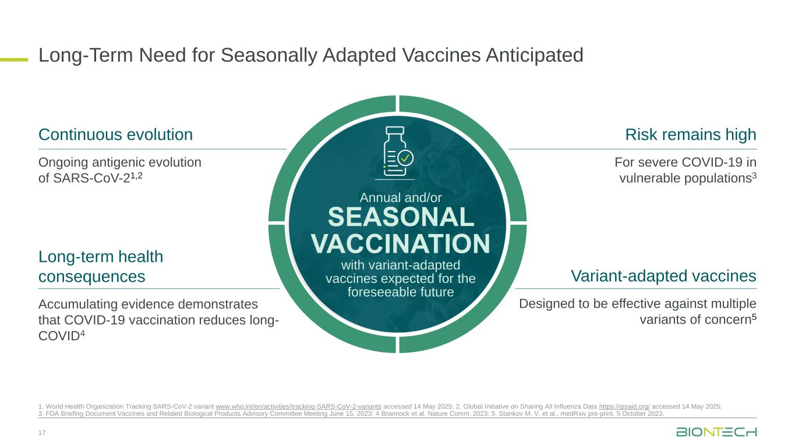
Variant-adapted vaccines Designed to be effective against multiple variants of concern5 Long-term health consequences Accumulating evidence demonstrates that COVID-19 vaccination reduces long- COVID4 Continuous evolution Ongoing antigenic evolution of SARS-CoV-21,2 Risk remains high For severe COVID-19 in vulnerable populations3 Long-Term Need for Seasonally Adapted Vaccines Anticipated 17 1. World Health Organization Tracking SARS-CoV-2 variant www.who.int/en/activities/tracking-SARS-CoV-2-variants accessed 14 May 2025; 2. Global Initiative on Sharing All Influenza Data https://gisaid.org/ accessed 14 May 2025; 3. FDA Briefing Document Vaccines and Related Biological Products Advisory Committee Meeting June 15, 2023; 4 Brannock et al, Nature Comm. 2023; 5. Stankov M. V. et al., medRxiv pre-print, 5 October 2023. Annual and/or SEASONAL VACCINATION with variant-adapted vaccines expected for the foreseeable future

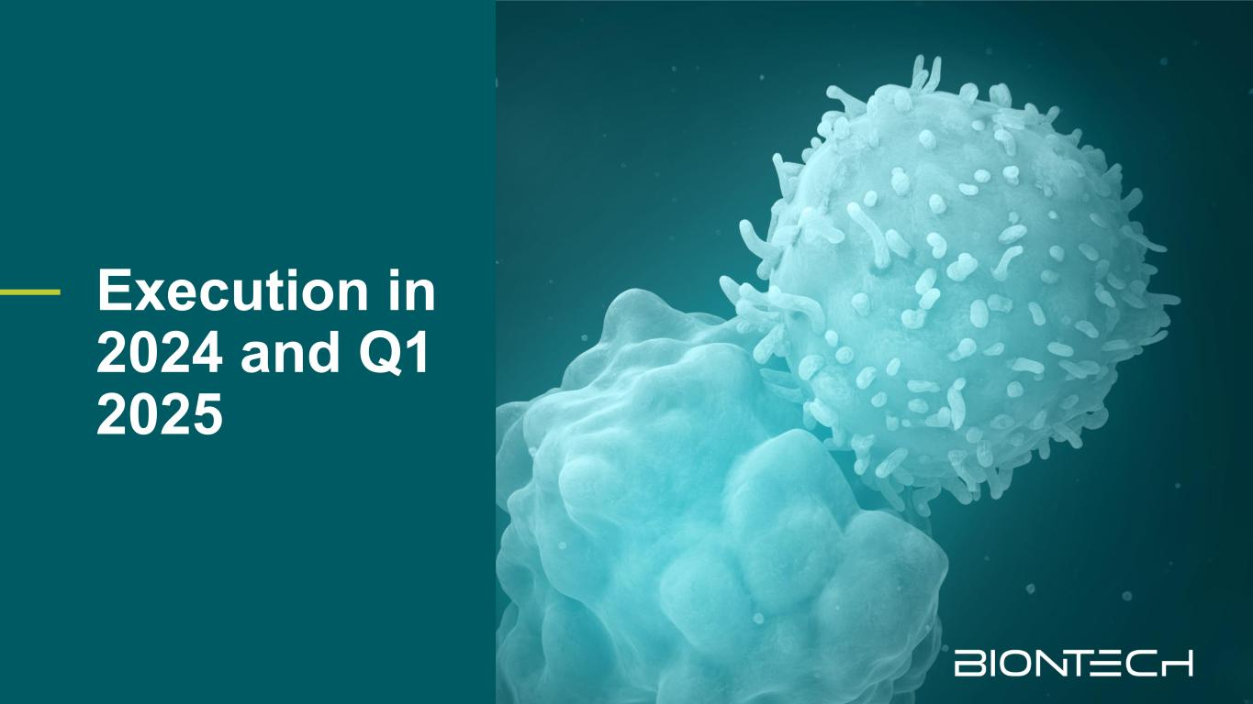
Execution in 2024 and Q1 2025

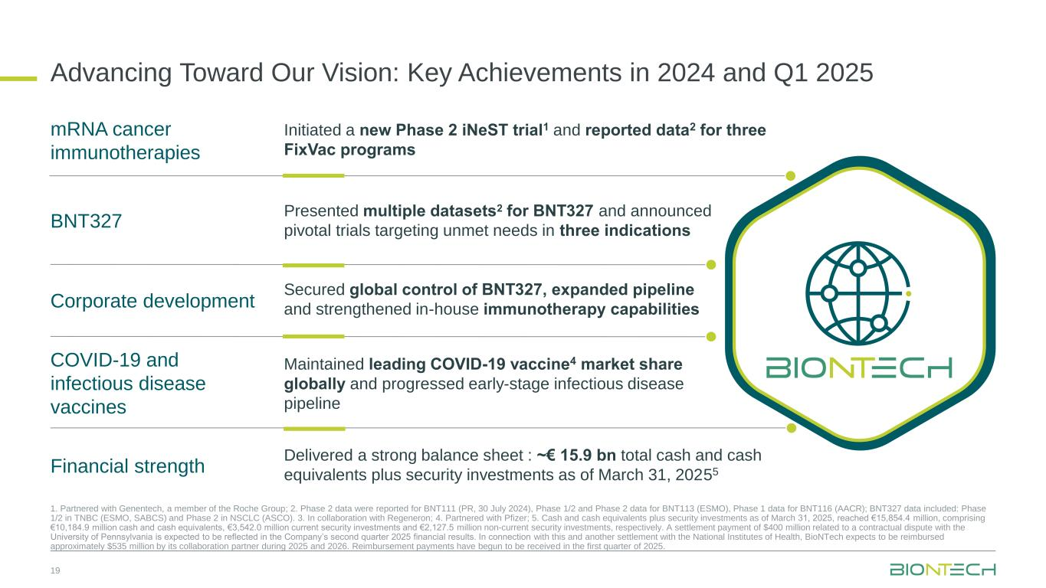
19 1. Partnered with Genentech, a member of the Roche Group; 2. Phase 2 data were reported for BNT111 (PR, 30 July 2024), Phase 1/2 and Phase 2 data for BNT113 (ESMO), Phase 1 data for BNT116 (AACR); BNT327 data included: Phase 1/2 in TNBC (ESMO, SABCS) and Phase 2 in NSCLC (ASCO). 3. In collaboration with Regeneron; 4. Partnered with Pfizer; 5. Cash and cash equivalents plus security investments as of March 31, 2025, reached €15,854.4 million, comprising €10,184.9 million cash and cash equivalents, €3,542.0 million current security investments and €2,127.5 million non-current security investments, respectively. A settlement payment of $400 million related to a contractual dispute with the University of Pennsylvania is expected to be reflected in the Company’s second quarter 2025 financial results. In connection with this and another settlement with the National Institutes of Health, BioNTech expects to be reimbursed approximately $535 million by its collaboration partner during 2025 and 2026. Reimbursement payments have begun to be received in the first quarter of 2025. Advancing Toward Our Vision: Key Achievements in 2024 and Q1 2025 Secured global control of BNT327, expanded pipeline and strengthened in-house immunotherapy capabilities mRNA cancer immunotherapies BNT327 Corporate development COVID-19 and infectious disease vaccines Financial strength Initiated a new Phase 2 iNeST trial1 and reported data2 for three FixVac programs Presented multiple datasets2 for BNT327 and announced pivotal trials targeting unmet needs in three indications Maintained leading COVID-19 vaccine4 market share globally and progressed early-stage infectious disease pipeline Delivered a strong balance sheet : ~€ 15.9 bn total cash and cash equivalents plus security investments as of March 31, 20255


Outlook 2025

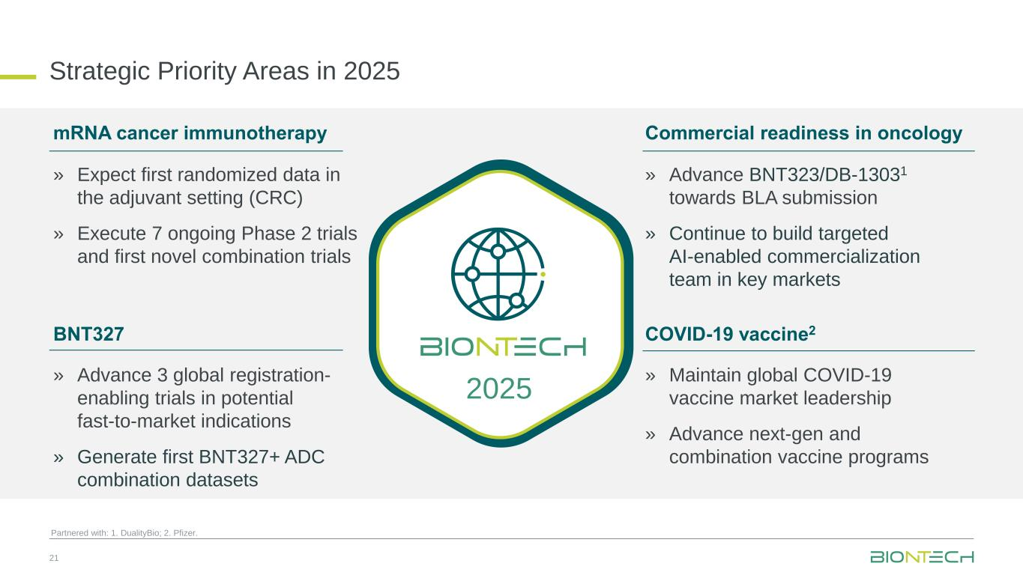
21 Partnered with: 1. DualityBio; 2. Pfizer. Strategic Priority Areas in 2025 mRNA cancer immunotherapy BNT327 Commercial readiness in oncology COVID-19 vaccine2 » Expect first randomized data in the adjuvant setting (CRC) » Execute 7 ongoing Phase 2 trials and first novel combination trials » Advance 3 global registration- enabling trials in potential fast-to-market indications » Generate first BNT327+ ADC combination datasets » Advance BNT323/DB-13031 towards BLA submission » Continue to build targeted AI-enabled commercialization team in key markets » Maintain global COVID-19 vaccine market leadership » Advance next-gen and combination vaccine programs 2025

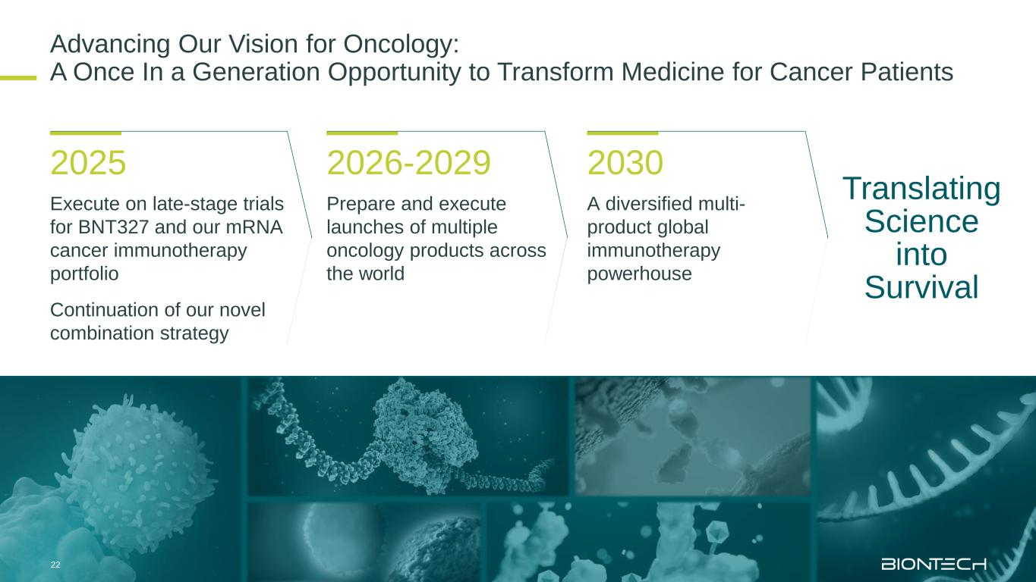
Advancing Our Vision for Oncology: A Once In a Generation Opportunity to Transform Medicine for Cancer Patients Execute on late-stage trials for BNT327 and our mRNA cancer immunotherapy portfolio Continuation of our novel combination strategy Prepare and execute launches of multiple oncology products across the world A diversified multi- product global immunotherapy powerhouse 2025 2026-2029 2030 Translating Science into Survival 22

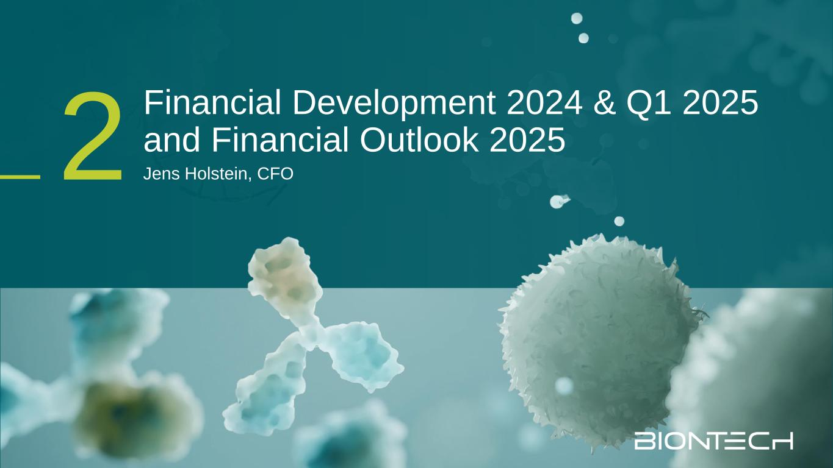
2 Financial Development 2024 & Q1 2025 and Financial Outlook 2025 Jens Holstein, CFO

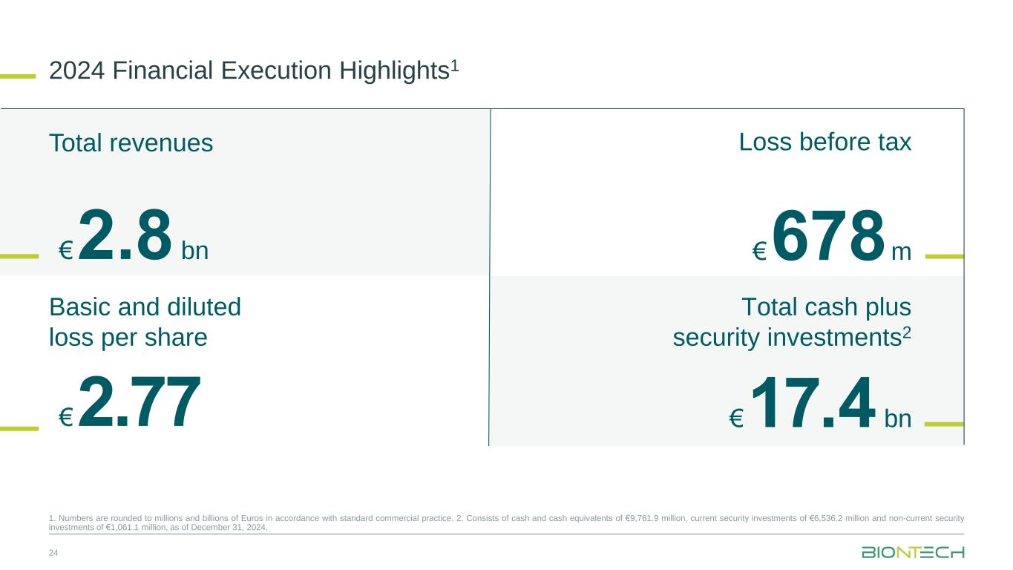
2024 Financial Execution Highlights1 24 Loss before tax € 2.77 € 678 m € 2.8 bn € 17.4 bn Total revenues Basic and diluted loss per share Total cash plus security investments2 1. Numbers are rounded to millions and billions of Euros in accordance with standard commercial practice. 2. Consists of cash and cash equivalents of €9,761.9 million, current security investments of €6,536.2 million and non-current security investments of €1,061.1 million, as of December 31, 2024.

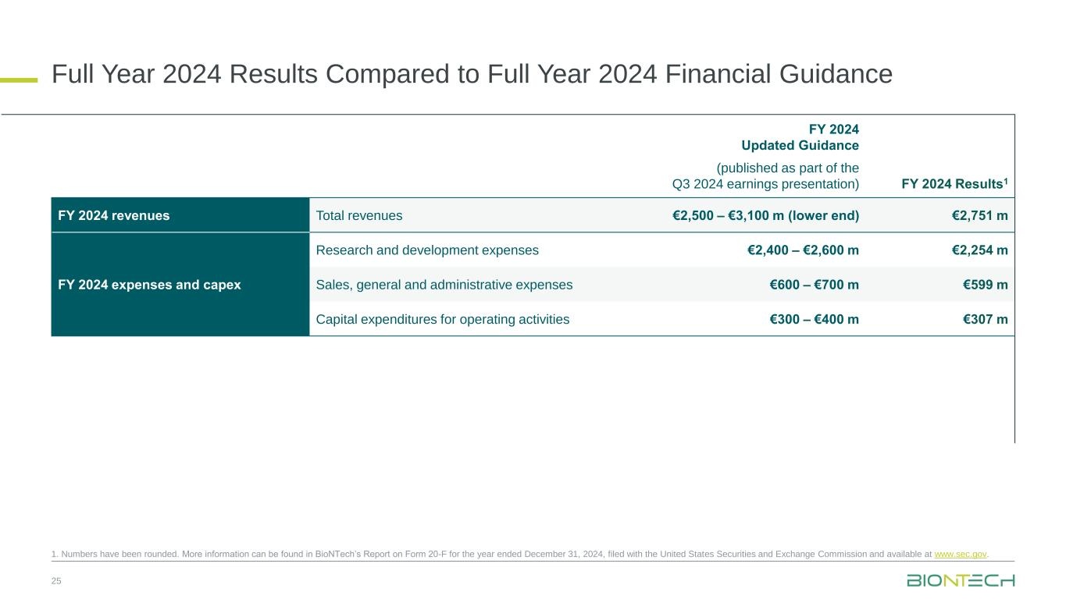
Full Year 2024 Results Compared to Full Year 2024 Financial Guidance 25 FY 2024 Updated Guidance (published as part of the Q3 2024 earnings presentation) FY 2024 Results1 FY 2024 revenues Total revenues €2,500 – €3,100 m (lower end) €2,751 m FY 2024 expenses and capex Research and development expenses €2,400 – €2,600 m €2,254 m Sales, general and administrative expenses €600 – €700 m €599 m Capital expenditures for operating activities €300 – €400 m €307 m 1. Numbers have been rounded. More information can be found in BioNTech’s Report on Form 20-F for the year ended December 31, 2024, filed with the United States Securities and Exchange Commission and available at www.sec.gov.

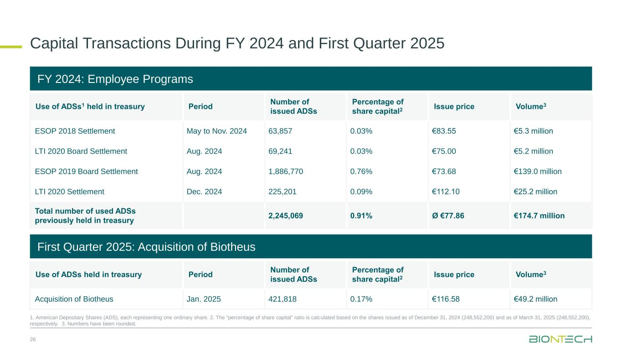
Capital Transactions During FY 2024 and First Quarter 2025 26 FY 2024: Employee Programs Use of ADSs1 held in treasury Period Number of issued ADSs Percentage of share capital2 Issue price Volume3 ESOP 2018 Settlement May to Nov. 2024 63,857 0.03% €83.55 €5.3 million LTI 2020 Board Settlement Aug. 2024 69,241 0.03% €75.00 €5.2 million ESOP 2019 Board Settlement Aug. 2024 1,886,770 0.76% €73.68 €139.0 million LTI 2020 Settlement Dec. 2024 225,201 0.09% €112.10 €25.2 million Total number of used ADSs previously held in treasury 2,245,069 0.91% Ø €77.86 €174.7 million 1. American Depositary Shares (ADS), each representing one ordinary share. 2. The "percentage of share capital" ratio is calculated based on the shares issued as of December 31, 2024 (248,552,200) and as of March 31, 2025 (248,552,200), respectively. 3. Numbers have been rounded. First Quarter 2025: Acquisition of Biotheus Use of ADSs held in treasury Period Number of issued ADSs Percentage of share capital2 Issue price Volume3 Acquisition of Biotheus Jan. 2025 421,818 0.17% €116.58 €49.2 million

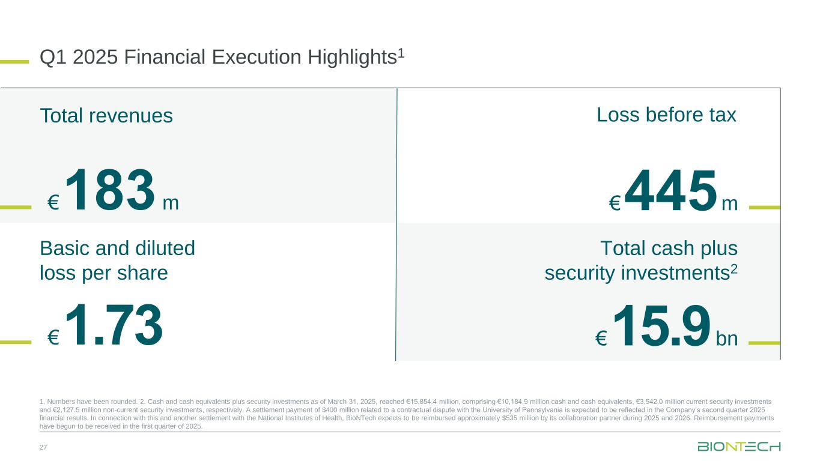
Q1 2025 Financial Execution Highlights1 27 Loss before tax € 1.73 € 445 m € 183 m € 15.9 bn Total revenues Basic and diluted loss per share Total cash plus security investments2 1. Numbers have been rounded. 2. Cash and cash equivalents plus security investments as of March 31, 2025, reached €15,854.4 million, comprising €10,184.9 million cash and cash equivalents, €3,542.0 million current security investments and €2,127.5 million non-current security investments, respectively. A settlement payment of $400 million related to a contractual dispute with the University of Pennsylvania is expected to be reflected in the Company’s second quarter 2025 financial results. In connection with this and another settlement with the National Institutes of Health, BioNTech expects to be reimbursed approximately $535 million by its collaboration partner during 2025 and 2026. Reimbursement payments have begun to be received in the first quarter of 2025.

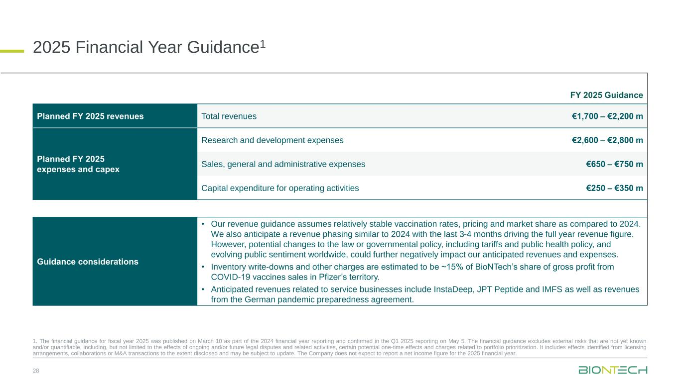
2025 Financial Year Guidance1 28 FY 2025 Guidance Planned FY 2025 revenues Total revenues €1,700 – €2,200 m Planned FY 2025 expenses and capex Research and development expenses €2,600 – €2,800 m Sales, general and administrative expenses €650 – €750 m Capital expenditure for operating activities €250 – €350 m Guidance considerations • Our revenue guidance assumes relatively stable vaccination rates, pricing and market share as compared to 2024. We also anticipate a revenue phasing similar to 2024 with the last 3-4 months driving the full year revenue figure. However, potential changes to the law or governmental policy, including tariffs and public health policy, and evolving public sentiment worldwide, could further negatively impact our anticipated revenues and expenses. • Inventory write-downs and other charges are estimated to be ~15% of BioNTech’s share of gross profit from COVID-19 vaccines sales in Pfizer’s territory. • Anticipated revenues related to service businesses include InstaDeep, JPT Peptide and IMFS as well as revenues from the German pandemic preparedness agreement. 1. The financial guidance for fiscal year 2025 was published on March 10 as part of the 2024 financial year reporting and confirmed in the Q1 2025 reporting on May 5. The financial guidance excludes external risks that are not yet known and/or quantifiable, including, but not limited to the effects of ongoing and/or future legal disputes and related activities, certain potential one-time effects and charges related to portfolio prioritization. It includes effects identified from licensing arrangements, collaborations or M&A transactions to the extent disclosed and may be subject to update. The Company does not expect to report a net income figure for the 2025 financial year.

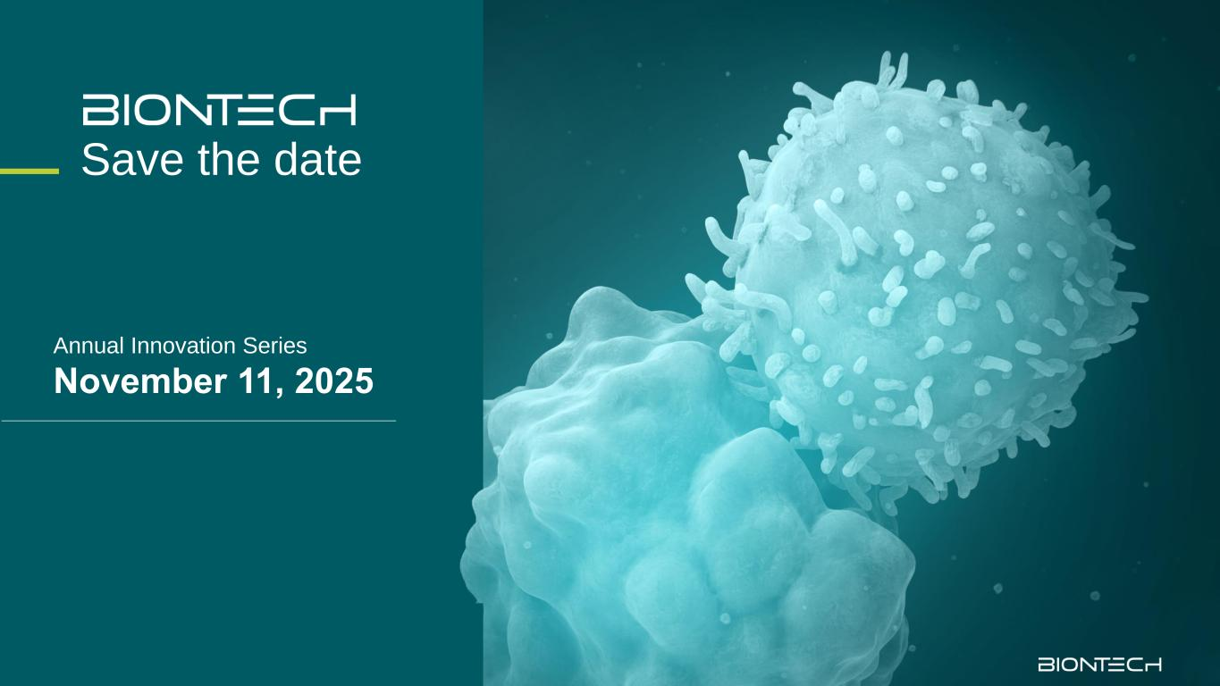
Save the date Annual Innovation Series November 11, 2025


Thank you for your attention.

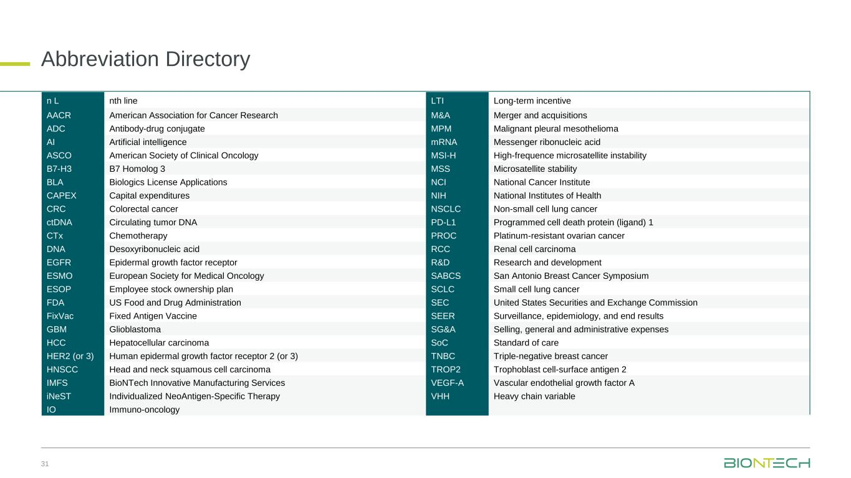
Abbreviation Directory n L nth line LTI Long-term incentive AACR American Association for Cancer Research M&A Merger and acquisitions ADC Antibody-drug conjugate MPM Malignant pleural mesothelioma AI Artificial intelligence mRNA Messenger ribonucleic acid ASCO American Society of Clinical Oncology MSI-H High-frequence microsatellite instability B7-H3 B7 Homolog 3 MSS Microsatellite stability BLA Biologics License Applications NCI National Cancer Institute CAPEX Capital expenditures NIH National Institutes of Health CRC Colorectal cancer NSCLC Non-small cell lung cancer ctDNA Circulating tumor DNA PD-L1 Programmed cell death protein (ligand) 1 CTx Chemotherapy PROC Platinum-resistant ovarian cancer DNA Desoxyribonucleic acid RCC Renal cell carcinoma EGFR Epidermal growth factor receptor R&D Research and development ESMO European Society for Medical Oncology SABCS San Antonio Breast Cancer Symposium ESOP Employee stock ownership plan SCLC Small cell lung cancer FDA US Food and Drug Administration SEC United States Securities and Exchange Commission FixVac Fixed Antigen Vaccine SEER Surveillance, epidemiology, and end results GBM Glioblastoma SG&A Selling, general and administrative expenses HCC Hepatocellular carcinoma SoC Standard of care HER2 (or 3) Human epidermal growth factor receptor 2 (or 3) TNBC Triple-negative breast cancer HNSCC Head and neck squamous cell carcinoma TROP2 Trophoblast cell-surface antigen 2 IMFS BioNTech Innovative Manufacturing Services VEGF-A Vascular endothelial growth factor A iNeST Individualized NeoAntigen-Specific Therapy VHH Heavy chain variable IO Immuno-oncology 31

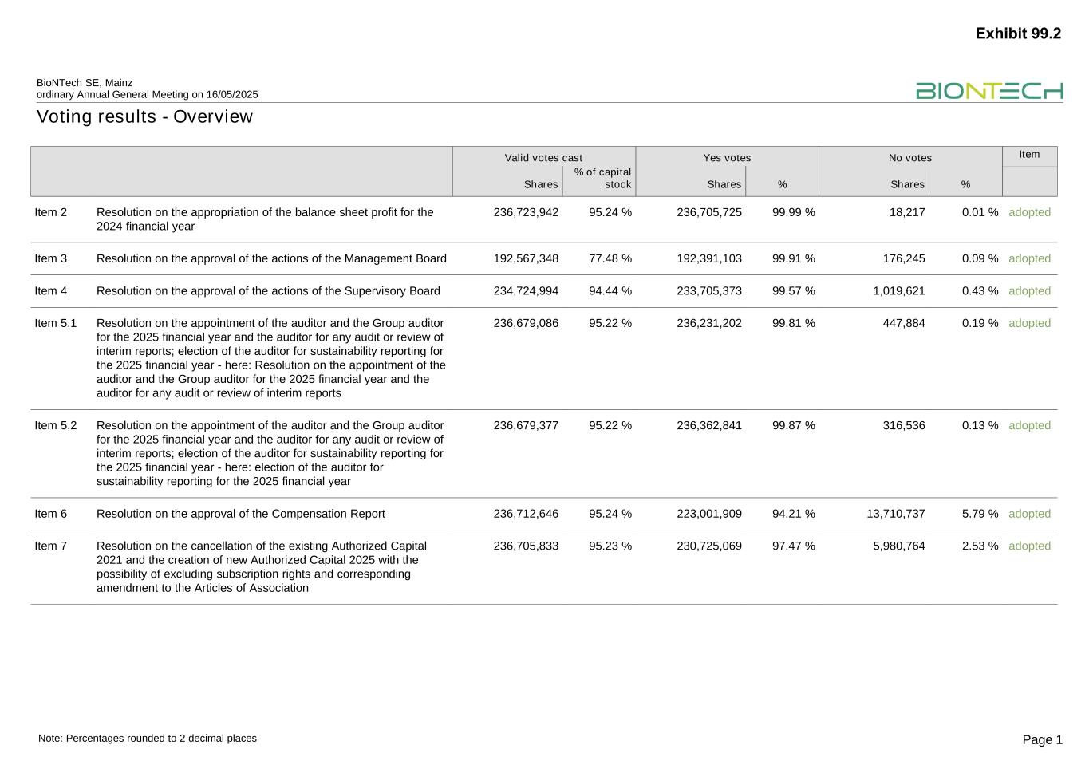
Voting results - Overview BioNTech SE, Mainz ordinary Annual General Meeting on 16/05/2025 Page 1Note: Percentages rounded to 2 decimal places Valid votes cast Yes votes No votes Item Shares % of capital stock Shares % Shares % Item 2 Resolution on the appropriation of the balance sheet profit for the 2024 financial year 236,723,942 95.24 % 236,705,725 99.99 % 18,217 0.01 % adopted Item 3 Resolution on the approval of the actions of the Management Board 192,567,348 77.48 % 192,391,103 99.91 % 176,245 0.09 % adopted Item 4 Resolution on the approval of the actions of the Supervisory Board 234,724,994 94.44 % 233,705,373 99.57 % 1,019,621 0.43 % adopted Item 5.1 Resolution on the appointment of the auditor and the Group auditor for the 2025 financial year and the auditor for any audit or review of interim reports; election of the auditor for sustainability reporting for the 2025 financial year - here: Resolution on the appointment of the auditor and the Group auditor for the 2025 financial year and the auditor for any audit or review of interim reports 236,679,086 95.22 % 236,231,202 99.81 % 447,884 0.19 % adopted Item 5.2 Resolution on the appointment of the auditor and the Group auditor for the 2025 financial year and the auditor for any audit or review of interim reports; election of the auditor for sustainability reporting for the 2025 financial year - here: election of the auditor for sustainability reporting for the 2025 financial year 236,679,377 95.22 % 236,362,841 99.87 % 316,536 0.13 % adopted Item 6 Resolution on the approval of the Compensation Report 236,712,646 95.24 % 223,001,909 94.21 % 13,710,737 5.79 % adopted Item 7 Resolution on the cancellation of the existing Authorized Capital 2021 and the creation of new Authorized Capital 2025 with the possibility of excluding subscription rights and corresponding amendment to the Articles of Association 236,705,833 95.23 % 230,725,069 97.47 % 5,980,764 2.53 % adopted Exhibit 99.2

